Complete Analysis On The Smooth Ear Stretching Kits

Ear stretching piercing began within expressive subcultures and creative groups. It symbolised identity, style, and personal meaning. Over time, ear piercing and stretching gained wider attention. Visual platforms helped share bold looks and fresh ideas. Soon, ear stretching jewelry became a popular fashion choice. Many admired the unique and artistic appeal. Ear stretching earrings added variety and charm to everyday looks. Styles evolved with changing tastes and preferences. Simple designs became statement pieces. This shift helped ear stretching move into mainstream fashion. It now reflects individuality, creativity, and modern self-expression across different lifestyles and communities. Fashion trends helped shape the rise of ear stretching styles. People explored creative options using ear stretching jewelry daily. Designs became more detailed, artistic, and expressive. Ear stretching earrings offered fresh looks for many occasions. Materials varied, giving more styling freedom. If you are looking for additional details on stretching ear kit, check out the above site.
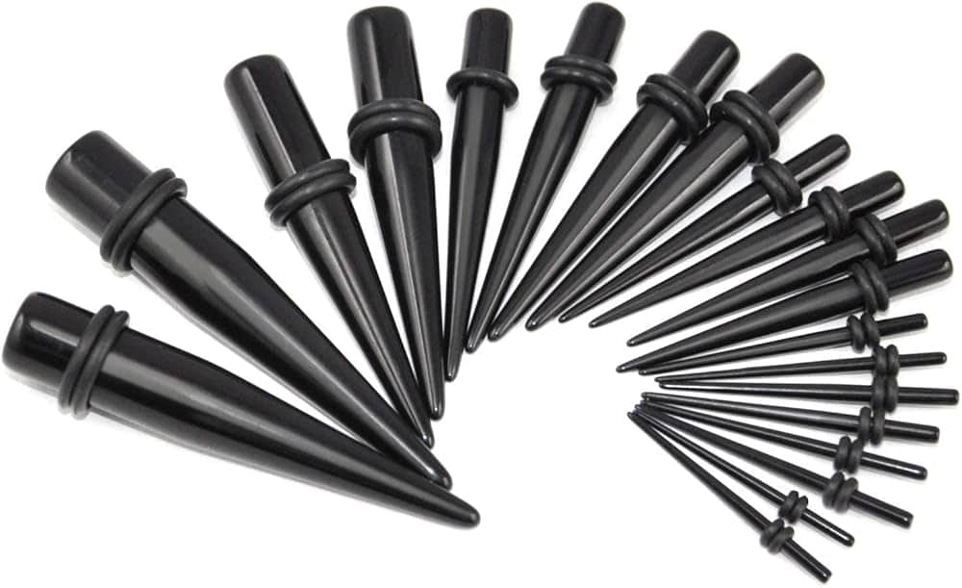
Ear plugs flesh tunnels became a popular design choice. Ear plugs tunnels also added bold visual appeal. Shapes and finishes continued to evolve over time. Minimal styles mixed with vibrant and decorative pieces. This created a balanced and modern aesthetic. The growing variety allowed everyone to express personality through unique ear stretching looks with ease and confidence. Comfort and safety became important as popularity increased steadily. Many people began using a beginner ear stretching kit first. A good ear stretch kit supports a smooth transition. An earring gauge kit helps maintain gradual and gentle progress. The ear gauge kit ensures proper sizing and comfort. A stretching ear kit allows steady and easy expansion. Ear stretching kits are designed for safe and simple use. Ear gauge stretching kits support consistent and careful stretching. A gauge ear stretching kit helps maintain comfort throughout the process. These tools promote a calm and positive experience while enhancing overall confidence. A wide range of options is now available for every style. Ear stretching kits come in many forms and variations. Each ear stretch kit offers different sizes and designs. An earring gauge kit provides flexible and adjustable choices.

The ear gauge kit suits both beginners and experienced users. A stretching ear kit allows personalised progress and comfort. Ear gauge stretching kits offer diverse shapes and finishes. A gauge ear stretching kit supports creative styling options. Ear plugs flesh tunnels add bold and striking looks. Ear plugs tunnels provide classic and modern appeal. This variety ensures something suitable for every taste and preference. Pricing and quality both play a key role in choices. A good ear stretch kit balances value and durability. Many ear stretching kits offer reliable and long-lasting materials. An earring gauge kit often combines affordability with strong design. The ear gauge kit supports both quality and comfort. A stretching ear kit provides steady performance over time. Ear gauge stretching kits ensure consistent and smooth usage. A gauge ear stretching kit delivers dependable and stylish results. Ear stretching jewelry continues to evolve with better craftsmanship. Ear stretching earrings reflect both value and visual appeal, making them a popular and lasting choice. Ear stretching remains stylish, expressive, and widely appreciated today.

