All You Have To Know About The Social Media Video Production Services

Choosing the right partner starts with clear understanding. A creative video agency should match your brand vision. It should offer strong creative video production with clear storytelling. Look for a best video production agency with varied work. A reliable video production agency shows consistency and clarity. A business video production company focuses on brand goals. Review past projects in brand video production. A skilled brand video production agency builds emotional connection. A trusted brand video production company delivers clean and engaging visuals. Good video production should feel natural and simple. Clear communication also shows strong professional approach and creative alignment. Experience matters when selecting a suitable partner. Go to the below mentioned website, if you're searching for additional information on professional social media video production services.

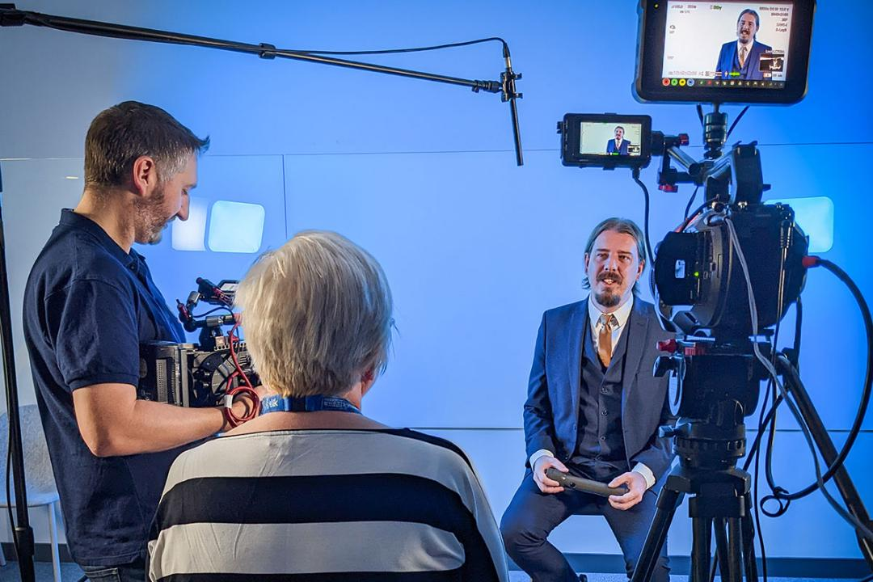

A creative video agency should understand different content needs. Strong creative video production supports brand identity and voice. The best video production agency adapts to changing trends easily. A flexible video production agency offers multiple content formats. A business video production company plans with clarity and purpose. A brand video production agency shapes ideas into visual stories. A brand video production company keeps messaging consistent. Brand video production should feel engaging and meaningful. Professional social media video production services enhance reach and visibility. Clear experience builds trust and long term collaboration value. Content style should align with audience behaviour and expectations. A creative video agency studies audience preferences carefully. Creative video production should feel fresh and engaging. The best video production agency focuses on storytelling flow. A skilled video production agency adapts content for platforms. A business video production company builds content with purpose. A brand video production agency creates strong emotional appeal. A brand video production company ensures visual consistency across formats. Brand video production should suit modern viewing habits.

Social media video production for Instagram, TikTok and YouTube needs fast pacing. Professional social media video production services improve engagement and audience retention effectively. Process clarity helps in smooth project execution and delivery. A creative video agency follows structured and simple workflows. Creative video production includes planning, shooting, and editing stages. The best video production agency keeps communication clear throughout. A video production agency ensures timely updates and progress sharing. A business video production company manages each step efficiently. A brand video production agency aligns ideas with brand message. A brand video production company ensures visual quality and tone. Brand video production benefits from organised planning and creative direction. Social media video production for paid ads needs clear goals and messaging for better results. Final results should support growth and long term value. A creative video agency focuses on impact and visibility. Creative video production helps brands stand out clearly. The best video production agency improves audience engagement consistently. A video production agency builds content that connects emotionally. A business video production company supports business growth strategies. A brand video production agency strengthens brand identity through visuals. A brand video production company builds trust with consistent messaging. Brand video production enhances recognition and recall value. Professional social media video production services boost content performance.

