Men's Nose Rings - Discover The Simple Facts About Them

Choosing body jewellery can feel exciting and simple for beginners. Start by understanding the basic difference between ear gauge and regular gauge earrings. An ear gauge refers to wider jewellery for stretched lobes. Regular gauge earrings suit standard piercings and classic looks. Many people explore earring gauges to express personal style. Beginners often prefer small ear gauges for a gentle start. These options feel comfortable and easy to manage daily. Explore different shapes, colours, and finishes for variety. Simple choices help build confidence and create a balanced look. With time, selection becomes easier and more enjoyable for everyday wear use. Moving ahead, explore ear gauges and plugs for varied styles. These pieces offer smooth surfaces and neat finishes. Ear plugs and stretchers help guide gradual size changes. Many beginners follow plugs ear stretching methods for comfort. Start slow and allow time for adjustment. Choose lightweight materials for daily ease and flexibility. Rounded edges feel gentle and support a relaxed experience. Clean designs suit both casual and smart outfits. Click on the below mentioned website, if you're looking for more information on mens nose rings.

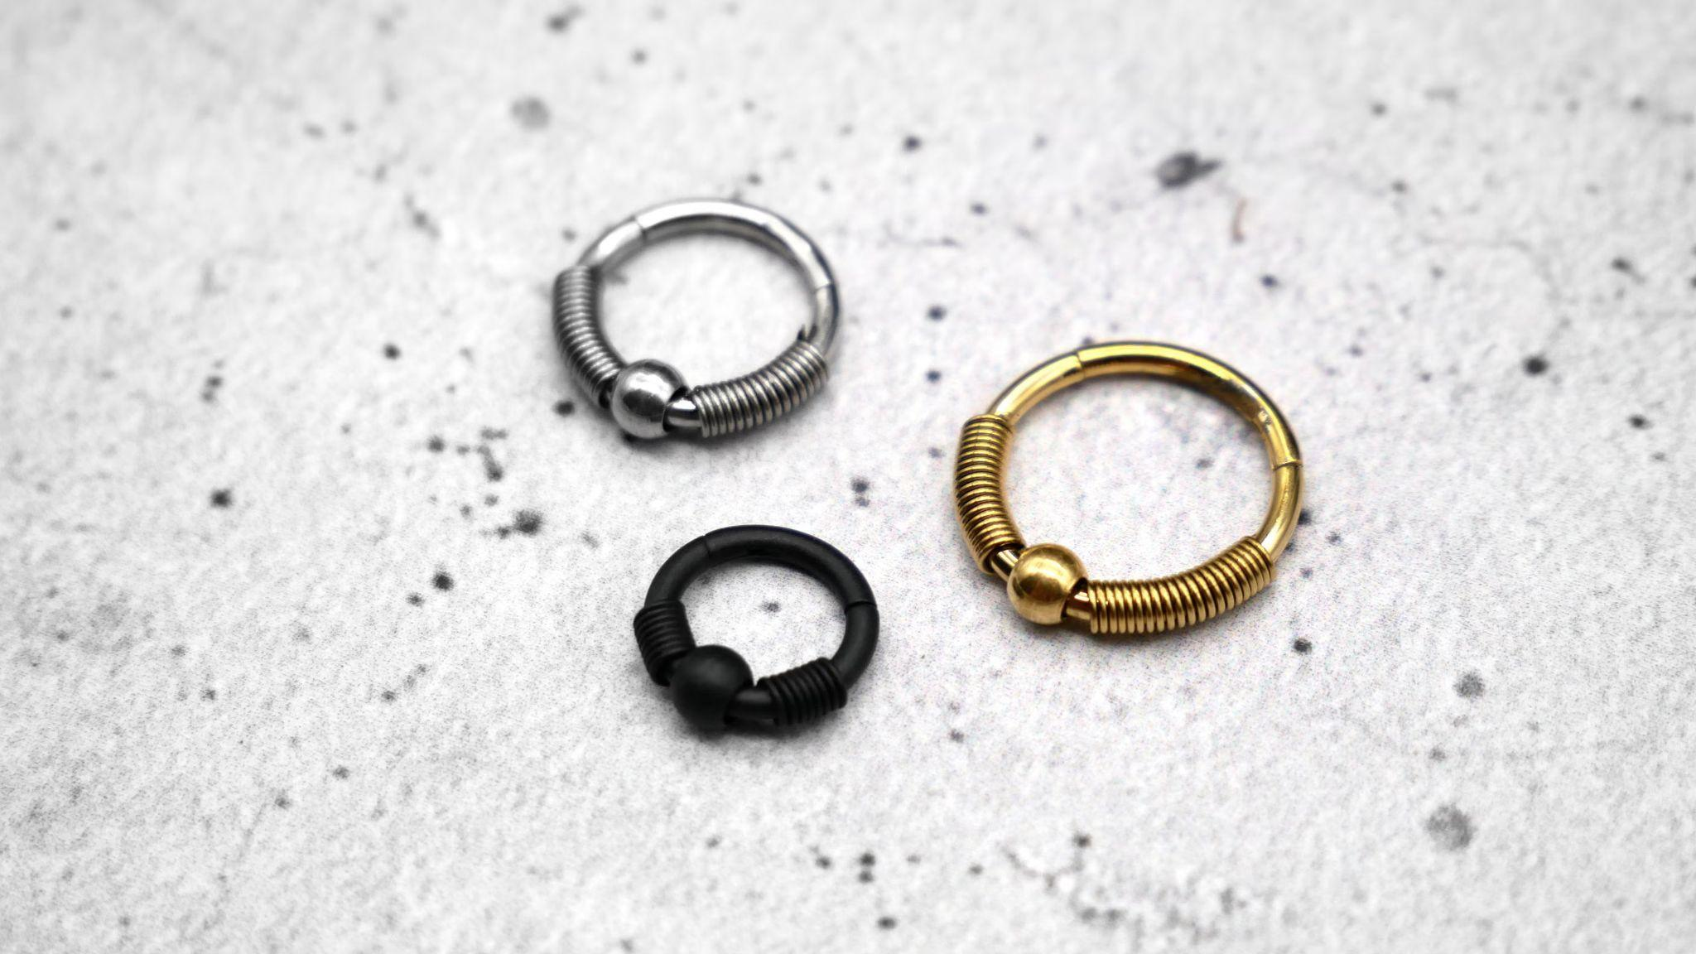

Balanced choices keep the look refined and stylish. With practice, handling and care feel simple and natural. This approach builds confidence and keeps jewellery enjoyable for everyday wear and easy maintenance routines. Alongside ear styles, nose studs and rings add subtle charm. Many people choose nose rings for a clean, modern look. Rings for nose piercing come in simple and elegant forms. Small hoops and studs suit daily wear and comfort. Smooth edges and light designs feel easy on the skin. Mixing styles creates a balanced and fresh appearance. Pairing pieces with outfits enhances overall style and expression. Soft finishes and classic shapes remain timeless and versatile. Care and gentle handling keep jewellery looking bright and neat. Consistent choices help create a polished and confident personal look for every occasion and comfort. Style also varies for different preferences and fashion moods. Mens nose rings offer bold yet simple styling choices. Many designs remain sleek and easy to wear daily.

Men's nose rings can match casual or refined outfits. Subtle finishes keep the look clean and balanced. Pairing with ear pieces creates a unified appearance. Small details often make a strong visual impact. Soft colours and neutral tones suit many wardrobes. Choosing pieces that reflect personality feels rewarding and expressive. Over time, styling becomes effortless and consistent. This approach keeps jewellery choices fresh, modern, and easy to enjoy for daily wear and comfort. Finally, choosing the right pieces depends on comfort and preference. Revisit each ear gauge option before making a choice. Compare earring gauges to find a suitable everyday style. Small ear gauges often feel light and easy to manage. Regular gauge earrings remain ideal for classic, simple looks. Mixing ear gauges and plugs creates variety and visual interest. Ear plugs and stretchers support gradual changes with ease. Plugs ear stretching methods help maintain a smooth transition. Nose studs and rings pair well with many styles. Rings for nose piercing and nose rings complete a balanced, confident look for daily wear style.

