In-Depth Study On The Top Web Design Agency

Finding the right web design agency needs clear thinking. Many web design agencies offer varied styles and approaches. A good web design company understands simple business goals. The best web design agency focuses on clarity and purpose. A skilled web designer creates clean and engaging layouts. Businesses often compare web design companies before deciding. This helps in choosing suitable small business web design services. Clear communication always supports better outcomes. Many prefer wordpress web design for ease and flexibility. Affordable web design options are also widely available. Careful research helps in selecting the right web design company. Choosing between a web designer and web design agency depends on needs. A solo web designer may offer personal attention and flexibility. If you're searching for additional details on web design companies in bristol, click on the previously mentioned website.

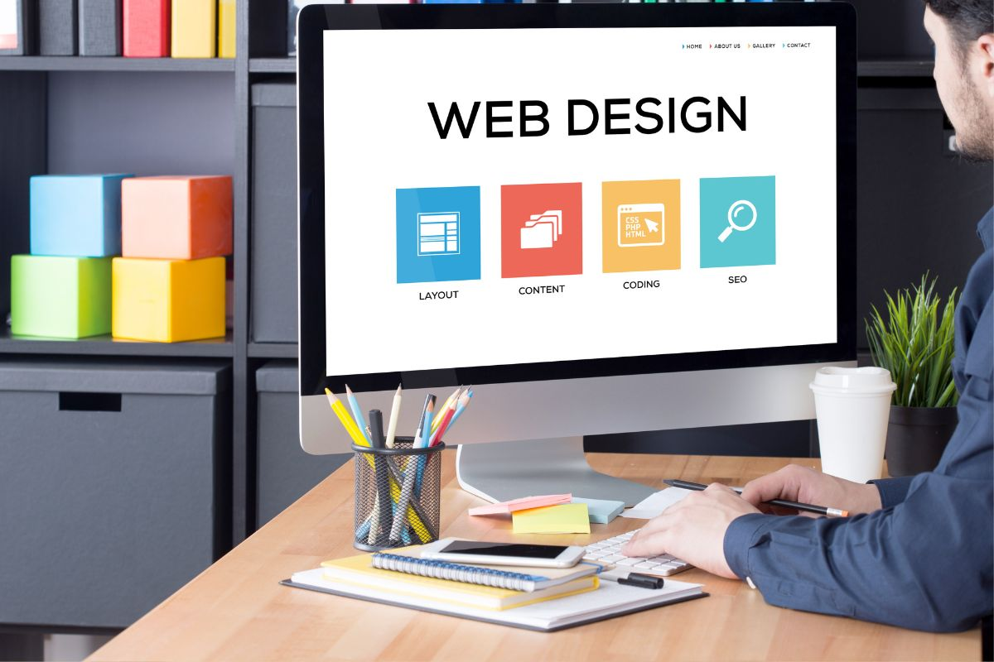

Larger web design companies provide wider skills and broader support. Many web design agencies offer complete solutions for growing businesses. The best web design agency combines creativity with clear structure. Affordable web design services can still deliver strong results. Small business web design often needs simple and clean layouts. A reliable web design company focuses on user experience. Wordpress web design is popular for easy updates and management. Comparing different web design companies helps in making confident decisions. Understanding goals is important before selecting a web design agency. Every web design company works differently with varied methods. The best web design agency listens and understands expectations clearly. A professional web designer creates designs that feel natural and smooth. Many web design companies focus on user-friendly and modern layouts. Small business web design often requires clarity and simplicity. Wordpress web design supports easy control and future updates. Affordable web design solutions help manage budgets wisely. Different web design agencies offer creative and flexible ideas.

Choosing the right web design company ensures a smooth design journey. Checking past work helps in selecting the best web design agency. Many web design companies show simple and creative design styles. A good web designer focuses on clean and easy layouts. Small business web design benefits from clear and engaging pages. Wordpress web design offers simple editing and useful features. Affordable web design can still look modern and professional. Web design agencies often provide helpful guidance and support. A reliable web design company keeps communication clear and steady. Comparing web design companies builds better understanding. This process helps in choosing a suitable web design agency confidently. A strong choice leads to better business growth and visibility. The best web design agency creates designs that feel natural and smooth. Many web design agencies offer flexible and creative solutions. A skilled web designer builds pages that are easy to explore. Web design companies often focus on simple and clean experiences. Small business web design supports steady growth and connection. Wordpress web design helps manage content with ease. Affordable web design ensures value and balanced spending. A trusted web design company delivers consistent results. Exploring different web design companies helps in making the right decision.

