Discover What a Professional Has to Say About the Gynecomastia Reduction

Affordable care is now easier with skilled gynecomastia surgeons. Many trusted gynecomastia doctors offer simple and effective options. An experienced gynecomastia doctor explains choices in clear language. People often search for a reliable gynecomastia clinic first. A good gynecomastia clinic provides comfort and support throughout. Clear guidance helps people feel calm and confident. Affordable plans make treatment more accessible for many. Quality care and fair pricing can go together. Choosing wisely helps achieve satisfying and natural outcomes. Simple steps and trusted care make the journey smooth. Understanding treatment options helps in finding affordable solutions. Many clinics provide safe gynecomastia removal with gentle methods. Others offer smooth gynecomastia reduction for natural shaping. Skilled gynecomastia surgeons use updated yet simple techniques. Many gynecomastia doctors focus on comfort and ease. A caring gynecomastia doctor ensures a relaxed experience. Each gynecomastia clinic follows simple and clear procedures. A trusted gynecomastia clinic offers guidance at every stage. These steps make the process feel easy and calm. Affordable care does not reduce quality or comfort. Visit the following website, if you're looking for more information about gynecomastia removal.
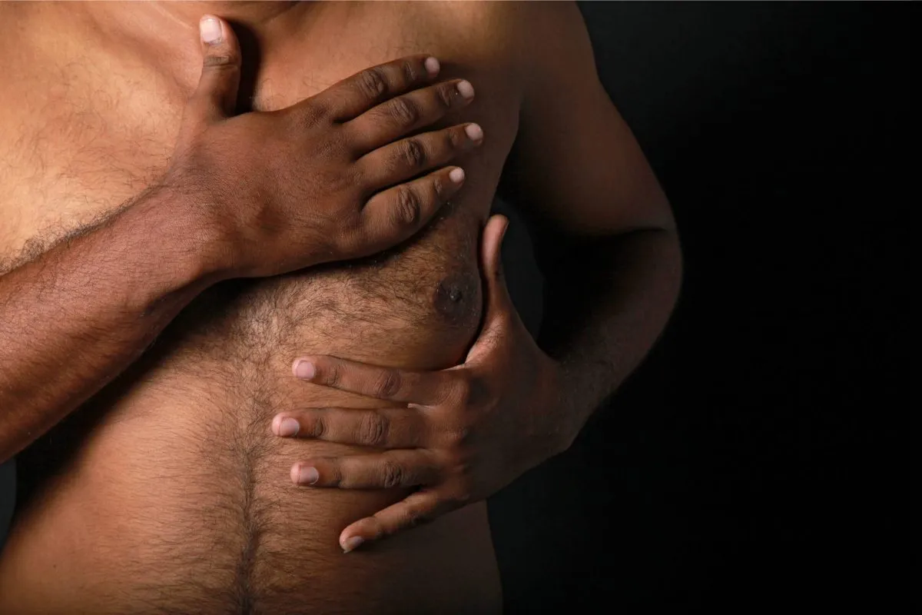
Cost plays a major role when planning the procedure. Many people ask about gynecomastia surgery price early. Understanding gynecomastia price helps in making better choices. A reliable gynecomastia clinic explains all costs clearly. Each gynecomastia clinic keeps pricing simple and transparent. Affordable options support better planning and comfort. Clear pricing builds trust and confidence in care. Balanced cost and quality help create a smooth experience. Patients feel more relaxed with clear and honest details. Simple cost guidance helps people move forward with ease. Visual results help people feel more confident about treatment. Many check gyno before and after results carefully. These images show real improvements in a simple way. Before and after gyno removal pictures build trust. Clinics often display gyno surgery before and after examples. These visuals reflect skill and consistent outcomes. Patients feel more assured after seeing these results. Clear transformations support better understanding and decisions. Good results inspire confidence in gynecomastia surgeons. Visual proof helps people choose the right care easily.

Affordable surgery today remains safe, simple, and effective. Skilled gynecomastia surgeons focus on comfort and care. Many gynecomastia doctors follow gentle and easy methods. Each gynecomastia doctor ensures a smooth and calm journey. Advanced gynecomastia removal techniques improve overall experience. Many prefer refined gynecomastia reduction for natural results. A supportive gynecomastia clinic guides every step clearly. Every gynecomastia clinic maintains a calm and clean setting. Simple care plans improve comfort and satisfaction. Affordable treatment now offers quality, confidence, and lasting positive results. Affordable options continue to improve access to trusted care. Skilled gynecomastia surgeons and experienced gynecomastia doctors provide simple guidance. A reliable gynecomastia doctor ensures clarity and comfort. Every gynecomastia clinic supports smooth gynecomastia removal and gynecomastia reduction. Clear gynecomastia surgery price and gynecomastia price details, along with gyno before and after results, build strong confidence.

