Detailed Study On The Professional Sports Massage Services

Modern lifestyles value ease and comfort every day. Many people now choose mobile massage for this reason. It brings relaxation directly to personal space. There is no need to travel or wait. A simple mobile massage booking makes everything quick. This service suits busy routines and tight schedules. It fits perfectly with daily life demands. Many search for full body massage near me online. They prefer instant options and fast response. A skilled massage therapist arrives at the chosen time. This smooth process makes massage in city life easier. Comfort and simplicity now shape how people enjoy massage today. Choosing massage at home offers unmatched ease and peace. It allows full relaxation without outside distractions. Click on the following site, if you're searching for more information regarding sports massage therapist london.

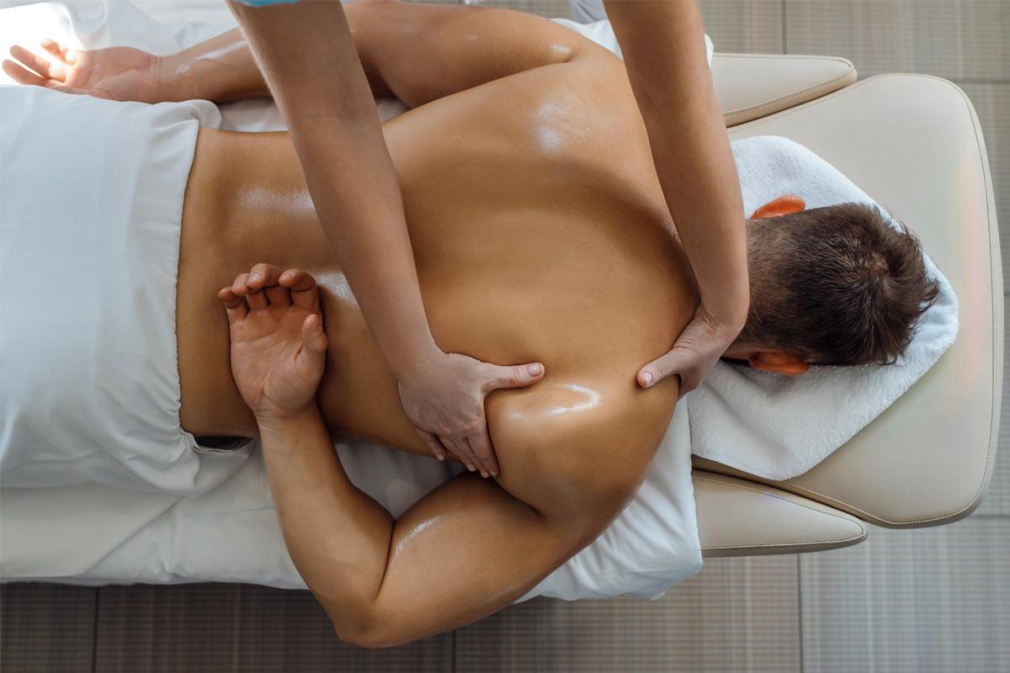

Many people enjoy calm surroundings during sessions. A full body massage therapist works with care and comfort. The experience feels more personal and soothing. There is no rush or travel stress involved. Mobile massage supports flexible timing and simple planning. It suits both morning and evening routines. Hotel room massage is another easy option for travellers. It offers the same comfort in a different setting. This approach keeps relaxation simple and accessible. Convenience plays a key role in choosing such services. Booking a session is now fast and effortless. Mobile massage booking platforms make the process smooth. A few simple steps complete the arrangement quickly. People can choose a suitable massage therapist easily. Options include a full body massage therapist or specialist care. A sports massage therapist is also available for active needs. Each service matches different comfort goals. Mobile massage removes the need for long planning. Everything feels organised and simple from start to finish. This ease attracts more people towards massage in city living. It creates a seamless experience that fits modern routines.

Mobile massage continues to grow in popularity everywhere. Many people prefer massage at home for comfort. It offers privacy and a peaceful environment. Hotel room massage also suits travel and short stays. It provides the same relaxing experience anywhere. People often search full body massage near me for quick options. They enjoy flexible timing and simple access. A massage therapist arrives ready and prepared. This service adapts to different needs with ease. Mobile massage supports a balanced and calm lifestyle. It blends comfort, ease, and relaxation in one experience. Relaxation remains the core benefit of every session. A full body massage therapist helps reduce daily tension. The calm setting enhances comfort and peace. Mobile massage creates a soothing atmosphere anywhere. It allows deeper rest without outside interruptions. A sports massage therapist helps refresh the body gently. Massage in city life becomes easier with such options. People enjoy flexible services without effort or delay. Hotel room massage adds comfort during travel moments. Massage at home keeps the mind and body balanced. This simple approach makes massage a natural part of daily wellness.

