Detailed Analysis On Professional Therapy Room Services

Finding the right therapy room hire requires careful and simple thinking. Many professionals search for a suitable therapy room that feels calm. A peaceful setting supports better sessions and stronger client trust. When exploring therapy rooms, focus on comfort and ease of use. Many also look for therapy room hire near me for convenience. This approach saves time and effort daily. Good counselling rooms to rent should feel private and welcoming. Suitable clinic rooms to rent should offer a clean and organised space. Many professionals also prefer talking therapy rooms to rent with soothing interiors and simple layouts. If you're searching for more information on talking therapy rooms to rent london, explore the previously mentioned site.

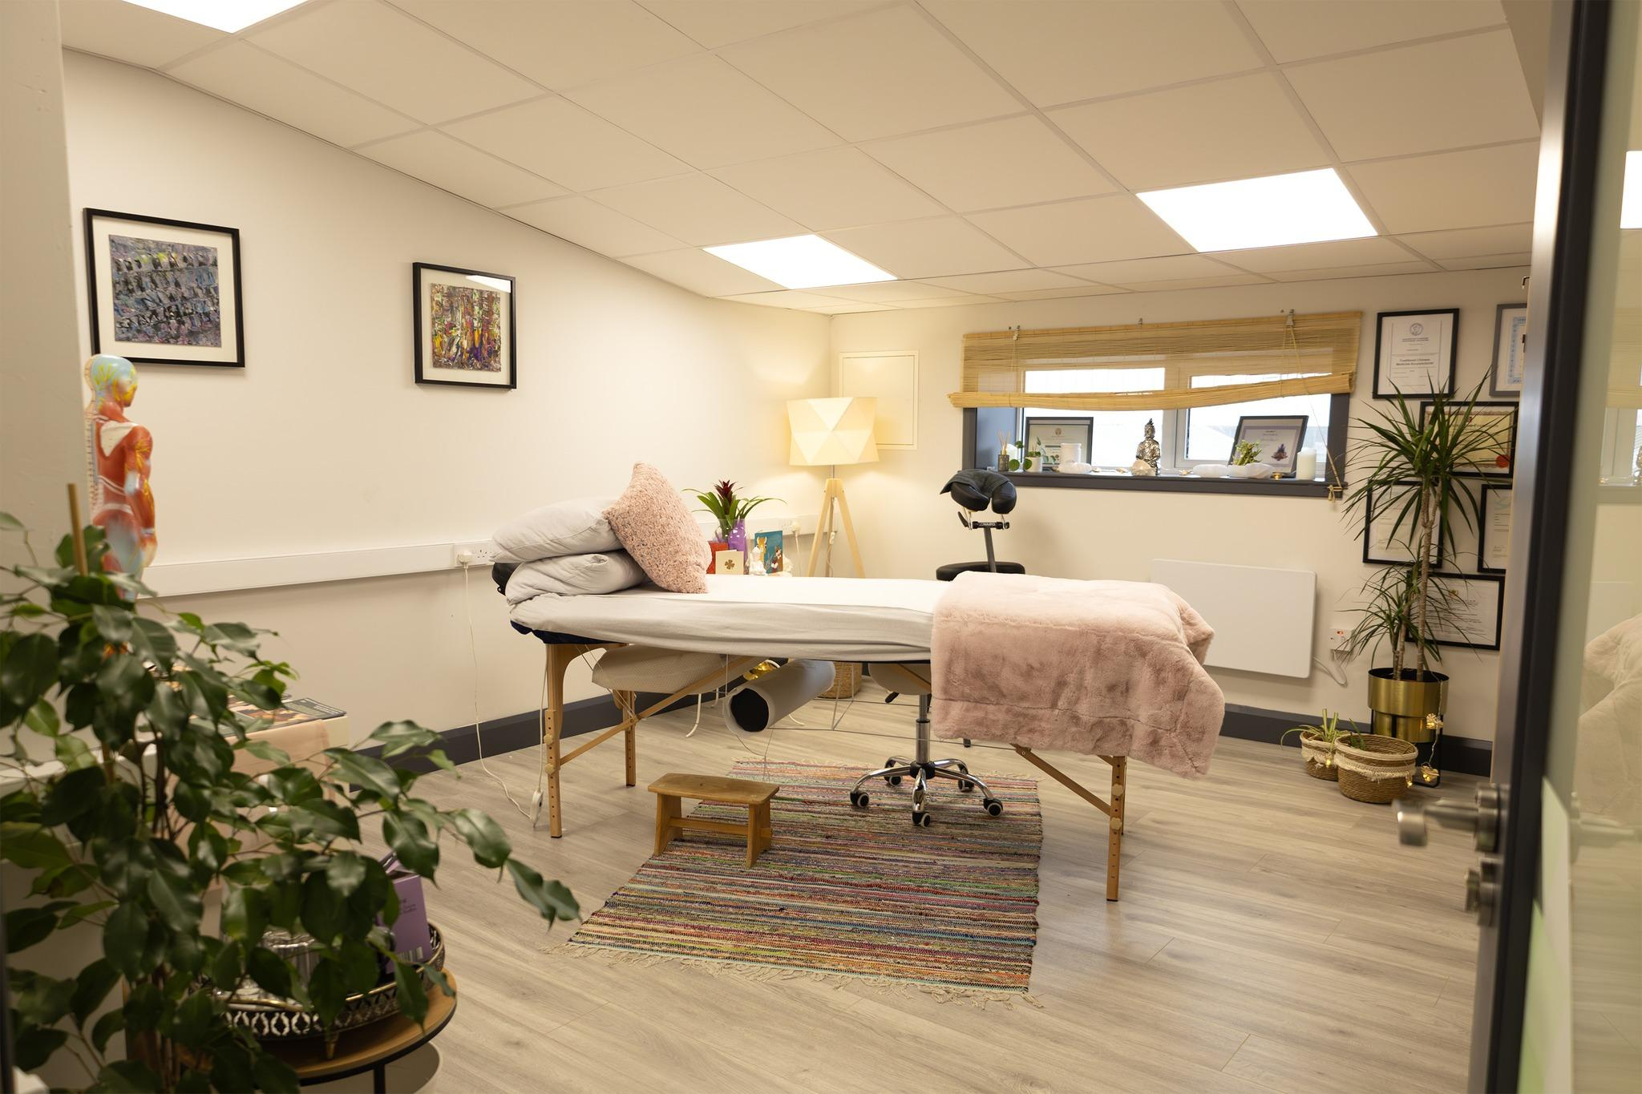

Choosing the right space involves matching needs with the right environment. A therapy room should support focus and relaxation during sessions. Many professionals prefer psychotherapy rooms to rent that feel quiet and secure. A clinic treatment room should also feel practical and well arranged. Simple layouts help maintain a smooth workflow during appointments. When exploring a treatment room to rent near me, ease of access matters. A nearby space helps maintain regular schedules. A medical clinic room should feel professional yet comfortable. Many also search for a medical room for rent that suits different therapy styles. Flexibility plays an important role in selecting the best therapy room hire. Many therapy rooms offer flexible timing and simple booking options. This helps professionals manage their schedules with ease. Counselling rooms to rent often provide adaptable spaces for various needs. Clinic rooms to rent may support both short and long sessions. Talking therapy rooms to rent should feel adaptable for different client preferences. Psychotherapy rooms to rent often include calm surroundings that support deep conversations. A clinic treatment room with flexible use adds more value. A treatment room to rent near me also saves daily travel effort.

Comfort and ambience help create a positive experience for clients. A therapy room should feel warm, quiet, and inviting. Therapy rooms with soft lighting support relaxation and trust. Counselling rooms to rent should provide privacy and peaceful surroundings. Clinic rooms to rent should feel clean and well maintained. Talking therapy rooms to rent often focus on calm colours and simple décor. Psychotherapy rooms to rent may include minimal distractions for better focus. A medical clinic room should feel organised and professional. A medical room for rent should also reflect care and attention in its setup. Making the right choice brings long term benefits for any practice. Therapy room hire supports growth and consistent client engagement. A well chosen therapy room improves confidence and daily workflow. Many prefer therapy room hire near me for ongoing convenience. Therapy rooms that match professional needs create better outcomes. Counselling rooms to rent and clinic rooms to rent offer reliable options. Talking therapy rooms to rent and psychotherapy rooms to rent support different approaches. A clinic treatment room or medical clinic room adds versatility. A treatment room to rent near me or medical room for rent ensures lasting ease.

