All You Want To Learn About The Personal Workout Training

Finding the right executive personal trainer can transform daily fitness habits. Busy routines need smart and flexible support systems. Executive personal training focuses on efficiency and comfort. It blends structure with adaptable schedules and goals. A personal trainer should understand lifestyle and time limits. A private personal trainer offers focused attention and privacy. This creates a calm and distraction free environment. Personal training becomes easier to follow and maintain. Tailored personal training helps match fitness with personal needs. It supports balance between work and wellness. Choosing wisely ensures better consistency and steady progress. The right guidance builds confidence and long term commitment. Understanding training style is important before making a choice. Check out the following website, if you're looking for more information regarding personal training liverpool street.

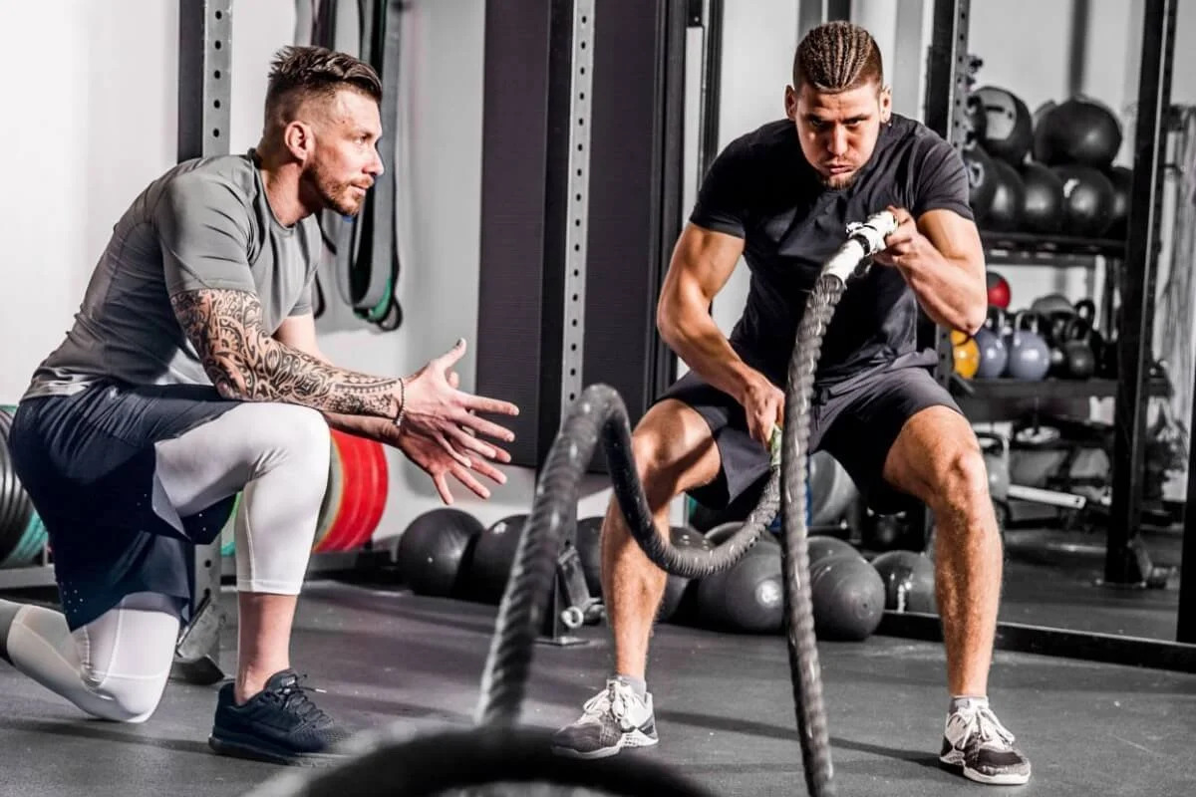

Executive personal training often includes flexible and refined sessions. These sessions respect time and energy levels. A private fitness training approach keeps sessions focused and calm. A personal trainer plans routines that feel manageable and enjoyable. An executive workout should be simple and effective. It should suit both beginners and experienced individuals. A private personal trainer helps maintain steady motivation. Personal training becomes more structured and goal driven. Tailored personal training adapts to changing needs. This ensures comfort and consistency over time. A good match improves both physical strength and mental clarity. Environment plays a key role in achieving better results. A private gym offers peace and controlled surroundings. This space supports better focus and fewer interruptions. Private fitness training thrives in such settings. A private personal trainer uses the space effectively. Executive personal training benefits from quiet and organised areas. A personal trainer ensures each session flows smoothly. An executive workout becomes more enjoyable in a calm place. Personal training feels more personal and meaningful. Tailored personal training fits well within private spaces. It allows better concentration and steady improvement.

A private gym creates a strong foundation for consistent progress and comfort.Communication is another key factor in choosing the right support. A personal trainer should listen and guide clearly.Executive personal training depends on clear understanding of goals. A private personal trainer builds trust through simple guidance. Personal training becomes smoother with open communication. Tailored personal training adjusts based on feedback and comfort. A private fitness training plan should feel natural and balanced. An executive workout should match daily energy levels. A personal trainer helps refine routines without pressure. This creates a positive and encouraging experience. Executive personal training grows stronger with clear and steady communication over time. Consistency builds lasting results and long term confidence. Executive personal training supports regular and structured progress. A private personal trainer ensures steady encouragement and support. Personal training becomes a habit rather than a task. Tailored personal training evolves with changing goals. A private fitness training routine stays flexible and practical. An executive workout remains simple and effective each session. A private gym adds comfort and focus to every visit. A personal trainer keeps motivation high and consistent. Choosing the right executive personal trainer creates lasting benefits. It supports a balanced and active lifestyle with ease.

