All You Want To Know About High Quality Washroom Cubicles

Finding the right toilet cubicle manufacturers needs careful thought. A good choice ensures lasting quality and neat design. Many toilet cubicles suppliers offer varied styles and finishes. It helps to compare options before deciding. Look at materials used in each toilet cubicle panel. Strong panels give better durability and smooth appearance. Well-made commercial toilet cubicles improve overall space appeal. Modern commercial washroom cubicles focus on comfort and privacy. Choosing trusted makers brings peace and confidence. Simple research helps identify reliable suppliers. A clear plan supports better decisions and long-term satisfaction. Quality materials play an important role in every setup. A strong toilet cubicle panel gives a clean and polished look. Are you searching about commercial washroom cubicles? Browse the previously discussed site.

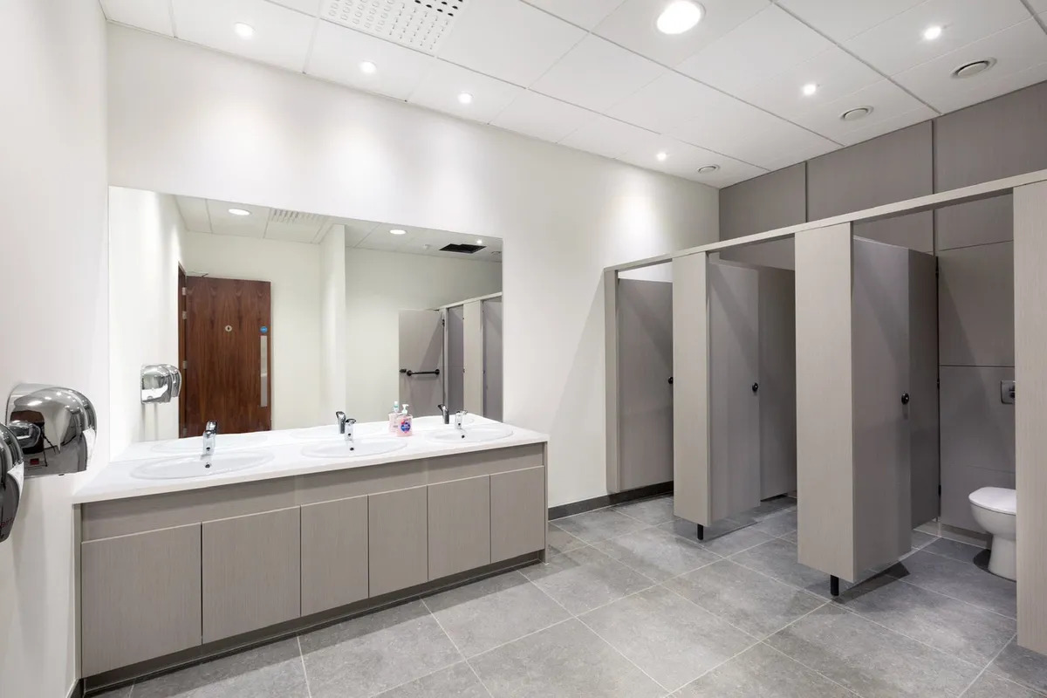

Well-built toilet cubicle partitions offer privacy and ease of use. A good cubicle partition for toilet improves comfort in shared spaces. Many spaces prefer a cubicle toilet partition with smooth finishes. These options create a tidy and welcoming environment. Good design also supports easy cleaning and care. A well-planned layout makes daily use simple. Choosing the right combination ensures a balanced and attractive washroom setup. Modern systems include smart panel solutions for better access. IPS duct panels help keep pipe areas neat and hidden. IPS access panels allow easy reach for maintenance needs. An IPS panel toilet setup improves overall appearance and order. Clean IPS duct panelling supports a seamless finish across the space. These panels enhance both function and style. They also support a clutter-free layout. Many suppliers now offer flexible IPS options. This makes planning simple and efficient. A neat system creates a calm and organised washroom environment. Design and layout should match the purpose of the space. Commercial toilet cubicles suit busy and shared environments. Commercial washroom cubicles need strong and durable materials. Good toilet cubicle partitions help manage space efficiently.

A well-placed cubicle partition for toilet improves user comfort. Balanced spacing supports smooth movement and privacy. Simple designs often work best in shared areas. Neutral colours give a calm and fresh look. Clean lines and smooth finishes enhance the overall feel. Thoughtful planning leads to a better user experience. Choosing the right supplier brings everything together smoothly. Trusted toilet cubicle manufacturers offer reliable and stylish solutions. Experienced toilet cubicles suppliers understand varied needs. They provide options that suit different layouts and preferences. Quality IPS duct panels and IPS access panels improve overall function. A strong IPS panel toilet system adds value to the space. Clean IPS duct panelling ensures a neat and modern finish. Well-designed toilet cubicle partitions complete the setup perfectly. Careful selection ensures a lasting and attractive washroom environment. Careful comparison always leads to better choices. Reliable toilet cubicle manufacturers provide lasting solutions. Trusted toilet cubicles suppliers ensure smooth service and support. Quality toilet cubicle panel and IPS duct panels enhance the space. Well-planned cubicle toilet partition creates a neat and comfortable

