All You Need To Learn About The Premium Quality Wildflower Seeds

Choosing the right wild seeds brings natural beauty and calm. Many gardeners start with wild flower seeds for easy growth. These seeds create colourful and lively outdoor spaces. Options like british wildflowers seeds feel classic and charming. Native wildflower seeds support healthy soil and happy pollinators. A good wildflower seed mix adds variety and visual interest. Each choice offers simple ways to enhance surroundings. Think about light, soil, and space before selecting seeds. Some prefer soft blooms, while others like bold colours. Careful selection helps plants grow strong and bright. This simple process ensures a pleasing and balanced garden area. Understanding types of wild seeds helps better decisions. A wildflower seed mix gives mixed colours and textures. Are you looking about purchase wildflower seeds? Browse the previously described website.

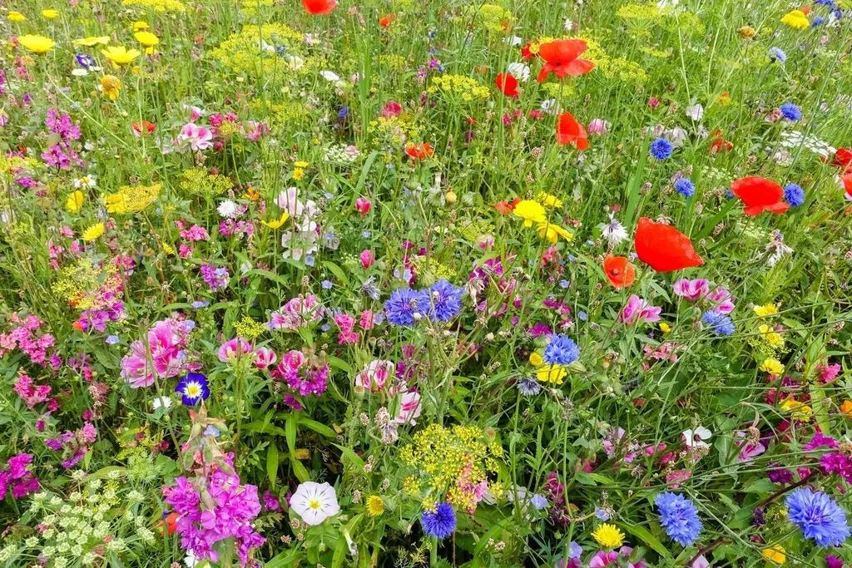

It creates a natural and flowing garden look. Wildflower seeds bulk options suit larger spaces and open areas. These packs offer good value and easy coverage. Many gardeners purchase wildflower seeds for quick planting plans. Choosing native wildflower seeds keeps growth simple and steady. These seeds blend well with natural surroundings. They also support bees and butterflies in gardens. A mix of wild grasses seeds adds gentle movement. This mix creates depth and balance. Simple choices lead to beautiful and lively outdoor spaces. Checking garden conditions helps match the right wild seeds. Light plays a key role in plant growth. Shade wild flowers grow well in low light areas. Wildflower seeds for shade offer soft blooms and calm tones. A wild flower mix for shade fills darker spots nicely. These choices keep gardens bright even without full sunlight. Soil should feel loose and healthy for best results. Adding wild grass seed improves texture and coverage. Wild grasses seeds create a soft and flowing landscape feel.

A balanced mix supports steady growth. These small checks help seeds grow with ease and comfort. Quality matters when selecting wild flower seeds for planting. Always choose fresh and clean wild seeds for best growth. Many gardeners purchase wildflower seeds from trusted sources. Wildflower seeds bulk packs help save effort and time. These packs suit large gardens and open fields. Native wildflower seeds adapt well and grow naturally. British wildflowers seeds offer classic charm and gentle beauty. A wildflower seed mix adds colour variation and interest. Mixing wild grasses seeds enhances overall garden appeal. Wild grass seed fills gaps and supports structure. Good choices create a soft and natural garden setting. Planning helps create a balanced and colourful garden space. Start with a simple wildflower seed mix for easy planting. Add native wildflower seeds for a natural look. Use wildflower seeds for shade in darker garden areas. A wild flower mix for shade keeps spaces lively and fresh. Include wild grasses seeds for soft movement and texture. Wild grass seed adds depth and gentle contrast. Many choose wildflower seeds bulk for larger areas. Others purchase wildflower seeds for small garden spaces. Each choice supports growth and beauty. Careful planning leads to a calm and vibrant outdoor space.

