A Few Details About 3D LED Neon Light Signs

Finding the right sign starts with clear style choices. Many prefer custom LED signs wedding for soft glow. Others like a classic neon sign wedding for charm. A custom neon sign wedding adds personal touch and warmth. A LED neon sign wedding offers modern look and feel. Couples explore custom LED signs for wedding to match themes. A wedding neon light sign creates a lovely focal point. Simple designs often look clean and elegant. Bright colours add life and energy. Soft tones give calm and gentle mood. The right sign blends well with décor and space. Good selection makes the event feel complete. Choosing quality makers is also very important. If you're looking to learn more about led neon sign wedding, browse the mentioned above website.

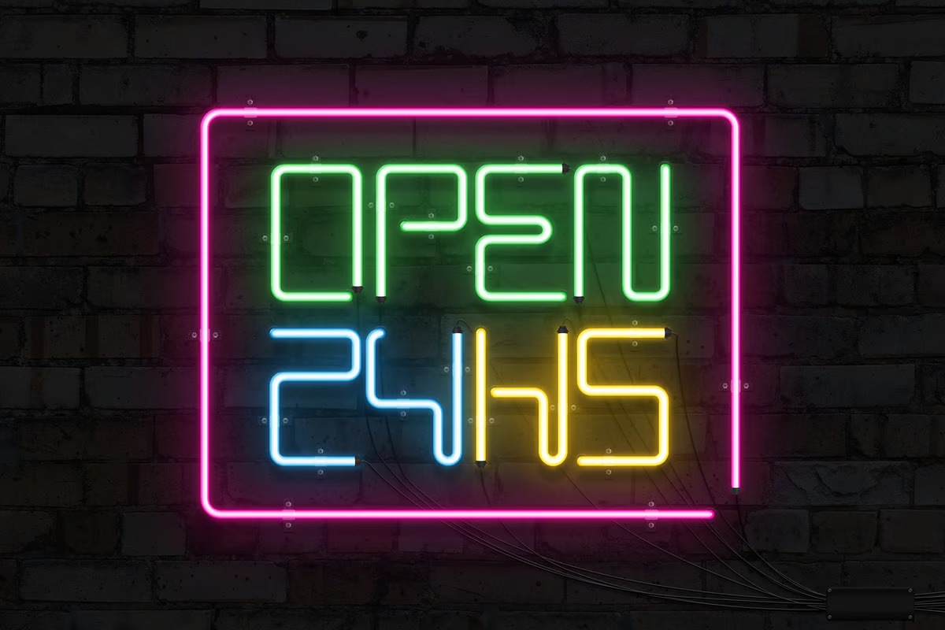

Trusted business neon sign makers ensure smooth design process. Skilled logo neon sign manufacturers create sharp and neat results. A custom company neon logo sign reflects brand identity clearly. Many businesses use neon company signs to attract attention. Clear communication helps achieve the desired outcome. Good makers offer flexible styles and options. They also guide on colour and size choices. Custom signs with lights should feel balanced and pleasing. A well-made neon light up sign custom gives long lasting beauty. Reliable service ensures a stress free experience. Design ideas play a key role in final results. A custom neon sign wedding can include names or phrases. A LED neon sign wedding works well with modern themes. Many choose custom LED signs wedding for soft brightness. Creative fonts bring personality and charm. Shapes like hearts or symbols look appealing. A wedding neon light sign adds warmth to settings. Businesses prefer custom company neon logo sign for branding. Neon company signs can be bold or minimal. Custom signs with lights offer many creative options. A neon light up sign custom fits both events and stores. Simple ideas often create strong visual impact.

Understanding the process helps in better decisions. It starts with choosing style and concept. Then a custom neon sign wedding design is created. Makers refine details for a clean finish. LED neon sign wedding options offer easy setup. Custom LED signs for wedding are simple to place. Business neon sign makers follow a clear workflow. Logo neon sign manufacturers shape each detail carefully. Custom company neon logo sign goes through final checks. Custom signs with lights are tested for brightness. A neon light up sign custom is then ready. The full process feels smooth and organised. Placement and usage also matter for best results. A wedding neon light sign looks stunning in dim settings. A neon sign wedding creates a magical evening effect. Custom LED signs wedding shine softly during the day. LED neon sign wedding works well in all lighting. Custom LED signs for wedding suit indoor and outdoor use. Neon company signs attract attention at night and day. Custom company neon logo sign enhances brand visibility. Business neon sign makers suggest ideal placement. Custom signs with lights should match the space. A neon light up sign custom adds charm everywhere. Good placement completes the overall look beautifully.

