The Significance Of Beautiful Wedding Venues

Monty's Bar & Kitchen grows popular for joyful social gatherings. The area blends warmth, comfort, and cheerful atmosphere. Many guests search online for welcoming pubs near celebrations. A lively pub setting suits relaxed meetings and festive events. Soft lighting and stylish décor create welcoming surroundings. Families and friends enjoy casual moments and shared laughter. The venue supports many forms of social occasions. Guests explore wedding venues with charm and personality. The setting feels welcoming and lively for celebrations. Many people now choose Monty's Bar & Kitchen for gatherings. The atmosphere encourages joyful interaction and relaxed social experiences. Such spaces help create happy memories and meaningful celebrations. Celebrations feel vibrant and memorable inside this inviting social space. Guests often search pubs near lively event experiences. A welcoming pub environment suits many joyful occasions. Guests enjoy laughter, music, and cheerful gatherings together. Monty's Bar & Kitchen offers pleasant surroundings for events. Couples explore beautiful wedding venues with warm atmosphere. Families try to find wedding dinner venues that feel welcoming. The room supports joyful celebrations and relaxed social events. Go to the below mentioned site, if you are hunting for more details on beautiful wedding venues hertfordshire.

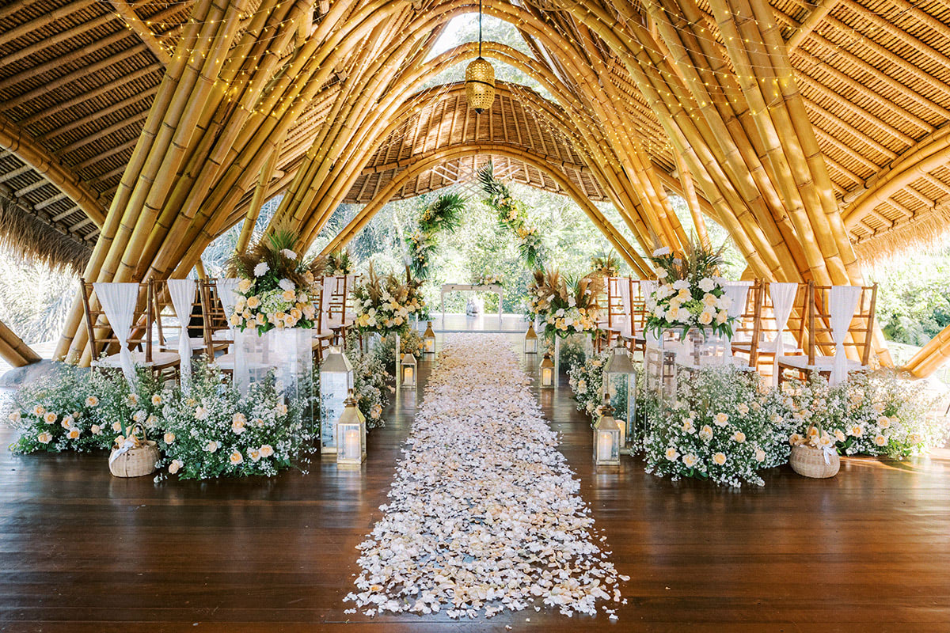
Event hosts appreciate flexible planning and creative arrangements. Guests easily find party venues near comfortable surroundings. An agreeable setting encourages conversation and happiness. Celebrations here feel lively, warm, and meaningful for every single guest attending. Planning celebrations becomes easy with flexible venue options available. Couples explore wedding packages designed for joyful occasions. Some hosts prefer creative freedom through dry hire venues. Such spaces allow personalised décor and festive arrangements. Monty's Bar & Kitchen supports imaginative celebration planning. Many families search online for party venue hire options. Event planners often consider party halls for hire. These spaces suit gatherings, anniversaries, and festive celebrations. Birthday parties also take advantage of lively and cheerful settings. Guests enjoy exploring birthday party venues with welcoming surroundings. The venue supports celebrations that feel joyful and memorable. Such flexibility encourages creative ideas and personalised celebration experiences. Atmosphere plays an important role in joyful celebrations. Guests appreciate beautiful wedding venues with charming surroundings. Soft lighting and elegant décor create graceful celebration spaces.

Couples admire wedding reception venues with warm ambience. Celebrations feel meaningful inside welcoming environments. Families often search for party venues near comfortable gathering spaces. Many hosts choose party venue hire for relaxed celebrations. Flexible layouts help organise social events easily. Event planners also explore party halls for hire. These halls support gatherings full of laughter and joy. The venue encourages memorable celebrations with elegant surroundings. Guests enjoy moments filled up with warmth, celebration, and cheerful social interaction. Family celebrations thrive inside lively social environments. Guests enjoy welcoming pubs near friendly gathering spaces. A pleasant pub atmosphere suits many joyful occasions. Monty's Bar & Kitchen welcomes gatherings full of warmth. Families celebrate birthdays inside lively party venues. Children and adults enjoy relaxed and happy surroundings. Couples explore wedding venues with charming atmosphere. Many hosts appreciate convenient wedding packages for celebrations. Others consider dry hire venues for personalised arrangements. Guests often search for party venues near comfortable settings.

