Precise Study On The Sound-Absorbing Rafts

Studios demand clear and balanced sound. Clean audio shapes every recording session. Felt acoustic baffles help control echo and soften noise. Many creative spaces now use acoustic felt baffles. These panels absorb unwanted reflections with ease. Acoustic sound baffles also enhance vocal clarity. They support crisp dialogue and rich music tones. Acoustic beams bring both function and style. Modern interiors favour simple, smart design. Acoustic ceiling beams blend seamlessly with open layouts. A sound-absorbing beam reduces harsh reverberation quickly. Such solutions create calm and focused environments. They also improve comfort for performers and listeners alike. Every studio benefits from thoughtful acoustic support overhead. Open-plan offices can feel loud and distracting. Clear communication matters in shared environments. Felt acoustic baffles reduce background noise effectively. Acoustic sound baffles improve speech clarity across desks. Acoustic beams break up sound waves gently. If you're looking for more information on acoustic grid ceiling, explore the above website.

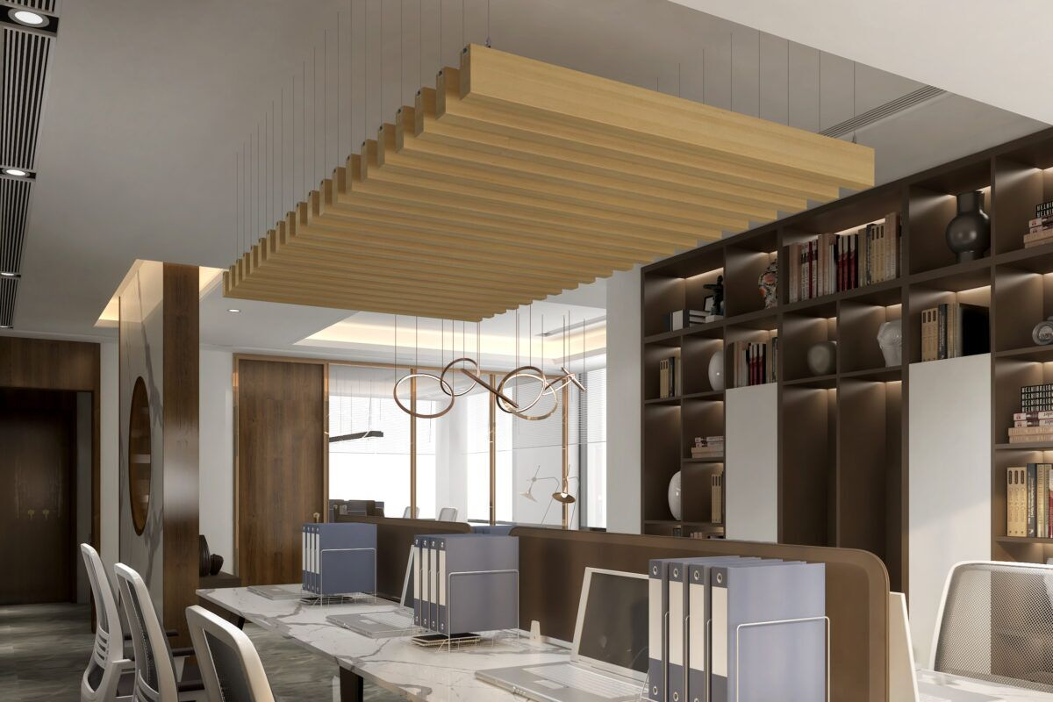

Many workplaces install acoustic ceiling beams overhead. A sound-absorbing beam helps meetings sound clearer. Designers often choose a grid baffle ceiling. This system works well in modern interiors. An acoustic grid ceiling controls echo subtly. An acoustic ceiling grid keeps layouts organised and neat. These solutions enhance comfort and productivity daily. Calm spaces encourage focus, creativity, and collaboration. Good acoustics support wellbeing and better performance. Schools and learning centres require balanced acoustics. Clear sound supports attention and understanding. Acoustic felt baffles soften noise in busy halls. Felt acoustic baffles absorb chatter in classrooms. Acoustic sound baffles create calmer study zones. Large spaces benefit from acoustic beams overhead. Acoustic ceiling beams manage echo in assembly areas. A sound-absorbing beam supports speech clarity during lessons. A grid baffle ceiling suits multipurpose rooms. An acoustic grid ceiling blends with simple interiors. An acoustic ceiling grid maintains order above. These solutions create peaceful spaces for growth. Students and teachers feel more comfortable each day.

Hospitality spaces depend on atmosphere and comfort. Guests value calm and inviting surroundings. Felt acoustic baffles soften sound in dining areas. Acoustic felt baffles improve conversation clarity. Acoustic sound baffles reduce clatter and echo. Acoustic beams add visual depth and warmth. Acoustic ceiling beams suit lounges and reception spaces. A sound-absorbing beam enhances relaxed settings. Many venues install a grid baffle ceiling. An acoustic grid ceiling offers balance and style. An acoustic ceiling grid supports open layouts. These features uplift ambience and enhance experience. Visitors enjoy peaceful and welcoming interiors. Modern spaces seek both beauty and function. Acoustic timber adds warmth and natural character. Designers favour acoustic timber beam features overhead. An acoustic timber baffle creates texture and charm. Felt acoustic baffles pair well with timber finishes. Acoustic felt baffles suit contemporary interiors easily. Acoustic beams shape sound and design together. Acoustic ceiling beams frame open ceilings gracefully. A sound-absorbing beam improves comfort discreetly. A grid baffle ceiling delivers structured elegance. An acoustic grid ceiling ensures harmony above. An acoustic ceiling grid supports flexible design choices. Thoughtful acoustic planning transforms studios and modern spaces.

