Individual Guide On Professional Video Storyteller

Modern brands rely strongly on visual communication today. Video content attracts attention and builds quick connection. Many businesses now prefer freelance professionals for creative projects. Brands often find a videographer for your brand through flexible networks. An independent videographer offers fresh perspective and creative energy. Each videographer freelance project brings unique ideas and storytelling style. Creative experts work both as videographer and cinematographer. Their visual skills support engaging and meaningful brand content. A talented video storyteller turns simple ideas into memorable stories. Many award-winning videographers also work independently. Their creative approach supports flexible collaboration. Businesses value this growing creative movement. Check out the following site, if you are looking for additional information concerning video storyteller in london.

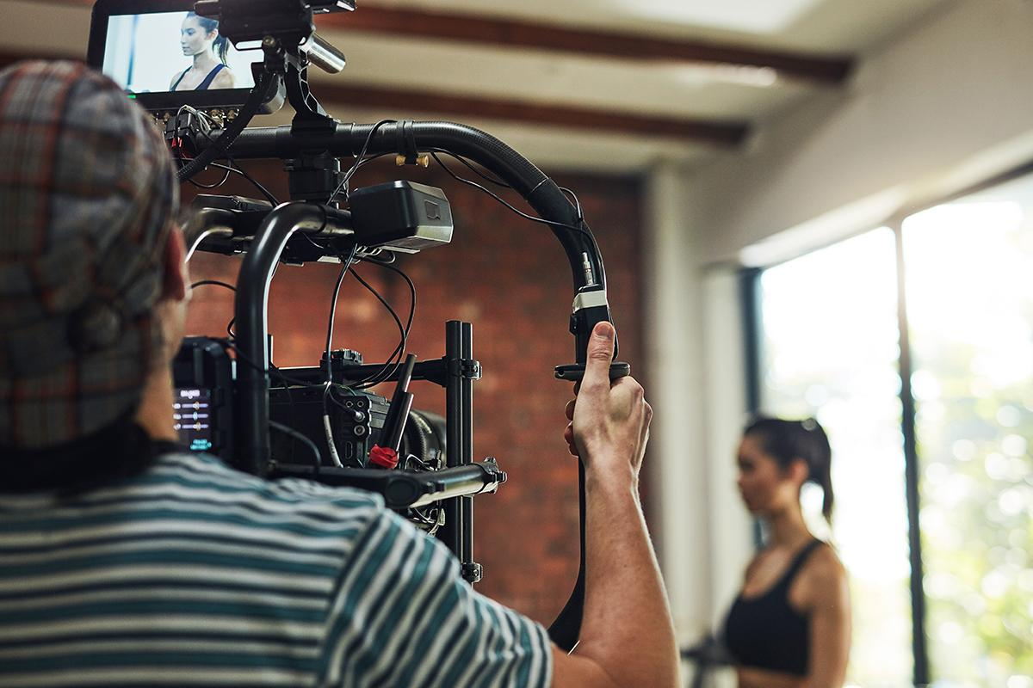

Freelance professionals bring creativity and adaptability to modern marketing. Many brands hire a professional videographer for strong visual presence. A corporate videographer helps express brand values clearly. Creative minds also work as videographer and cinematographer together. Their work blends motion, light, and storytelling beautifully. A skilled video storyteller shapes emotional brand communication. Many award-winning videographers began through freelance opportunities. Every videographer freelance project supports innovation and fresh style. Businesses often find a videographer for your brand easily online. Collaboration remains smooth and efficient with freelancers. Creative professionals adapt quickly to brand needs. Their visual craft strengthens audience connection. Brands value originality and artistic thinking in visual storytelling. An independent videographer often brings imaginative vision to projects. Each videographer freelance project encourages creativity and expressive storytelling. Many professionals work both as videographer and cinematographer. Their visual craft blends emotion, movement, and narrative harmony. A thoughtful video storyteller builds powerful brand messages. Businesses often hire a professional videographer for creative campaigns. Some also hire a professional video editor for polished results. A video editor agency may assist with larger projects. Many creators also offer freelance video editing service support. These creative options help brands communicate clearly. Visual storytelling continues growing in importance.

Strong brand communication often depends on meaningful visual stories. A corporate videographer helps shape clear brand identity. Many companies find a videographer for your brand easily today. Creative experts also work as videographer and cinematographer together. Their storytelling vision supports emotional and memorable messages. A skilled video storyteller captures attention through powerful visuals. Brands often hire a professional videographer for marketing campaigns. Some projects involve an experienced video editor agency. Others prefer flexible freelance video editing service support. Businesses also hire a professional video editor for refinement. Many award-winning videographers contribute to strong brand presence. Promotional campaigns benefit greatly from engaging video storytelling. Businesses frequently hire a professional videographer for promotions. A corporate videographer helps communicate products and services clearly. Creative professionals also work as videographer and cinematographer. Their visual storytelling supports memorable promotional content. A passionate video storyteller builds emotional audience connection. Many brands find a videographer for your brand easily online. Every videographer freelance project adds fresh creative perspective. Award-winning videographers often lead high quality visual campaigns. Some companies partner with a video editor agency. Others choose flexible freelance video editing service support. Many brands also hire a professional video editor.

