Important Things About Affordable Stretcher Earrings

Minimalist jewellery trends continue to shape modern style. Clean lines and subtle pieces feel elegant. Simplicity now speaks louder than excess. Stretched ears follow this refined direction. Many choose premium stretched ear jewellery online for a polished look. Smooth finishes and muted tones stay popular. Premium ear tunnels online offer quiet confidence. Delicate plugs create a balanced appearance. Fashion lovers explore plugs and tunnels for sale daily. An ear plugs and ear tunnels shop online makes browsing easy. Choices feel curated and tasteful. Affordable tunnel piercing jewellery also supports this calm trend. Style remains expressive yet understated. The stretching journey has also embraced simplicity. Many prefer ear stretching kit dead stretching methods. This approach feels natural and gradual. A surgical steel dead stretching kit is often chosen. Materials appear sleek and refined. Comfort and elegance go together. Click on the below mentioned website, if you are hunting for more details regarding buy stretcher earrings at affordable prices.

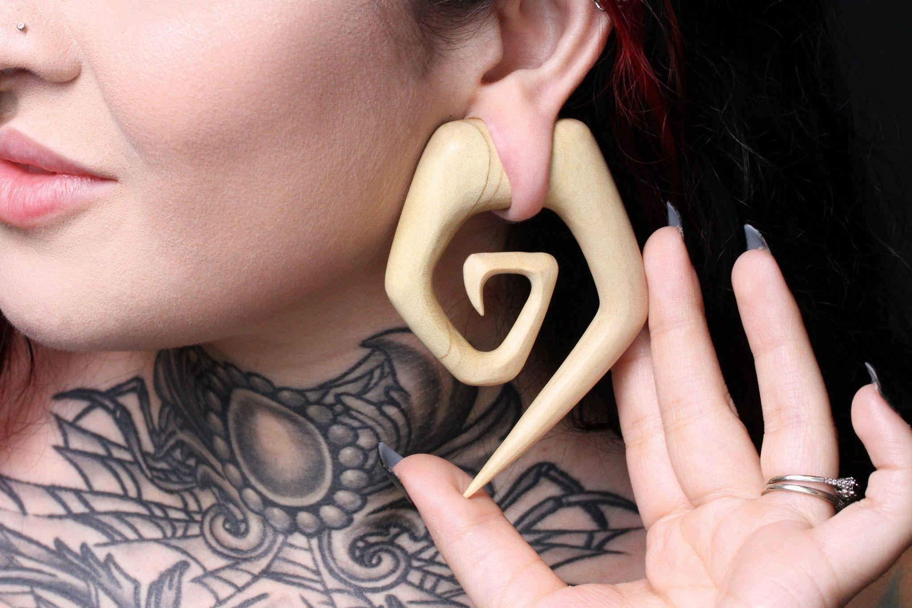

The best dead stretching kit supports steady progress. Many search for professional stretching kits delivered across platforms. Convenience matters in modern living. An ear stretcher jewellery shop often provides matching pieces. Aftercare becomes part of daily routine. The overall experience feels smooth and controlled. Minimal tools create a clean process. Minimalist fashion values quality over excess. Buyers now seek premium stretched ear jewellery online with timeless appeal. Soft textures and neutral shades feel sophisticated. Premium ear tunnels online blend with everyday outfits. Many explore affordable tunnel piercing jewellery for subtle charm. It is easy to buy stretcher earrings at affordable prices today. Online stores simplify comparison and choice. An ear plugs and ear tunnels shop online offers variety. Plugs and tunnels for sale appear in refined designs. Simplicity allows creativity without clutter. Each piece feels personal yet graceful. Statement looks can still remain minimal. Larger tunnels feature smooth edges and soft shine. Premium stretched ear jewellery online supports bold simplicity.

Premium ear tunnels online highlight shape over detail. Many choose plugs and tunnels for sale in muted finishes. An ear stretcher jewellery shop often showcases clean designs. Buyers prefer to buy stretcher earrings at affordable prices without fuss. Affordable tunnel piercing jewellery keeps style accessible. Modern shoppers value ease and clarity. An ear plugs and ear tunnels shop online offers curated collections. Each choice reflects calm confidence. Finding refined jewellery has become effortless. Many search for the best dead stretching kit first. A surgical steel dead stretching kit feels reliable and sleek. Professional stretching kits delivered across platforms add convenience. Once stretched, premium stretched ear jewellery online completes the look. Premium ear tunnels online remain highly sought after. Plugs and tunnels for sale suit varied tastes. Affordable tunnel piercing jewellery widens possibilities. Many buy stretcher earrings at affordable prices with ease. An ear plugs and ear tunnels shop online offers smooth browsing. Minimalist stretched jewellery continues to flourish.

