Ear Stretching Jewelry All Sizes - What You Need To Learn

Affordable jewellery has become a strong trend in body fashion. Many people seek stylish pieces without high cost. Today it is easy to buy ear stretching kit online through modern stores. These options offer ear stretching jewelry in all sizes. This variety suits beginners and experienced users alike. Many collections include premium earring gauges and plugs with polished designs. Fashion lovers also explore affordable ear gauge jewellery for everyday style. Stores often shop stainless gauge earrings set for durability and shine. Premium gauges piercing plugs also remain popular among jewellery enthusiasts who appreciate elegance with practicality. Comfort and accessibility matter greatly when choosing stretching jewellery. A well designed set supports both appearance and ease. Many buyers prefer to buy ear stretching kit online because it offers convenience. These kits often include ear stretching jewelry in all sizes. Beginners appreciate having flexible options. Affordable ear gauge jewellery allows experimentation without heavy expense. Some users prefer to shop stainless gauge earrings set for smooth finish and reliability. Click on the following website, if you are seeking for more details on ear stretching jewelry in all sizes.

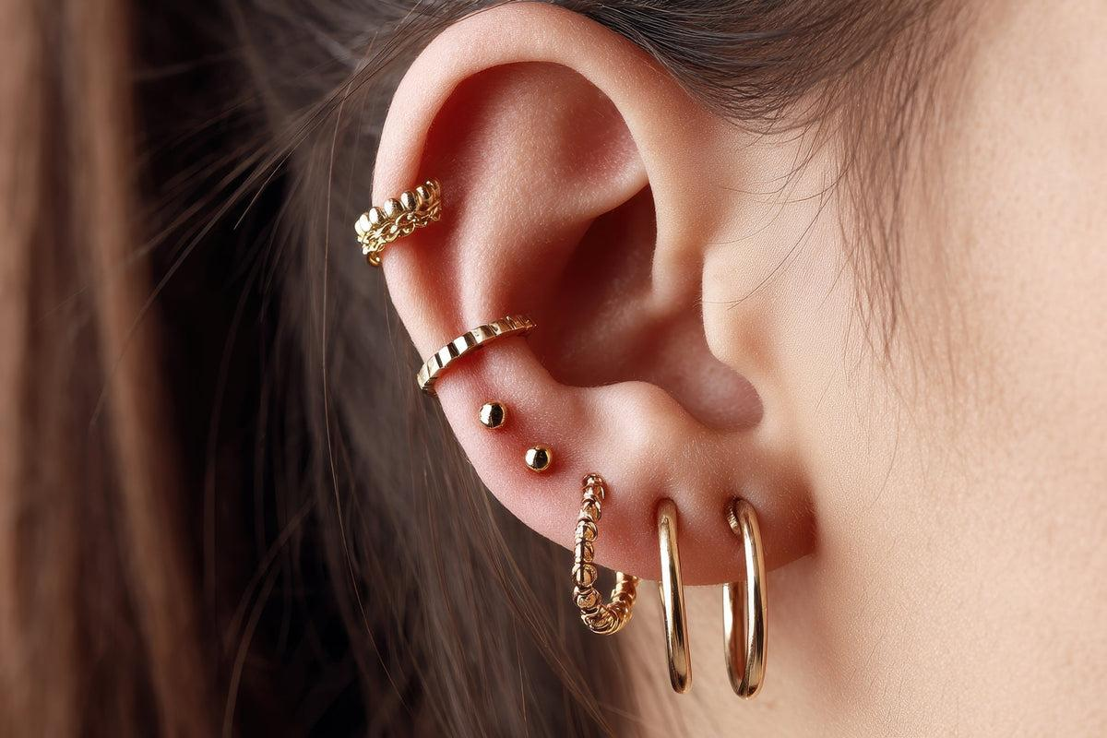

Premium earring gauges and plugs also add refined detail. Premium gauges piercing plugs combine comfort and design, making them a favourite choice among jewellery collectors. Material choice plays an important role in stretching jewellery. Glass options have become especially popular for their smooth feel. Many people now explore a glass stretching kit when starting their journey. A glass ear stretching kit supports gradual and comfortable stretching. Another preferred option is a glass dead stretching kit. These kits are valued for simplicity and elegance. Many users buy ear stretching kit online to access these modern materials easily. After stretching, jewellery choices expand to include premium earring gauges and plugs along with ear stretching jewelry in all sizes for versatile styling. Body jewellery trends also extend beyond ears. Nose adornments continue to attract attention. Many people enjoy wearing stylish nose rings with stretched ear jewellery. A classic nose ring piercing adds character to personal style. Some prefer a subtle nose ring and nose stud combination. This pairing creates balance with ear gauges and plugs.

Fashion enthusiasts often combine nose jewellery with affordable ear gauge jewellery. Premium gauges piercing plugs can complement these pieces beautifully. This mix of accessories allows creative styling while maintaining a coordinated and expressive appearance. Modern collections now showcase many striking tunnel designs. Many buyers shop ear tunnels today to discover the latest styles. Premium flesh tunnels for sale often feature smooth finishes and refined shapes. These pieces are ideal for both everyday and statement looks. Some enthusiasts order plugs tunnel now to update their collection. Best-selling ear tunnel plugs remain popular for their balance of comfort and fashion. Premium earring gauges and plugs continue to evolve with changing trends. With ear stretching jewelry in all sizes available widely, building a stylish and affordable jewellery collection has become easier than ever. Growing interest in body jewellery continues to inspire creative styling. Many enthusiasts explore affordable ear gauge jewellery alongside premium earring gauges and plugs. With options to buy ear stretching kit online and discover best-selling ear tunnel plugs, jewellery lovers enjoy endless variety while expressing personality through tunnels, plugs, and stylish nose rings.

