Discover What A Professional Has To Say About The Bell Tent Hire for Sleepovers

Planning a cosy outdoor gathering often begins with finding the right shelter. Many hosts prefer a bell tent to rent for comfort. Soft fabric walls create a calm and welcoming atmosphere. Families also explore bell tents to hire for relaxed sleepovers. These tents provide charm, warmth, and gentle style. A suitable bell tent rental helps shape a memorable celebration. Event planners also consider simple tent hire for flexible setups. A classic bell tent blends comfort with decorative appeal. Guests enjoy the open space and cosy interior. With thoughtful choices, the event area becomes peaceful, inviting, and charming for gatherings and quiet sleepover moments. A comfortable outdoor setup often begins with careful planning. Many people prefer practical tent hire for gatherings. The round shape of a bell tent feels warm. Decorative fabrics add a calm and stylish look. Families often choose bell tent hire for sleepovers. Soft bedding and cushions create gentle comfort. Click on the below mentioned website, if you're searching for additional information concerning tent hire kent.

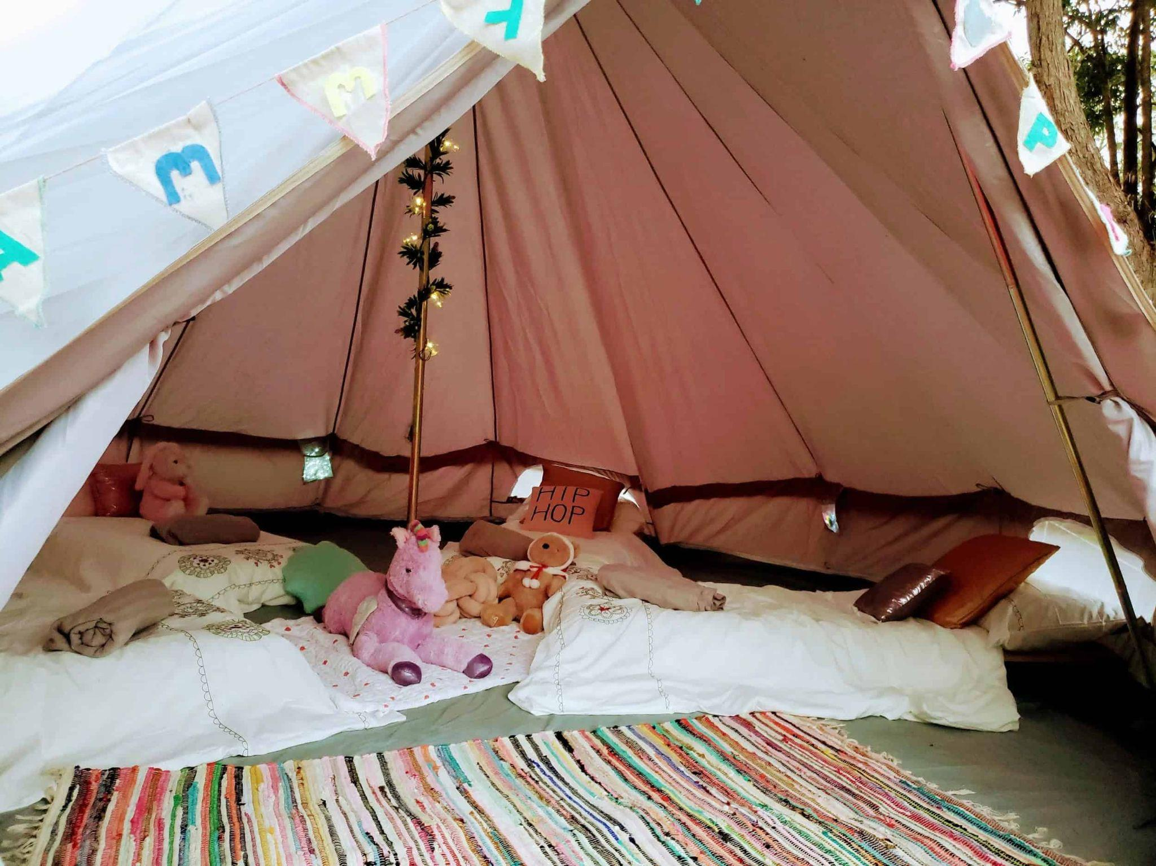

This idea also suits relaxed parties and celebrations. Many hosts also select glamping tent hire for luxury touches. A quality bell tent rental offers both comfort and beauty. Guests enjoy restful moments under canvas. Thoughtful tent hire choices make outdoor sleepovers welcoming, relaxing, and memorable for everyone attending the cosy gathering. Comfort and warmth matter during special gatherings. Many families choose bell tent hire for gentle sleepovers. Soft bedding and warm lights create a dreamy setting. A charming sleepover bell tent hire feels cosy and inviting. The round bell tent shape supports calm relaxation. Decorative fabrics add simple elegance to the space. Hosts often explore bell tents to hire for events. This option provides flexible outdoor comfort. A reliable bell tent rental helps shape beautiful celebrations. Guests appreciate peaceful and stylish surroundings. With thoughtful planning, every tent hire arrangement feels warm, charming, and welcoming for shared moments and joyful overnight gatherings. Outdoor celebrations often feel magical beneath soft canvas shelter. Many hosts explore glamping tent hire for elegant comfort.

Gentle lighting and cosy rugs create inviting surroundings. A stylish bell tent to rent offers charm and warmth. Decorative cushions add soft colour and texture. Guests enjoy calm spaces created through thoughtful tent hire. Families also consider bell tent hire for relaxed gatherings. This setup supports peaceful evenings and quiet conversation. A lovely bell tent brings atmosphere to the event. Soft interiors encourage comfort and connection. With careful bell tent rental choices, outdoor spaces become warm, welcoming, and beautifully arranged for celebrations. A well prepared gathering space feels warm and welcoming. Many organisers begin with reliable tent hire options. A classic bell tent creates peaceful charm outdoors. Families often choose bell tent hire for special occasions. The shape offers open space and gentle comfort. Hosts also explore bell tents to hire for sleepovers. This idea suits relaxed evenings and cosy celebrations. Many events benefit from simple bell tent rental solutions. A stylish sleepover bell tent hire creates a calm atmosphere. Soft fabrics enhance warmth and comfort.

