Detailed Study On The Video Production for Brands

Modern brands often begin with a clear creative goal. A promotional video production project starts with simple planning. Teams explore ideas that share value and emotion. Creative video production helps express messages with clarity. Many choose video production for brands and SMEs. This approach suits growing businesses and expanding organisations. A reliable video production and video marketing company supports this journey. Early discussions shape style, tone, and visual mood. Many brands contact a video production agency for guidance. Some decide to hire a video company for steady direction. Others prefer a creative content agency for your brand. These partners help transform ideas into engaging promotional stories. The next step focuses on building a clear concept. Creative video agencies for projects guide early story direction. They explore themes that match the brand message. Teams often collaborate with a video production team. This process shapes scenes, mood, and narrative flow. A skilled video production company helps organise each stage smoothly. Many organisations hire a professional videographer for visual expertise. These experts understand lighting, framing, and natural movement. Businesses may also work with one of the top video production companies. Check out the below mentioned website, if you are searching for more details regarding video production in london for brands and smes.

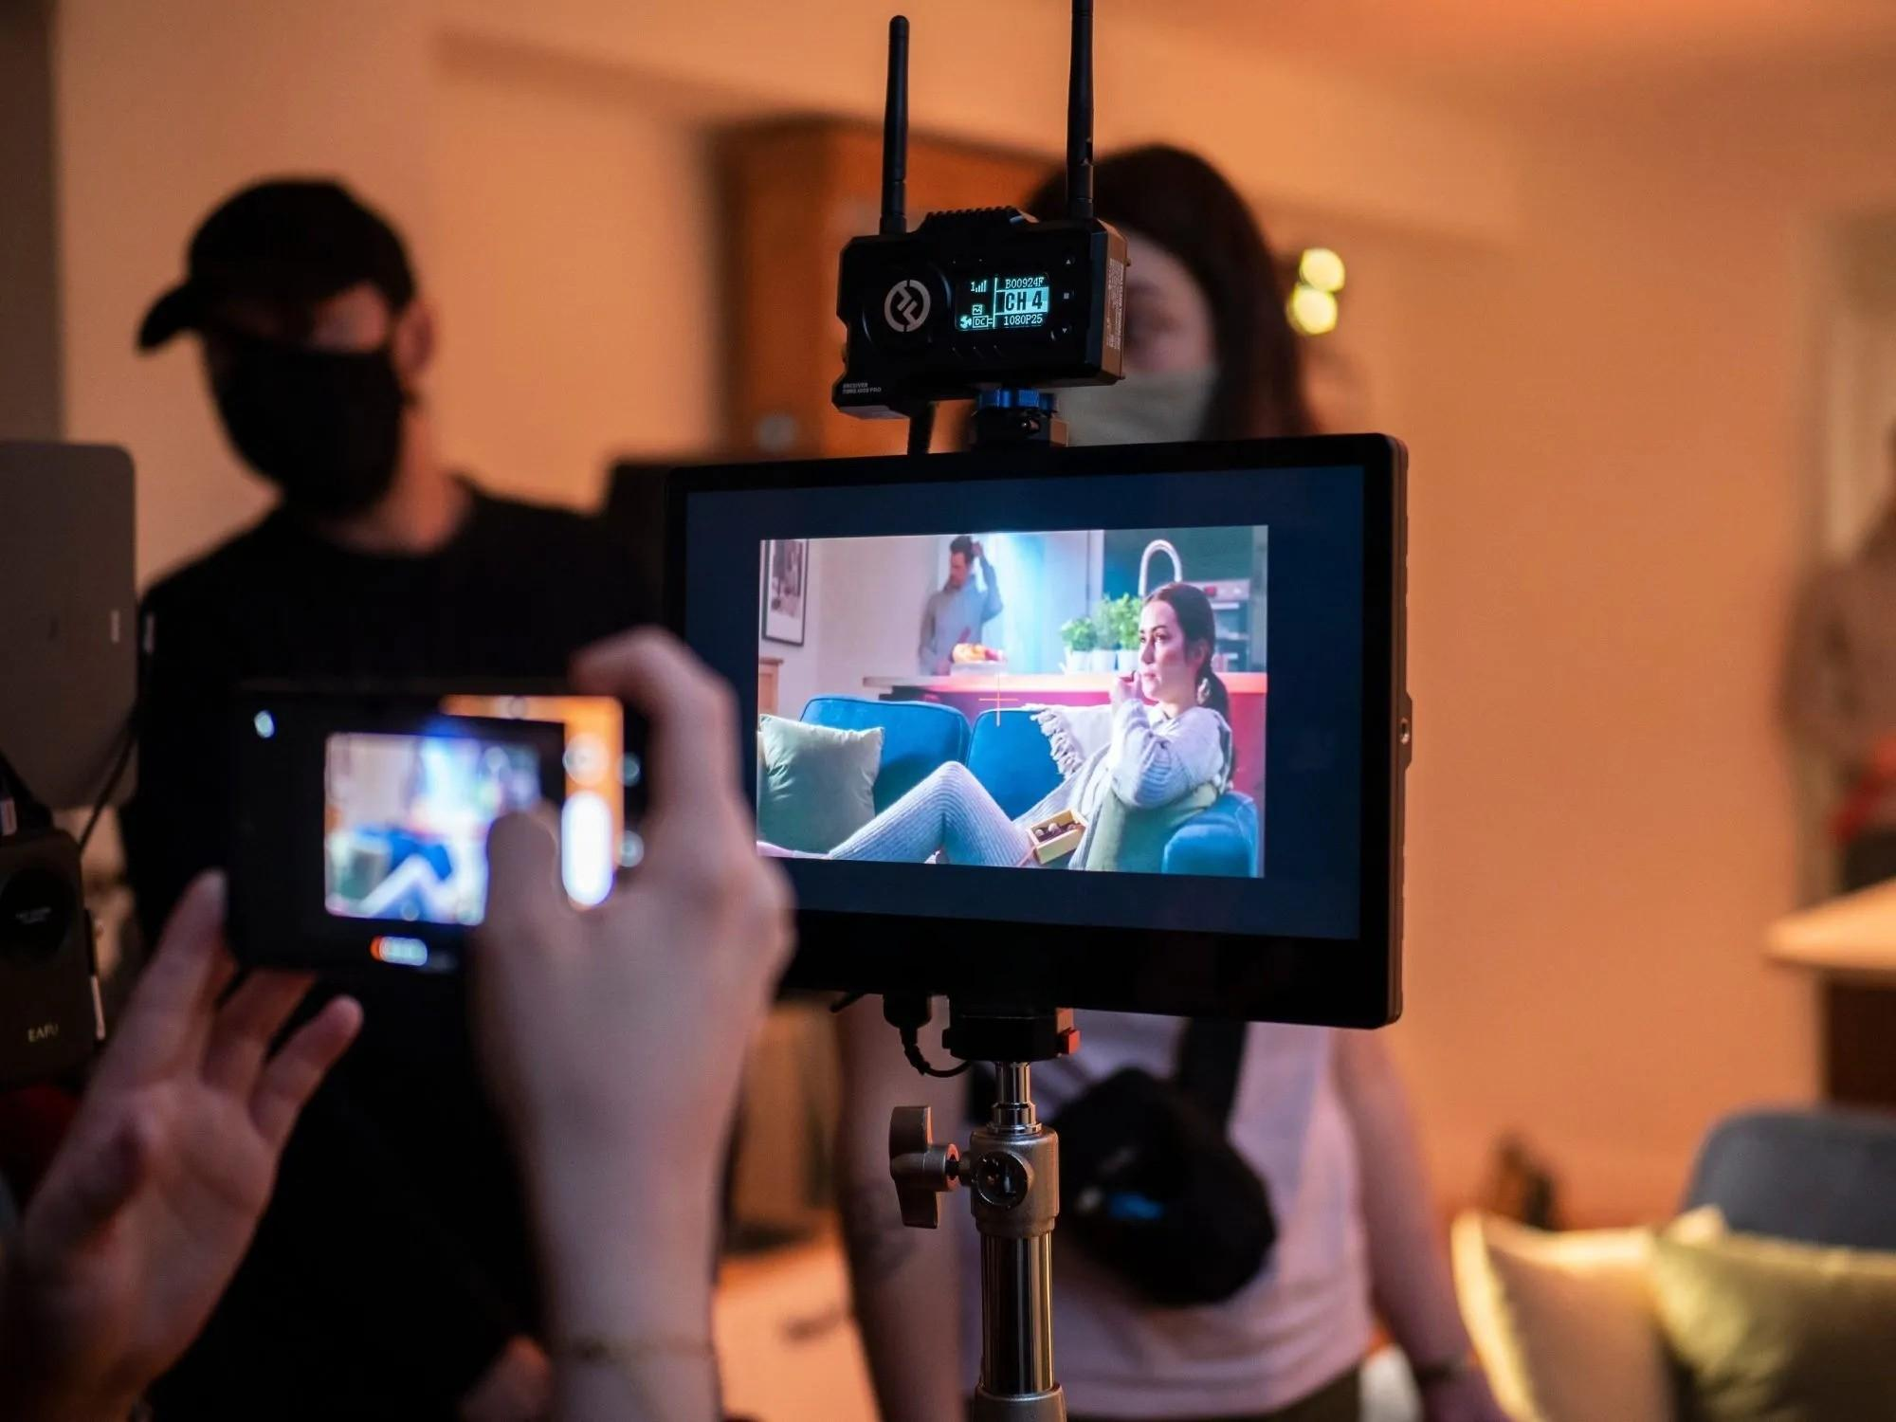

Such partners refine ideas into structured plans. Many choose topnotch video production studios for dependable production support. Planning then moves into organised preparation. Teams schedule scenes and outline creative tasks. A promotional video production project benefits from careful preparation. Creative video production remains the central focus. Many organisations considering to hire a video production house explore options. They compare ideas from several creative video agencies for projects. Businesses often contact a video production agency for guidance. A trusted video production company coordinates the overall plan. Teams also collaborate with a video production team for smooth progress. Many brands choose video production for brands and SMEs. This approach keeps messaging clear and visually engaging. Production begins once planning feels complete and organised. Cameras capture scenes that reflect the brand message. Many teams hire a professional videographer for visual storytelling. Skilled professionals guide the filming process calmly. Some brands work with one of the top video production companies.

Others prefer topnotch video production studios for strong creative support. A reliable video production and video marketing company ensures clear structure. Teams collaborate with a video production team throughout filming. This process supports consistent visual style and tone. Creative video production remains focused on clarity and emotion. Many organisations hire a video company to maintain smooth production flow. The final stage focuses on shaping the finished visual story. Editors refine footage into a meaningful narrative. A promotional video production project reaches its creative form here. Many businesses contact a video production agency for support. A creative content agency for your brand may guide final decisions. Some brands choose were on of the award-winning video production companies. Others explore a trusted video production company for reliable delivery. Creative video agencies for projects ensure the message feels strong. Many organisations considering to hire a video production house review results carefully. This process highlights the value of video production for brands and SMEs.

