Deceased Repatriation And Their Misconceptions

Gentle care matters when families face sudden loss abroad. Compassion guides every step during deceased repatriation services. Families often feel fragile and deeply emotional. Kind support offers calm during painful moments. Staff communicate with warmth and respect. They listen closely to family wishes. Careful guidance brings peace during confusing periods. Many families need reassurance and steady support. Dead body repatriation requires dignity and empathy. Each action reflects honour and sincere regard. Body repatriation services aim to ease emotional strain. The repatriation of deceased process respects memory and love. Through calm assistance, repatriation deceased arrangements become comforting and thoughtful. During sorrowful times, understanding hearts create meaningful support. Families appreciate patient guidance and clear communication. International repatriation of deceased services focus on human compassion. Gentle words help reduce worry and confusion. Many relatives struggle with sudden loss abroad. Repatriation of deceased body arrangements require thoughtful care. Support teams handle body repatriation with quiet respect. Repatriation of dead body procedures often feel overwhelming. Calm reassurance makes the process feel lighter. Go to the below mentioned website, if you are seeking for more details on deceased repatriation.

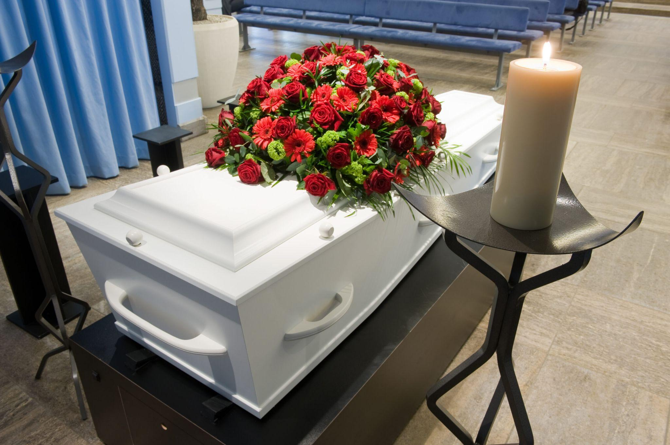

Global funeral repatriation services provide steady guidance. Each step honours memories with grace and sensitivity. Dead body repatriation therefore becomes a respectful journey. Families feel comfort through caring communication and attentive service. Empathy also brings clarity during delicate arrangements. Families receive gentle explanations at every stage. Repatriation of a deceased body abroad needs calm coordination. Caring professionals approach each task with patience. Their attitude reflects kindness and deep understanding. International repatriation of deceased services prioritise emotional reassurance. Body repatriation arrangements are handled with dignity. The repatriation dead body process becomes smoother through guidance. Loved ones feel supported through thoughtful care. Repatriation of deceased body services value respectful communication. Global funeral repatriation providers maintain a compassionate approach. Each action expresses honour for the departed soul. Empathy transforms complex steps into a calmer experience. Comfort grows when services act with kindness. Families seek reassurance and gentle assistance. Repatriation deceased arrangements focus on respect and sensitivity. The repatriation of deceased journey requires careful attention.

Dead body repatriation services help families feel supported. Compassion guides each stage of body repatriation work. Professionals approach repatriation of dead body tasks thoughtfully. Repatriation dead body services remain calm and respectful. Global funeral repatriation providers understand emotional needs. International repatriation of deceased arrangements emphasise dignity. Repatriation of a deceased body abroad requires patience. Every moment honours memory, love, and lasting tribute. Empathy shapes every part of deceased repatriation services. Families value gentle communication and compassionate care. The repatriation of deceased body process respects emotions deeply. Body repatriation services maintain dignity throughout arrangements. Global funeral repatriation providers support families with kindness. International repatriation of deceased services ensure respectful guidance. Repatriation of dead body work focuses on honour and memory. Dead body repatriation services help families feel comfort. Repatriation deceased support encourages calm during sorrow. Repatriation dead body arrangements offer reassurance and care. Repatriation of a deceased body abroad remains handled with compassion. Through empathy, every farewell receives respect and peace.

