Complete Study On The Medical Consulting Room

A calm workspace supports care, guidance, and personal wellbeing. Many practitioners prefer therapy room rental for flexible practice space. Comfortable interiors create trust and peace for visitors. Clean décor and warm lighting improve comfort and calm feelings. Many professionals explore clinic rooms to rent for daily sessions. These spaces support different services and supportive conversations. Quiet surroundings help people feel safe and relaxed. Many centres also offer therapy rooms for hire with thoughtful design. A welcoming consulting room supports clear communication and helpful discussion. Such spaces encourage focus, warmth, and understanding. Well arranged environments support positive interactions and smooth professional work each day. Modern practice often values flexible working arrangements. Check out the following site, if you are looking for additional information concerning medical consulting room.

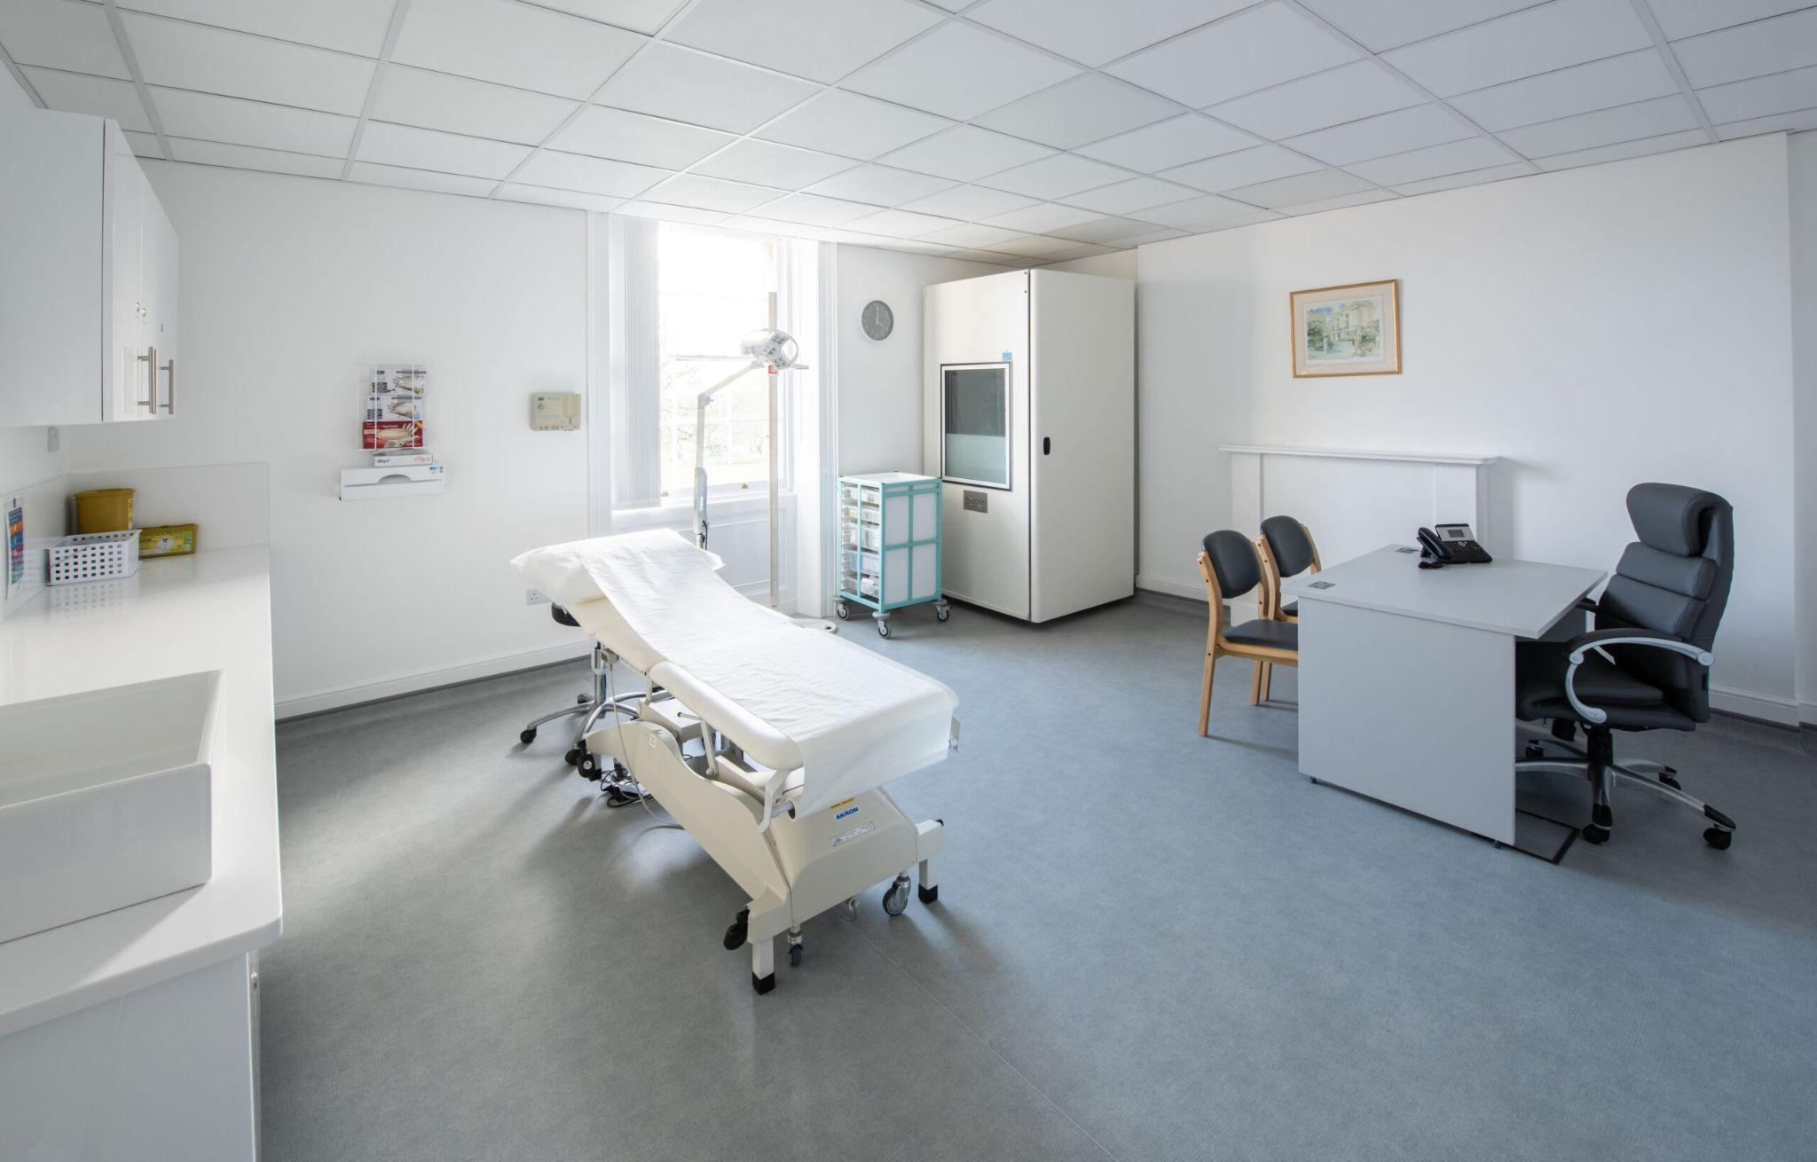

Many professionals search for therapy room hire to manage schedules easily. Shared spaces allow calm sessions without long commitments. Practitioners often prefer to rent consulting room spaces when needed. This approach provides convenience and professional settings. Flexible options support both part time and full time services. Many providers offer simple consulting room rental plans for regular sessions. These arrangements help maintain organised and calm working routines. Comfortable spaces also support professional confidence and steady service delivery. With organised schedules, practitioners can focus on care, conversation, and helpful support for every visitor. Well prepared spaces also support medical professionals. Many providers offer a welcoming medical clinic room for daily practice. Clean environments encourage trust and calm experiences. Health specialists often choose a quiet medical consulting room for private discussions. These rooms support careful conversation and respectful guidance. Comfortable seating and warm décor improve the overall atmosphere. Many centres also provide medical clinic room for rent with flexible access. Practitioners benefit from organised spaces that support professional care. A peaceful medical consulting room also improves comfort for visitors. Calm surroundings help people speak freely and receive guidance with confidence and reassurance. Professional spaces also support collaboration and shared practice. Many professionals explore consulting room hire to meet growing service needs.

Shared environments encourage connection and supportive professional communities. A comfortable consulting room allows private meetings and thoughtful discussion. Practitioners often combine services within clinic rooms to rent environments. Such spaces encourage cooperation and professional growth. Many centres offer therapy rooms for hire designed for calm conversation. These rooms support therapy, counselling, and supportive guidance. Well arranged interiors create welcoming environments for visitors. Quiet and organised surroundings allow professionals to focus on meaningful interaction and quality care. Affordable access also attracts many professionals to shared workspaces. Many practitioners explore therapy room rental for practical daily sessions. Budget friendly spaces allow steady growth and flexible practice. Comfortable therapy room hire options support both new and experienced professionals. Many providers also offer simple consulting room rental plans. These arrangements support calm and organised service delivery. A welcoming medical clinic room for rent provides professional surroundings for health services. Quiet medical clinic room environments encourage comfort and trust. A peaceful medical consulting room completes the experience. Such spaces support care, understanding, and respectful communication for every visitor.

