Complete Study On The E Learning Video Production

Visual storytelling grows fast within modern business communication. Many groups prefer clear moving visuals over long text. This shift supports the rise of video content creation everywhere. Brands value engaging clips that show ideas simply. Professional videography services help present messages with clarity and charm. Many organisations also depend on trusted production services today. These teams guide the full creative process smoothly. Businesses also explore flexible video creation services for varied needs. Such services deliver promotional, informative, and creative visual material. Corporate teams now choose corporate video production to strengthen brand identity. Skilled planning ensures each project communicates purpose clearly. Businesses today explore varied approaches within visual storytelling. A skilled corporate videographer helps shape clear and engaging narratives. Corporate video production supports internal messages and external promotion. If you are searching for additional details on e learning video production, visit the previously mentioned website.

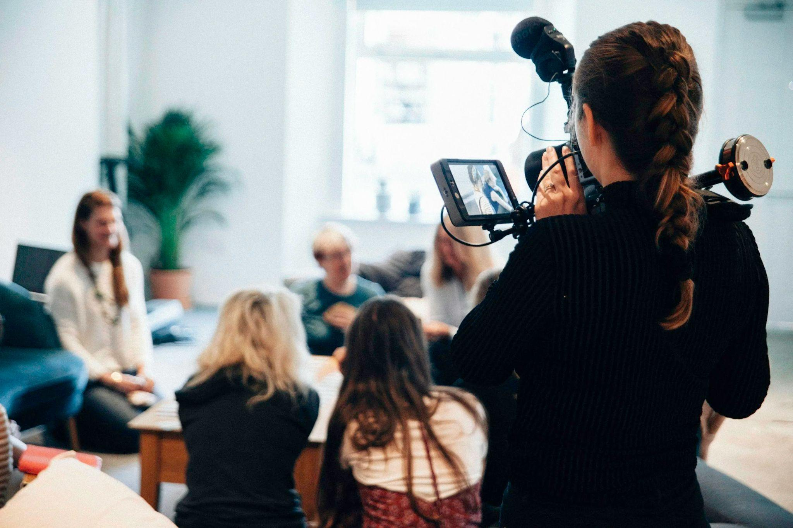

Such projects explain services and values through appealing visual scenes. Many organisations also explore explainer video production for simple communication. These clips clarify ideas quickly and creatively. An experienced explainer video production house builds structured visual stories. Many explainer video production companies support this growing demand. Their teams combine creativity with organised planning. As interest grows, brands adopt flexible production services for campaigns. Audiences enjoy information presented through expressive moving images. Learning platforms also benefit from the growth of video communication. Many organisations collaborate with e learning video production companies today. These teams design visual lessons that explain ideas simply. Clear visuals support strong understanding among viewers. E learning video production offers structured and friendly teaching formats. Many groups also adopt video production e-learning for flexible learning content. Such videos present topics using clear visuals and simple explanations. Educational clips help teams absorb information quickly. Production services guide this creative process carefully. Video creation services help shape informative and engaging learning materials. These resources build understanding through clear visual storytelling. Marketing teams value the wide promotional reach of visual media.

Creative video content creation attracts attention across many digital channels. Clear visuals communicate ideas faster than plain text. Businesses use videography services to craft appealing promotional material. Many brands also combine corporate video production with explainer video production. This approach strengthens brand communication and engagement. A corporate videographer captures authentic scenes and meaningful visuals. Many explainer video production companies design stories with clear messages. Each explainer video production house focuses on creativity and clarity. Professional production services guide planning and editing smoothly. Fresh storytelling ideas keep visual content engaging and relatable. Creative teams explore many styles within video content creation. Simple visuals help audiences connect with everyday messages. Videography services support authentic storytelling through expressive scenes. Businesses often combine corporate video production with friendly learning material. E learning video production also supports knowledge sharing within organisations. Many e learning video production companies shape engaging learning visuals. Video production e-learning helps audiences absorb ideas comfortably. Brands also use explainer video production for simple explanations. Production services and video creation services together support flexible communication strategies.

