Body Piercing Jewellery - What You Need To Learn

Body jewellery has become a popular form of personal style. Lots of people enjoy body jewelry and piercing as creative expression. Jewellery for body piercing offers many shapes, colours, and finishes. Options include studs, rings, and decorative bars. Many shoppers explore piercing jewellery online for convenient choices. Online retailers show wide collections and simple comparisons. Ear tunnels and plugs attract attention for bold style. Ear plugs piercing also adds an original touch. Some prefer delicate nose pieces. A ring nose stud gives subtle shine. Nose stud piercing remains a vintage fashion choice. A stud for nose piercing suits simple everyday wear. Such variety makes body jewellery appealing and expressive. Fashion lovers enjoy body jewellery for its creative charm. Body jewelry and piercing allow unique personal style. Jewellery for body piercing will come in classic and modern forms. Many individuals choose pieces through piercing jewellery online. Browsing online galleries feels easy and enjoyable. Ear tunnels and plugs can be found in many colours and shapes. Ear plugs piercing often highlights bold and artistic style. Some prefer elegant facial pieces. A ring nose stud adds gentle sparkle. Are you looking about jewellery for body piercing? Browse the before discussed website.

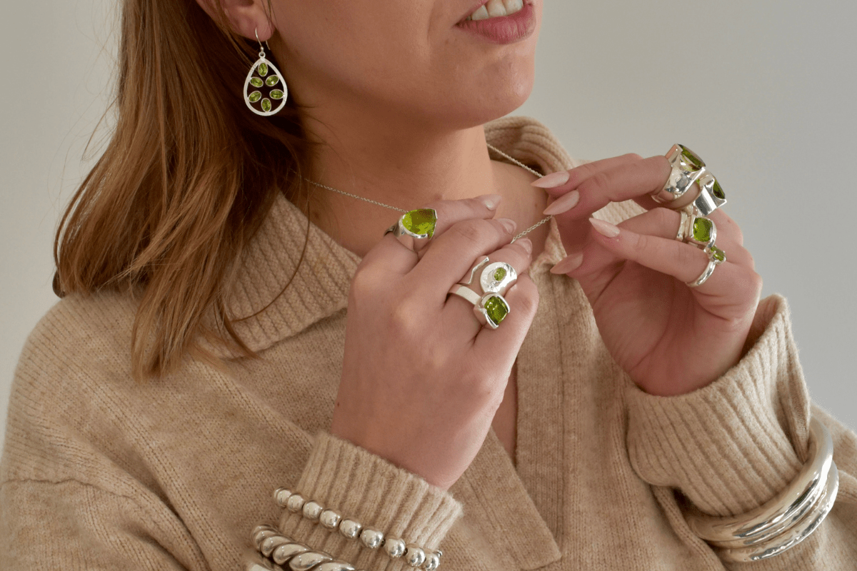

Nose stud piercing suits both simple and decorative looks. A stud for nose piercing remains an eternal option. These choices help people explore fresh styles. Body jewellery continues growing as a stylish cultural trend. Many beginners enjoy researching body jewellery styles. Body jewelry and piercing often begins with simple pieces. Jewellery for body piercing includes studs, hoops, and bars. Shoppers frequently explore piercing jewellery online for inspiration. Ear tunnels and plugs are popular among stretching enthusiasts. Ear plugs piercing creates a bold visual effect. Some prefer smaller facial adornments. A band nose stud offers elegant shine. Nose stud piercing suits everyday wear and celebrations. A stud for nose piercing appears neat and stylish. Stretching ear sizes chart helps beginners understand gradual changes. Stretching ear sizes progress slowly and safely. Creative trends keep body jewellery exciting and fresh.

Body jewelry and piercing often reflect changing fashion ideas. Jewellery for body piercing appears in many artistic forms. Lots of people browse piercing jewellery online for new inspiration. Ear tunnels and plugs show colourful designs and patterns. Ear plugs piercing offers bold and stylish appearance. Some prefer graceful facial ornaments. A band nose stud adds classic elegance. Nose stud piercing remains popular across many fashion styles. A stud for nose piercing provides a nice and subtle look. Stretching ear sizes chart supports creative stretching journeys. The sweetness of body jewellery lies in its wide choice. Body jewelry and piercing allow endless personal expression. Jewellery for body piercing includes delicate and bold designs. Many shoppers enjoy searching piercing jewellery online for variety. Ear tunnels and plugs offer striking decorative appeal. Ear plugs piercing highlights artistic personality and style. Some individuals favour refined facial pieces. A band nose stud provides soft sparkle and charm. Nose stud piercing suits casual and formal looks. A stud for nose piercing remains an easy favourite. Stretching ear sizes chart supports careful style decisions.

