Audio Visual Equipment Hire - What Every Person Must Look Into

Event success often relies on clear sound and strong visuals. Good planning always includes the right audio visual setup. Many organisers choose to hire AV equipment for better results. This ensures smooth delivery and clear communication. AV hire supports presentations, speeches, and live performances. It creates a polished and engaging atmosphere. Av hire for events also improves audience focus and comfort. Quality sound and lighting help maintain attention throughout. Proper audio hire adds clarity and depth to every moment. When planners hire sound equipment, events feel more professional and organised. A strong stage setup shapes how an event is perceived. Stage hire allows better visibility and structured presentation flow. Event stage hire creates a central focus for guests. It helps speakers and performers stand out clearly. Stage hire for festivals supports larger crowds and lively performances. A well-built stage adds style and presence. Browse the below mentioned site, if you are seeking for more details concerning av hire for events.

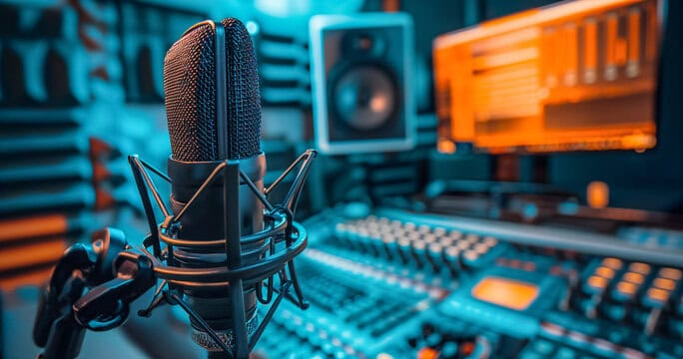

It enhances confidence for presenters and entertainers. Combined with AV hire, it creates a seamless experience. The setup supports movement and interaction. This improves overall engagement and keeps audiences interested. Lighting plays a vital role in creating the right mood. Party lights add colour and energy to the setting. A skilled lighting production company designs balanced and appealing effects. Soft lighting suits calm events and formal gatherings. Bright lights enhance excitement and celebration. When combined with audio visual tools, lighting transforms the space. It highlights key moments and draws attention naturally. Good lighting also improves visibility for guests. It creates a welcoming and vibrant environment. This helps events feel complete and memorable. Sound quality greatly influences audience satisfaction. Clear audio ensures every message is heard easily. Many organisers prefer to hire sound equipment for this reason. It avoids confusion and keeps communication smooth. Audio hire supports music, speeches, and announcements effectively. Balanced sound levels create comfort and enjoyment. It also helps maintain energy during long events.

Combined with AV hire, sound becomes more impactful. Guests stay engaged and attentive throughout. This creates a strong connection between presenters and audiences. When all elements work together, events feel seamless and impressive. Hire AV equipment ensures consistency across sound and visuals. Stage hire supports structure and clear presentation flow. Party lights hire and lighting production company services enhance ambience. Audio hire and hire sound equipment improve clarity and reach. AV hire for events brings everything into harmony. Each element supports the overall experience. Guests enjoy smooth transitions and engaging moments. A well-planned setup creates lasting impressions. It turns simple gatherings into memorable and meaningful occasions. Careful planning ensures every element works in harmony. AV hire supports smooth coordination and balanced delivery. Audio visual tools keep guests engaged from start to finish. Stage hire provides a clear focal point for activities. Party lights hire adds warmth and energy. When planners hire AV equipment and hire sound equipment, events feel refined, organised, and truly memorable.

