All You Want To Know About The Wood Wall Panelling

Fresh interiors now favour natural texture and warm surfaces. Many homes show elegant wall panelling wood with calm style. Surfaces feel richer through decorative wall panels and subtle detail. Stylish decorative panelling brings depth and gentle character. Designers often prefer wooden decorative panels for walls for visual interest. These panels create soft contrast with simple furniture. Calm spaces feel welcoming and balanced with layered wood texture. Easy installation also attracts many homeowners. Ready solutions like wall panelling kits simplify interior refresh projects. Modern rooms often mix natural tones with light patterns. This design trend highlights comfort, warmth, and timeless decorative appeal. Simple upgrades remain popular through practical design solutions. Many households now choose DIY panelling for quick style updates. Convenient DIY wall panelling kits help create clean and neat surfaces. Practical MDF wall panelling kits offer smooth finishes and versatile style. Elegant shaker wall panelling kits bring classic charm to interior walls. Hallways and vertical spaces benefit from wall panelling kits for stairs. Check out the following website, if you are searching for more information regarding wall panelling wood.

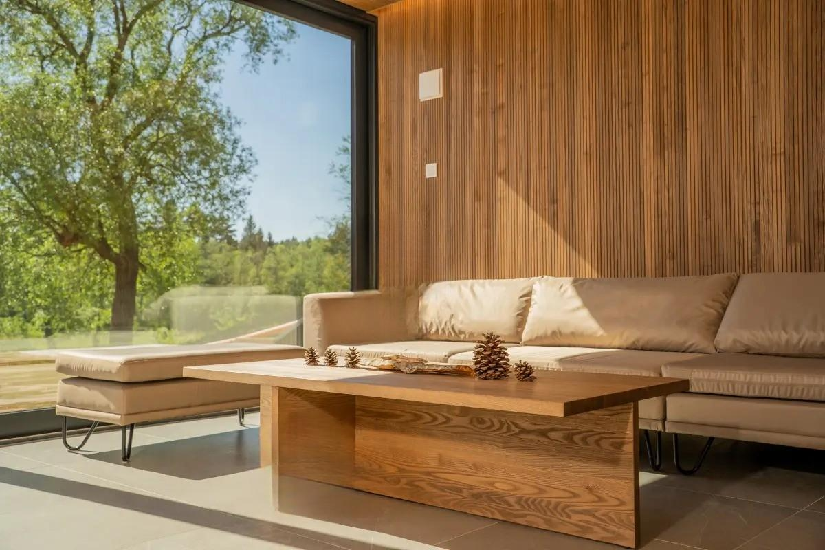

Many also select dedicated stair wall panelling kits for flowing stair designs. These choices support creative home styling. Panels create gentle structure while remaining decorative. The trend focuses on comfort, harmony, and balanced interior style. Open layouts inspire creative ways to divide interior space. A stylish room divider adds gentle separation without heavy walls. Many prefer a warm wood room divider for natural elegance. Classic room divider wood designs create visual balance indoors. A modern wood slat room divider allows light and airflow. Flexible layouts also welcome a DIY room divider approach. Decorative panels often pair with divider structures for harmony. These features shape calm zones for rest or activity. The look feels organised yet open. Contemporary interiors value versatility, softness, and decorative flow between areas. Many interior themes blend panels with warm decorative elements. Rich textures appear through decorative wall panels and elegant wood surfaces. Stylish wooden decorative panels for walls highlight artistic wall designs. Soft shadows form through structured decorative panelling across wide surfaces. Interiors often combine panels with functional dividers. A wood slat room divider adds rhythm and gentle pattern indoors.

A refined room divider wood design also enhances visual harmony. These elements bring calm depth into simple spaces. The overall effect feels balanced, natural, and welcoming. Such trends continue shaping stylish interior environments. Modern decorating celebrates creativity and personal expression. Homeowners enjoy mixing wall panelling wood with versatile panel systems. Practical wall panelling kits support flexible design possibilities. Simple upgrades through DIY panelling remain widely appreciated. Easy solutions like DIY wall panelling kits support creative projects. Many interiors also include MDF wall panelling kits for smooth surfaces. Classic shaker wall panelling kits maintain a timeless decorative feel. Stairways gain style using wall panelling kits for stairs. Flowing designs appear through matching stair wall panelling kits. Together these trends create calm, stylish, and welcoming interiors. Interior styling continues evolving with flexible decorative solutions. Many spaces combine decorative wall panels with functional features. A stylish room divider or elegant wood room divider shapes cosy areas. Creative interiors also feature a DIY room divider with natural texture. Balanced designs highlight decorative panelling, creating warm, graceful spaces filled with harmony and visual comfort.

