All You Want To Know About The Stainless Fastener Specialists

Choosing the right stainless fastener begins with careful checks. Quality always comes first. A reliable fastener manufacturer follows strict control steps. Materials are selected with care and attention. Finishes look smooth and clean. Shapes remain even and balanced. Trusted stainless fastener manufacturers focus on consistency. Leading stainless steel fastener manufacturers value precision and care. Experienced steel fasteners manufacturers maintain steady standards. Reputed stainless steel fasteners manufacturers review every batch. A dependable stainless steel fastener supplier shares clear product details. Established stainless steel fastener suppliers ensure steady stock. Professional stainless fastener suppliers maintain organised stainless fastener supplies for every project need. A strong fastener supplier offers clarity and confidence. Products feel solid and dependable. Stainless nuts and bolts should appear uniform and neat. Threads must look smooth and aligned. Imperial stainless steel nuts and bolts require equal attention. Trusted stainless steel fastener distributors check each delivery carefully. A reliable fastener wholesaler manages storage with order and care. Structured fastener wholesale systems improve traceability. Clear packaging protects stainless fastener supplies during handling. Click on the below mentioned website, if you are seeking for more information concerning stainless fastener.

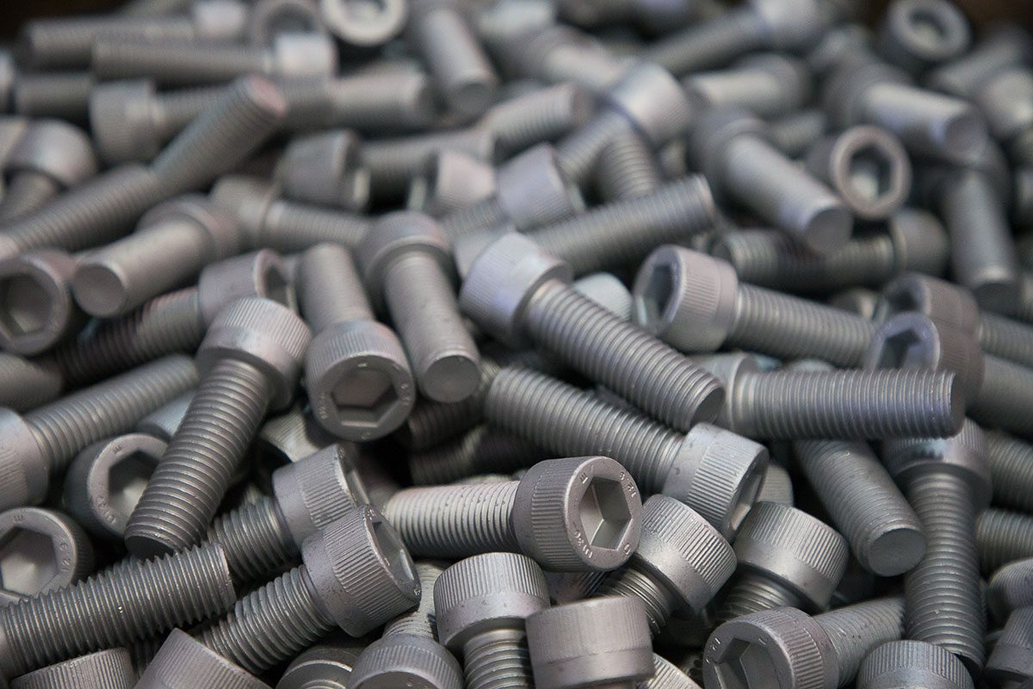

Experienced stainless fastener manufacturers follow simple inspection routines. Every stainless steel fastener supplier ensures clean finishing and safe packing before dispatch. Strong partnerships encourage lasting cooperation and assurance. Careful selection of a reliable fastener supplier strengthens every project. Quality stainless fastener supplies support steady performance and dependable results over time. Good quality control supports long term reliability. A respected fastener manufacturer values steady improvement. Processes remain organised and transparent. Stainless steel fastener manufacturers monitor sourcing practices carefully. Responsible stainless steel fastener suppliers review materials before production. Skilled stainless fastener suppliers keep communication open and simple. A professional fastener supplier answers queries clearly and quickly. Efficient stainless steel fastener distributors manage stock rotation smoothly. Dedicated fastener wholesaler teams inspect goods before release. Strong fastener wholesale channels maintain dependable flow. Well managed stainless fastener supplies reflect discipline and thoughtful supervision at every stage. Consistency builds trust across every order. Stainless steel fasteners manufacturers focus on uniform design.

Stainless fastener manufacturers aim for lasting strength. Careful steel fasteners manufacturers protect product integrity. A dependable stainless steel fastener supplier values repeat satisfaction. Experienced stainless steel fastener suppliers encourage open feedback. Trusted stainless steel fastener distributors handle goods with caution. A supportive fastener supplier maintains helpful service. Reliable fastener wholesaler networks simplify bulk purchasing. Organised fastener wholesale systems improve availability. Quality stainless fastener supplies ensure stainless nuts and bolts perform smoothly in varied applications. Imperial stainless steel nuts and bolts also reflect careful workmanship. A thorough checklist makes selection easier and clearer. Start by reviewing the fastener manufacturer background. Confirm stable stainless fastener supplies and storage methods. Assess communication from stainless fastener suppliers. Compare service from different stainless steel fastener manufacturers. Review support from each stainless steel fastener supplier. Examine offers by stainless steel fasteners manufacturers. Speak with trusted stainless steel fastener suppliers. Understand distribution handled by stainless steel fastener distributors. Evaluate terms from a fastener wholesaler or fastener wholesale partner. Ensure stainless nuts and bolts meet expectations. Confirm imperial stainless steel nuts and bolts match project needs. Careful checks deliver confidence and lasting value.

