A Few Details About Professional Funeral Services

Modern life has changed how families live. Many people move across borders for work. Families often live in different countries. Traditions still hold deep meaning for them. This shift increased demand for funeral directors. Families want trusted guidance during loss. They often search for a crematorium near loved ones. They also explore funeral repatriation options. A repatriation funeral helps bring someone home. Cultural ties remain strong and valued. Funeral repatriation services now play a vital role. They connect distant relatives with care. Services have grown more organised and supportive. This rise reflects changing lifestyles and global families.International travel has become more common today. Many families are spread across continents. When loss occurs abroad, choices matter deeply. Funeral repatriation offers a respectful solution. A repatriation funeral allows return to homeland. Families seek repatriation funeral services for guidance. These services manage arrangements with compassion. Repatriation funeral directors understand cultural customs. They ensure dignity at every step. Funeral directors coordinate with care and sensitivity. Families also arrange repatriation of cremated remains. Are you hunting about south london funeral directors? Browse the earlier talked about site.

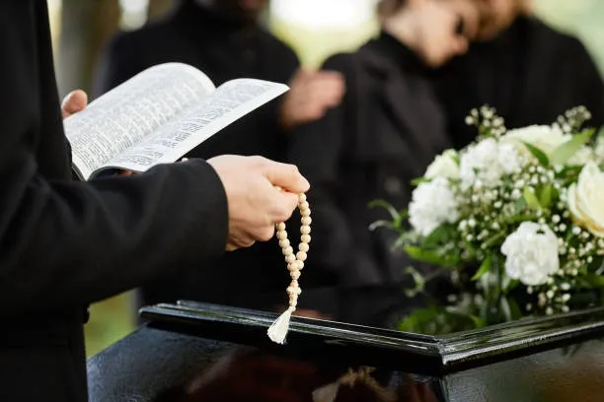

This option feels simple and meaningful. It helps honour beliefs and traditions. Such services continue gaining trust and recognition worldwide.Cultural values strongly influence funeral decisions. Many wish to rest in ancestral soil. Others prefer ceremonies near relatives. Searches for a crematorium near family increased. Funeral directors respond with flexible arrangements. Funeral repatriation services respect varied traditions. Repatriation funeral directors guide families gently. They simplify complex emotional moments. Repatriation of cremated remains offers comfort. It allows closeness without long delays. Repatriation funeral services adapt to beliefs. They provide personalised and thoughtful support. Families appreciate this considerate approach. Modern services balance tradition with convenience. This harmony explains growing popularity today. Communication has improved greatly in recent years with the help of advanced technology. Families connect instantly across long distances. Planning a repatriation funeral feels more manageable.

Funeral directors offer clear and caring advice. Funeral repatriation services provide steady reassurance. Repatriation funeral directors handle each stage calmly. They support documentation and ceremony planning. Repatriation of cremated remains is arranged smoothly. Families also locate a crematorium near relatives easily. Repatriation funeral services ensure respectful transfers. These services reduce stress and confusion. Support feels compassionate and dependable. This reliability builds lasting confidence among families.Modern funeral practices now reflect global lives. People value connection, heritage, and remembrance. Funeral directors recognise these evolving needs. Funeral repatriation has become widely accepted. Repatriation funeral services provide comfort and clarity. Repatriation funeral directors offer steady guidance. Families trust funeral repatriation services completely. Repatriation of cremated remains remains meaningful and practical. Many still search for a crematorium near home. Each repatriation funeral honours love and legacy. These services celebrate life with dignity. Their rising demand shows changing family structures. Tradition and mobility now move together gently.

