Wild Flower Seed & Seed Mixtures - Discover The Truth About Them

Wildflower meadows attract gardeners seeking colourful, lively outdoor spaces. Many communities now celebrate natural planting with joyful enthusiasm. the team supports newcomers wanting simple, rewarding meadow projects. Advice often comes from a specialist wildflower seed supplier online. Readers browse their full range before choosing suitable seeds today. Gentle guidance encourages greener habits across shared gardens everywhere. Growing interest shows beauty and wildlife can happily coexist. Simple meadow ideas inspire families seeking relaxing outdoor moments together. Popular choices promote colourful landscapes supporting pollinators and seasonal variety. Such movements encourage greener futures through shared planting efforts. Enthusiasm keeps community planting efforts thriving. Long term planting offers savings and enduring seasonal colour. Meadows need little care while rewarding owners yearly. Gardeners choose wildflower-only mixtures for reliable natural flowering displays. Many prefer their native wildflower seed range supporting biodiversity. Guides help beginners explore wildflower mix options confidently. Balanced planting builds resilient habitats welcoming butterflies and gentle bees. Communities share seeds, spreading colourful spaces across neighbourhood gardens. If you are hunting for more information on explore wildflower mix options, just go to the above site.

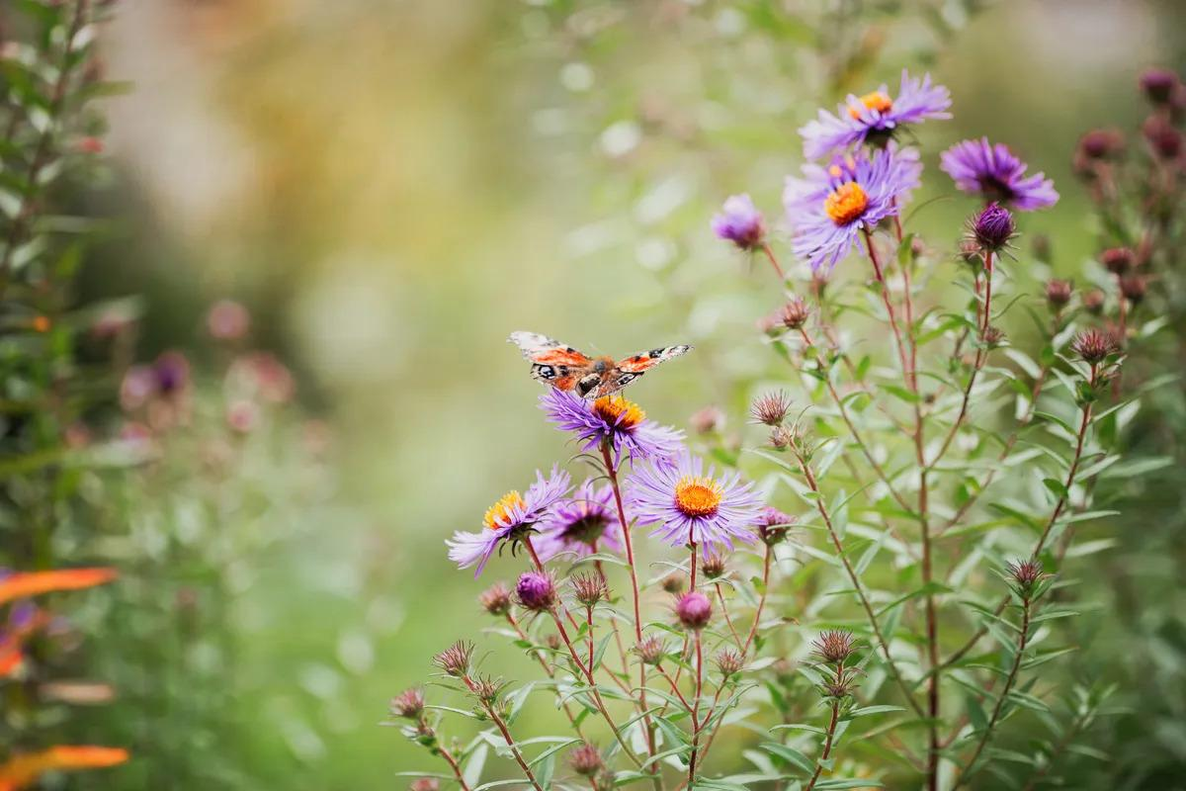

Support groups encourage greener living through relaxed shared meadow projects. Sustainable planting choices ensure landscapes remain attractive for generations. These practices bring harmony between homes and surrounding environments. Enthusiastic growers share knowledge encouraging successful meadow planting everywhere. Beautiful meadows create calming scenes filled with vibrant seasonal colour. Designers promote natural textures improving outdoor atmosphere across properties. Visitors often find the right seed mixture here easily. Many gardeners start using general purpose meadow mix successfully. Soft colours and waving grasses deliver relaxing scenic garden views. Creative planting blends shapes, fragrances, and seasonal flowering interest. Homeowners appreciate evolving landscapes offering peaceful retreats after busy routines. Natural displays encourage outdoor relaxation while supporting friendly wildlife populations. Gardens filled with flowers promote joy, mindfulness, and creative inspiration. Attractive meadows boost property charm and shared community enjoyment. Seasonal beauty encourages outdoor gatherings. Home gardens and workplaces both benefit from flowering meadow spaces. Landscapers choose solutions suitable for private and shared environments. Beginners enjoy a great starting point for meadow planting. Many growers trust their basic meadow seed mixture yearly. Residential lawns transform easily into colourful relaxed natural sanctuaries.

Commercial grounds welcome visitors using bright seasonal flowering displays. Balanced landscapes encourage employees, residents, and guests enjoying outdoor surroundings. Flowering spaces inspire wellbeing, creativity, and calmer social interactions. Shared green areas strengthen connections between neighbours enjoying peaceful environments. Successful meadow projects deliver beauty supporting wildlife across communities. Joyful planting brings colour into daily lives. Quality seeds ensure strong growth and colourful lasting meadow displays. Gardeners prefer reliable suppliers offering consistent seed quality standards. Helpful guides explain choices ideal for creating a wildflower meadow. Support services encourage customers selecting mixes matching diverse garden dreams. Ethical growing methods promote harmony between landscapes and surrounding wildlife. Simple maintenance routines help meadows flourish throughout changing seasonal cycles. Enthusiastic communities celebrate colourful flowering spaces encouraging relaxed outdoor living. Planting projects unite neighbours sharing seeds and nurturing greener futures. Natural meadows remain popular choices supporting pollinators and scenic beauty. Growing awareness ensures continued interest across gardening communities worldwide.

