The Significance Of Rooms for Therapy on Rent

Practitioners seek calm places supporting caring and healing sessions. Guidance through the platform simplifies searches for welcoming professional environments. Users browse available rooms and quickly compare comforting interiors. Clear details help teams find a therapy space confidently. Experts also find a suitable therapy space using guidance. Helpful pages show their therapy room listings with clarity. Visitors see what's available across supportive community centres easily. Content remains a useful resource for practitioners everywhere today. Friendly tools encourage planners toward flexible room hire for therapists. Managers book a room on a sessional basis easily. Teams explore pay-as-you-go options securing smooth bookings worldwide. Professionals value simple processes when choosing therapy or medical rooms. Search filters organise their medical room listings for easier decisions. Clients browse medical rooms for rent using friendly dashboards. Many teams find a medical consulting room without stress. Directories highlight suitable spaces for clinical work supporting wellbeing. Visitors also browse available rooms suited for counselling activities. Are you hunting about their london therapy room listings? Go to the earlier described site.
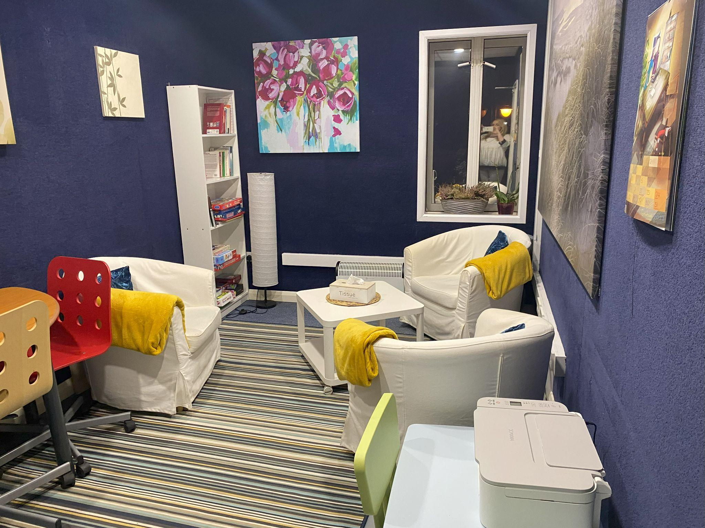
Advisors help planners find a therapy space through guidance. Community groups use the platform gaining dependable booking support. Managers discuss their sessional and ad hoc options openly. Teams book a room on a sessional basis quickly. Owners explore pay-as-you-go options enabling accessible practice everywhere. Affordable access encourages therapists seeking reliable shared professional workplaces. Smart comparisons help users browse available rooms saving resources. Guides show how to find a suitable therapy space economically. People find a therapy space while protecting careful budgets. Portals keep the platform friendly, supportive, and transparently organised today. Listings remain a useful resource for practitioners improving confident decisions. Owners present flexible room hire for therapists attracting newcomers. Planners review their sessional and ad hoc options regularly. Directories share their medical room listings supporting affordable outreach. Managers browse medical rooms for rent ensuring choices. Clinics find medical consulting rooms serving clinical work. Well designed centres welcome therapists needing organised peaceful consultation environments. Guides help teams see what's available across supportive facilities. Portals display their therapy room listings clarifying room features.

Users browse available rooms matching counselling and wellbeing services. Professionals find a suitable therapy space meeting everyday expectations. Supporters encourage flexible room hire for therapists improving service reach. Managers book a room on a sessional basis routinely. Visitors explore pay-as-you-go options supporting responsive appointment planning. Teams find medical consulting rooms ensuring clinical work. Directories organise their medical room listings enabling clear preparation everywhere. Seekers browse medical rooms for rent confident arrangements swiftly. Trusted connections unite communities using the platform for shared wellbeing. Networks help teams find a therapy space without delays. Guidance helps experts find a suitable therapy space quickly. Visitors browse available rooms while planners see what's available across. Listings remain a useful resource for practitioners supporting collaboration everywhere. Teams review their sessional and ad hoc options encouraging access. Owners provide flexible room hire for therapists bridging service gaps. Managers book a room on a sessional basis confidently. Users explore pay-as-you-go options connecting carers with welcoming clinics. Directories share medical listings guiding future partnerships.

