Tent Hire Specialist - Discover The Reality About Them

Garden gatherings flourish when hosts choose flexible bell tent hire. Families trust the team at experienced planners supporting celebrations happily. Consult a tent hire specialist guiding joyful event experiences everywhere. Guests can learn more about services creating memorable occasions together. Hosts explore bell tent options matching varied party themes easily. Planners see their bell tent packages simplifying festive preparations nicely. Organisers review their event and party hire page online today. These setups remain perfect for parties and celebrations worldwide always. Hosts explore their party packages ensuring comfort across gatherings nightly. Elegant luxury bell tents create welcoming atmospheres for wedding festivities. Preparation feels easier using their premium tent hire option everywhere. Designers add a luxury touch for your event ambience gracefully. Couples see their luxury bell tent range inspiring receptions beautifully. Visitors explore bell tent options ensuring relaxed guest comfort daily. Are you looking for a tent hire specialist in west sussex? Browse the earlier discussed website.
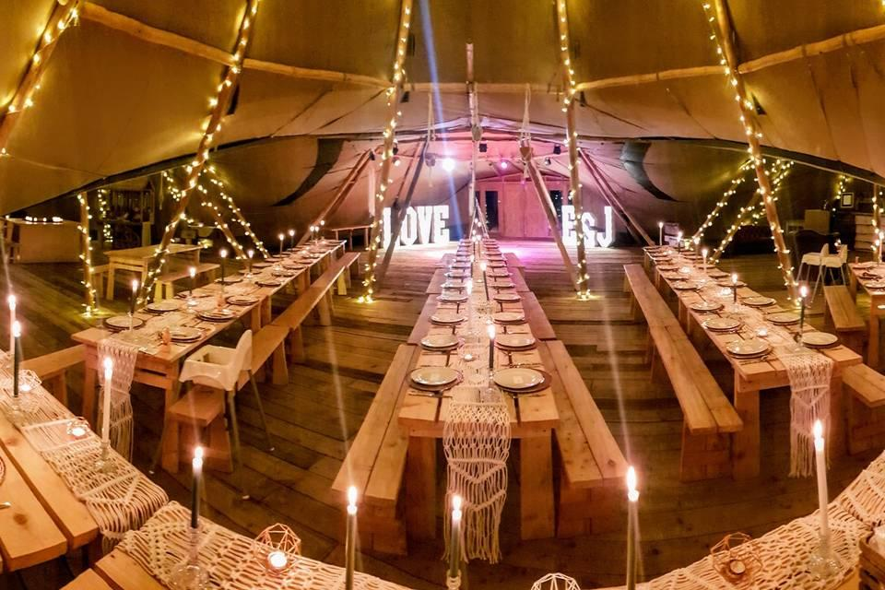
Advisors help learn more about bell tent hire benefits widely. Supporters from the team at coordinate smooth festive arrangements together. Clients appreciate a tent hire specialist delivering seamless hospitality solutions. Hosts compare party tent options before confirming joyful bookings quickly. Visitors open their event and party hire page confidently online. Packages stay perfect for parties and celebrations throughout changing seasons. Day gatherings shine using luxury bell tents under gentle sunshine. Night events sparkle through explore their party packages creatively nightly. Guests learn more about festive comforts offered within tents inside. Hosts explore bell tent options balancing daylight and evening moods. Organisers see their bell tent packages suiting vibrant receptions beautifully. Readers visit their event and party hire page regularly online. Celebrations feel perfect for parties and celebrations across timelines universally. Advisors from the team at recommend thoughtful lighting solutions nightly. Consult a tent hire specialist arranging serene overnight settings carefully. Hosts enjoy party tent options enhancing cheerful guest interactions everywhere. Outdoor occasions succeed using their premium tent hire option confidently. Designers craft a luxury touch for your event outdoors beautifully.

Visitors see their luxury bell tent range handling climates smoothly. Families explore bell tent options during sunny breezy gatherings happily. Guests learn more about bell tent hire versatility worldwide today. Organisers see their bell tent packages supporting rainy celebrations comfortably. Readers open their event and party hire page seeking inspiration. Experiences stay perfect for parties and celebrations despite weather changes. Guides from the team at share helpful seasonal advice freely. Consult a tent hire specialist recommending adaptable party tent options. Planners compare explore bell tent options before final decisions wisely. Buyers learn more about services through friendly booking guides online. Hosts review their full bell tent range for suitability everywhere. Clients see their bell tent packages matching celebration visions clearly. Everyone explores party tent options creating memorable hosting journeys together. Readers open their event and party hire page confidently again. Selections remain perfect for parties and celebrations across communities globally. Experts from the team at suggest balanced luxury bell tents. Choose premium tent hire option adding elegant comfort indoors. Finally see their luxury bell tent range completing bookings smoothly.

