Precise Analysis On The full Body Mobile Massage

Relaxation has become an essential part of daily living. Many people search for calm moments after busy routines. A full body mobile massage offers gentle comfort and deep ease. It helps the body feel lighter and the mind feel peaceful. The idea of mobile massage makes relaxation more accessible and simple. A full body massage can reduce tension and support emotional balance. It creates a soothing environment that feels natural and safe. The comfort of at home massage brings warmth and ease. Hotel room massage also provides quiet relaxation. Such experiences encourage calm thoughts and renewed energy. Stress often affects the body and emotions in subtle ways. A full body massage helps release pressure and restores inner harmony. Many people look for full body massage near me to enjoy comfort without effort. The idea of massage 24 hours makes relaxation feel always possible. A 24 hour mobile massage supports flexible and convenient care.Mobile massage allows peaceful moments without disruption. The presence of a mobile massage therapist brings reassurance and professional support. If you're searching for additional details on full body mobile massage london, click on the earlier mentioned site.

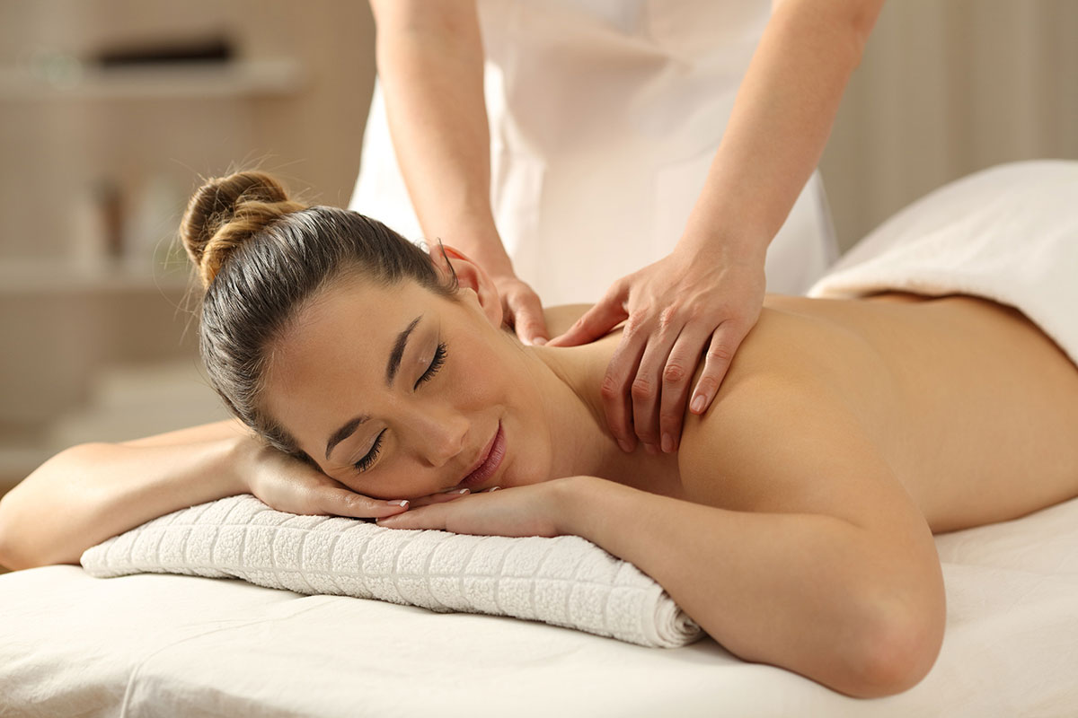

The experience encourages calm breathing and gentle comfort. It supports better mood and natural relaxation. Such moments feel refreshing and deeply satisfying. Modern lifestyles demand comfort that fits personal routines. A full body mobile massage suits different needs and preferences. Mobile massage creates a relaxed environment without travel stress. Massage in city settings can feel convenient and accessible. At home massage offers privacy and emotional ease. Hotel room massage provides quiet moments in a familiar setting. These options make relaxation feel natural and effortless. A full body massage supports physical comfort and mental clarity. People often feel renewed after such sessions. The flexible nature of mobile massage makes it suitable for varied lifestyles and daily rhythms. Relaxation should feel inclusive and easy for everyone. A full body mobile massage adapts to different comfort levels. Mobile massage helps people feel safe and cared for. Full body massage near me becomes a simple search for calm.

Massage 24 hours offers freedom to choose peaceful moments anytime. A 24 hour mobile massage enhances convenience and comfort. The role of a mobile massage therapist adds trust and gentle guidance. At home massage encourages a peaceful atmosphere. Massage in city environments remains accessible and welcoming. Such experiences create lasting impressions of ease and well-being. Comfort grows when relaxation meets variety and choice. A full body massage can feel gentle or deeply soothing. Mobile massage brings diverse styles that suit personal preferences. Hotel room massage offers quiet comfort and privacy. At home massage creates warmth and emotional security. Full body mobile massage connects physical ease with mental calm. Mobile massage therapist support strengthens confidence in the experience. Massage in city surroundings remains adaptable and flexible. Full body massage near me continues to attract attention for convenience. Massage 24 hours and 24 hour mobile massage make relaxation feel effortless and always within reach.

