Individual Guide On Editing & Post-Production

Successful video projects start through clear planning and collaboration today. Teams grow confident while working with creative partners delivering smoothly. Choose a freelance videographer supporting concepts using flexible skills daily. Clients always see portfolio samples before confirming creative direction together. Open communication builds trust and ensures smooth production journeys everywhere. Creative planning keeps goals aligned across teams ensuring outcomes shine. Professional guidance supports storytelling through organised shoots and thoughtful preparation. Early preparation reduces stress while encouraging expressive visuals for audiences. Shared ideas inspire crews creating memorable scenes across diverse platforms. Clear cooperation guarantees satisfying experiences for clients seeking lasting impact. Preproduction discussions shape expectations guiding crews toward confident filming stages. Detailed preparation encourages smoother sessions supporting creative teamwork daily worldwide. After filming teams organise clips supporting editing and post-production work smoothly. Creative experts offer reliable video editing services enhancing stories beautifully. Editors refine sequences using simple tools delivering engaging results consistently. Check out the following site, if you're looking for more details regarding his editing and post-production work.

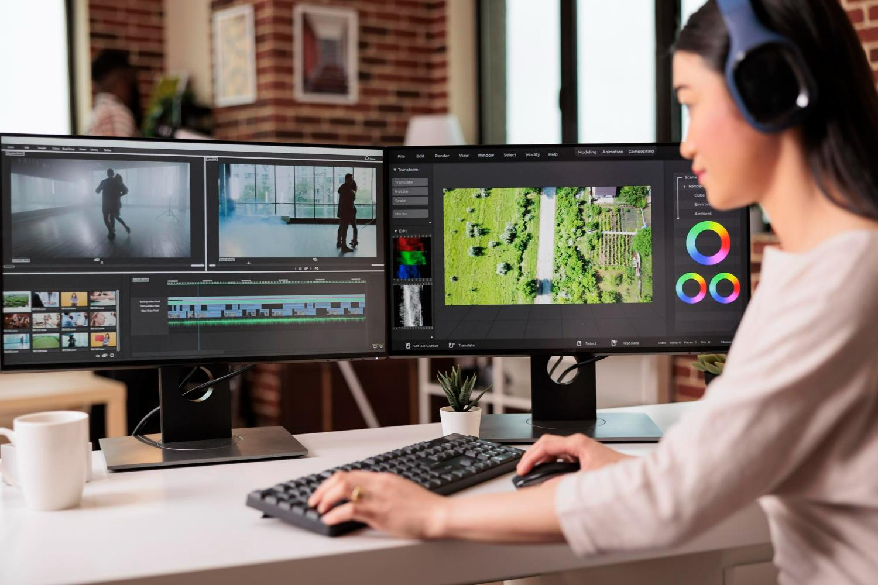

Teams can learn more about the editing process through friendly sessions. Smooth workflows help studios handle revisions with positive creative energy. Supportive planning strengthens cooperation between shooting and editing groups daily. Clear schedules encourage timely delivery across varied creative media channels. Coordinated teams celebrate progress ensuring clients enjoy polished stories everywhere. Budget differences influence planning yet creativity drives strong storytelling outcomes. Smaller productions benefit greatly from flexible creative collaboration daily worldwide. Larger projects also thrive through organised teams supporting ambitious visions. Producers enjoy working with adaptable crews handling diverse expectations smoothly. Smart choices help clients balance quality goals across spending ranges. Teams invite viewers to see portfolio comparisons inspiring confident decisions. Reliable partners provide affordable video editing services improving storytelling experiences. Experts help get your footage professionally edited creating captivating results. Flexible solutions support creative teams during varied production journeys globally. Balanced investment ensures memorable outcomes satisfying audiences seeking engaging stories.

Sound harmony and visual balance shape engaging viewing experiences everywhere. Skilled creators adjust elements ensuring stories feel immersive and expressive. Teams combine filming strengths with editing and post-production work smoothly. Creators invite clients to learn more about editing process together. Balanced audio choices support emotional connections across engaging visual journeys. Careful adjustments deliver clarity while preserving natural cinematic atmosphere daily. Supportive video editing services refine tones for pleasing audience responses. Creative collaboration encourages smoother communication between departments crafting polished outcomes. Consistent quality builds confidence among partners seeking memorable storytelling solutions. Harmonised sound and visuals guarantee enjoyable experiences for diverse audiences. Subtle effects and gentle transitions enhance stories without distracting viewers. Editors craft sequences supporting brands through creative storytelling methods daily. Teams value working with a freelance videographer delivering expressive visuals. Clients can see portfolio updates showing refined editing progress clearly. Specialists combine editing and post-production work adding subtle artistic touches. Professionals encourage viewers to learn more about editing process online. Friendly teams get your footage professionally edited using creative care. Flexible video editing services deliver memorable narratives for growing communities. Positive collaboration ensures final films inspire loyal audiences seeking beauty.

