In-Depth Study On The Order Mounjaro Online

The weight loss pen mounjaro is gaining attention. It supports healthy weight management goals. Many adults explore this modern treatment option. The mounjaro pen is simple and practical. It is also called the mounjaro injection pen. This treatment fits structured care plans. Access begins with a proper consultation. Many choose a mounjaro private prescription route. A private prescription mounjaro offers guided support. The process feels smooth and reassuring. People often ask how mounjaro get prescription works. Healthcare providers assess suitability carefully. Once approved, treatment can begin steadily. The approach focuses on balance and wellbeing. Many individuals now order mounjaro online safely. The process feels convenient and discreet. To order mounjaro online, consultation is required. Some search using mounjaro order online queries. Trusted providers operate as a mounjaro online pharmacy. An online pharmacy mounjaro service simplifies access. A registered mounjaro pharmacy ensures quality supply. Digital systems make ordering straightforward. Patients upload details and receive guidance. Approval leads to dispatch of the mounjaro pen. Support remains available throughout treatment. If you're looking for additional details on order mounjaro online uk, explore the previously mentioned site.
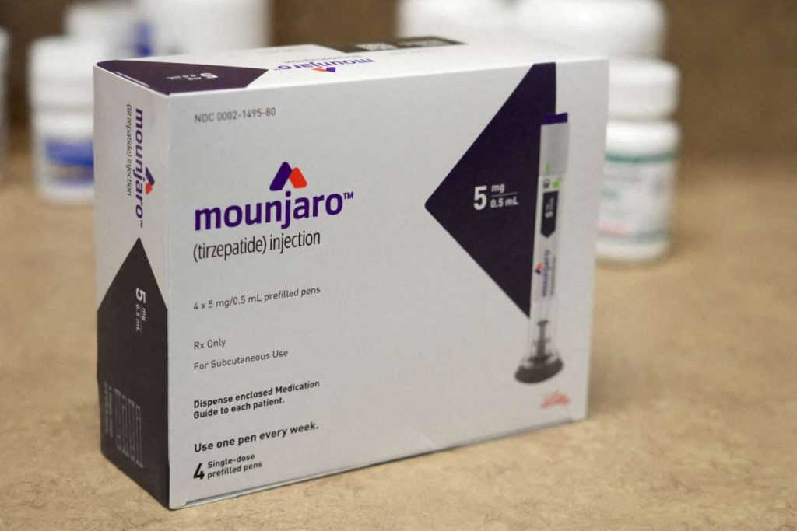
Many appreciate clear instructions and steady communication. The entire journey feels organised and secure. Understanding costs is part of planning. People often ask how much is mounjaro. Pricing can vary between providers. A careful mounjaro price comparison helps decision making. Many search for the cheapest mounjaro responsibly. Value should align with professional support. Transparent pricing builds confidence and trust. Online services display clear cost details. This helps avoid confusion or doubt. Those who order mounjaro online review options carefully. A reliable mounjaro online pharmacy explains fees clearly. Support teams guide patients step by step. The goal is clarity and peace of mind. Treatment with the mounjaro injection pen feels manageable. The design of the weight loss pen mounjaro is practical. The mounjaro pen supports consistent routine. Guidance comes with every private prescription mounjaro. Providers explain usage in simple terms. People asking about mounjaro get prescription receive full advice. Clear instructions encourage steady progress. Benefits often include appetite control support. Many appreciate structured care plans.

Mounjaro side effects are discussed positively and calmly. Providers offer reassurance and ongoing monitoring. The experience remains supportive and balanced. Patients feel encouraged throughout the journey. Digital healthcare continues to expand rapidly. More people order mounjaro online each day. Convenience drives interest in mounjaro order online services. Growth of online pharmacy mounjaro platforms continues steadily. A trusted mounjaro pharmacy adapts to demand. The rise of mounjaro private prescription access reflects change. Easy ways to mounjaro get prescription increase confidence. Transparent mounjaro price comparison tools improve choice. Questions like how much is mounjaro remain common. Searches for cheapest mounjaro also continue growing. The weight loss pen mounjaro represents modern treatment progress. The future appears promising and accessible. Ongoing support enhances confidence in treatment. Many continue to order mounjaro online with ease. A dependable mounjaro online pharmacy ensures smooth service. Guidance with mounjaro get prescription remains clear and simple. Patients value steady communication and reassurance. Transparent mounjaro price comparison builds further trust. Questions about how much is mounjaro feel easier to answer. The weight loss pen mounjaro continues to inspire commitment and positive lifestyle change.

