Important Things About Seamless Ring Jewellery

Shopping for body jewellery online feels simple and relaxed today. Online stores offer clear choices and smooth browsing paths. Many people enjoy piercing jewellery online because it saves time. Designs appear neatly displayed with helpful images and descriptions. Body piercing jewellery is shown in many styles and finishes. Body jewellery collections feel organised and easy to explore. Piercing jewellery sections often guide selection gently. Filters help narrow options without confusion. Visual clarity builds trust and comfort. Shopping becomes calm rather than rushed. Ease of access supports confident decisions. Browsing feels pleasant and controlled. Choices appear balanced and inviting. This relaxed approach encourages thoughtful selection and satisfaction. Understanding size helps avoid mistakes while shopping online. Clear guides simplify choosing body jewellery without stress. Piercing jewellery online often includes fit tips. Are you hunting about body piercing jewellery uk? Check out the previously discussed site.

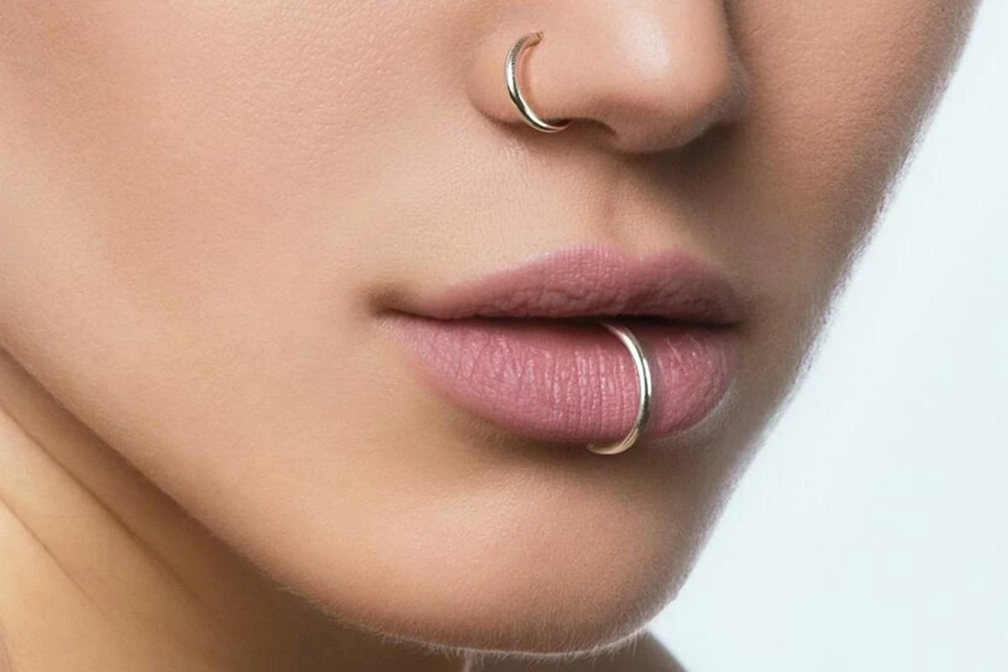

These tips support everyday comfort and secure wear. Body piercing jewellery should feel snug yet gentle. Many prefer checking measurements before adding items. Body jewellery styles vary in shape and size. Plugs and tunnels need careful matching for comfort. Simple visuals explain fit without effort. Clear descriptions prevent guesswork. Confidence grows through guidance. Selecting feels reassuring and smooth. Comfort remains the focus throughout browsing. Easy guidance improves the entire shopping experience. Materials matter when choosing piercing jewellery for daily wear. Quality materials support comfort and long wear. Body jewellery online often highlights smooth finishes. These finishes feel kind on the skin. Piercing jewellery online descriptions focus on safe choices. Body piercing jewellery benefits from careful material selection. Nose jewellery deserves extra attention for comfort. A nose piercing stud should feel light. Nose ring studs often offer smooth edges. A secure feel improves peace of mind. Comfort supports confidence every day. Gentle materials reduce worry. Shopping becomes pleasant and stress free. Quality adds lasting value and reassurance. Choosing between styles feels easier with clear comparisons. Nose ring and nose piercing stud styles suit different looks.

Nose ring piercing designs feel expressive and classic. Nose jewellery collections show variety clearly. Nose ring studs suit simple and clean styles. A nose piercing stud feels subtle and neat. Body jewellery options support personal expression. Piercing jewellery styles range from bold to soft. Visual examples inspire confidence. Simple explanations guide choices gently. Style decisions feel enjoyable. Exploring options feels creative. Comfort and style blend naturally. Shopping remains enjoyable and relaxed. Hygiene awareness builds trust while shopping online. Piercing jewellery online often explains care gently. Body jewellery online descriptions highlight cleanliness standards. This reassurance supports confident buying decisions. Body piercing jewellery should arrive clean and ready. Piercing jewellery packaging often feels secure. Nose jewellery deserves careful handling for peace of mind. Nose ring pieces should feel fresh and safe. Nose piercing stud items need hygienic presentation. A clean process builds comfort. Trust grows through transparency. Shopping feels safe and positive. Ease combines with reassurance. The experience feels complete and satisfying.

