Great Things About Decorative Wedding Lighting

Event planners follow fresh styles shaping modern celebrations worldwide today. Creative teams review indoor stage options for dynamic gatherings everywhere. Many organisers trust their indoor stage hire service easily. Hosts browse indoor stages here before confirming designs quickly. Experts help clients find the right stage for your event smoothly. Trends favour flexible décor, immersive sound, and colourful lighting experiences. Simple layouts support smooth movement across lively venues tonight. Fresh concepts encourage memorable moments during social and corporate functions. Design choices blend elegance, comfort, and practical staging features beautifully. Planning teams share creative guidance ensuring enjoyable guest experiences always. Celebrations thrive. Outdoor productions increasingly use versatile outdoor stages for community celebrations nightly. Organisers compare their outdoor stage hire options before bookings. Teams plan staging for festivals and outdoor events carefully. Managers see what's available for outdoor hire during preparations. Weather friendly designs create safe, vibrant, and welcoming event spaces. Open air settings encourage relaxed moods and cheerful networking opportunities. Are you looking for see their wedding and event lighting? Look at the earlier talked about site.

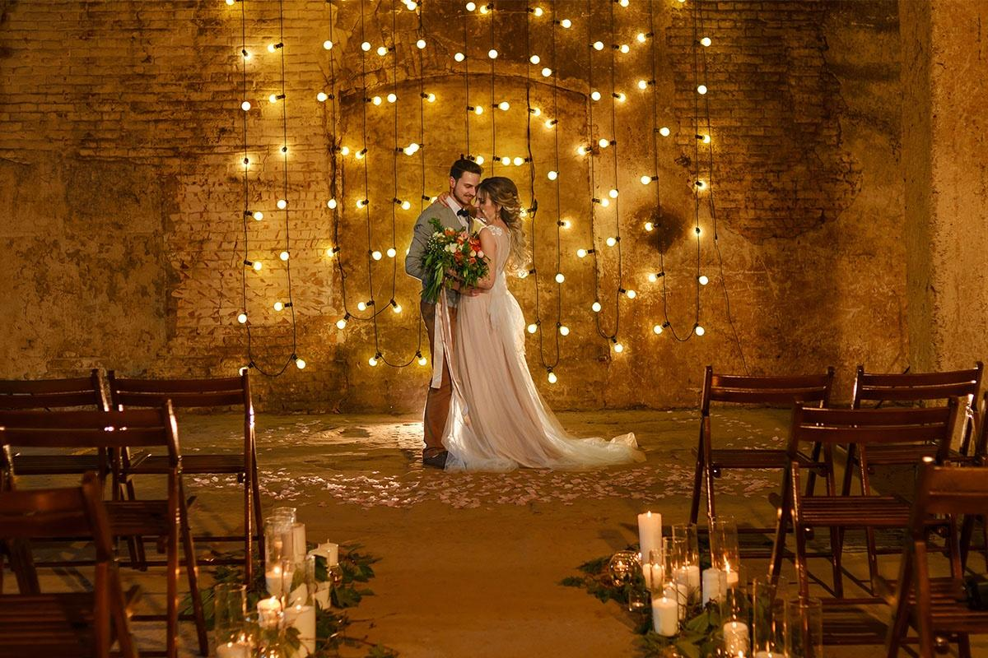

Smart layouts improve audience views across large celebration grounds comfortably. Support crews deliver seamless setups using adaptable staging structures everywhere. Decor elements blend colours, textures, and creative performance backdrops attractively. Good coordination keeps programmes running smoothly throughout energetic festivities daily. Celebrations flourish. Modern organisers rely on dependable AV hire service during gatherings. Planners review their audio visual equipment range before confirmations. Experts design AV solutions for events supporting immersive atmospheres everywhere. Clients explore their AV hire options ensuring engaging presentations easily. Clear screens, crisp audio, and lighting create captivating showcases nightly. Simple technology choices support conferences, ceremonies, and creative exhibitions effectively. Production teams coordinate rehearsals ensuring smooth transitions between programme segments. Balanced sound coverage keeps audiences attentive across lively event environments. Visual storytelling strengthens brand messages using expressive stage content beautifully. Creative planning encourages memorable participation during social and business occasions worldwide. Couples admire elegant wedding lighting enhancing romantic celebration atmospheres beautifully.

Planners recommend their lighting hire for weddings and events frequently. Designers discuss lighting options for your big day during consultations. Hosts see their wedding and event lighting inspiring memorable receptions. Soft illumination, colourful effects, and décor accents craft joyful spaces everywhere. Creative fixtures transform halls, gardens, and marquees into magical venues. Flexible lighting plans suit intimate ceremonies and lively receptions perfectly. Skilled crews adjust brightness ensuring comfortable moods throughout festive gatherings. Decor planners combine fabrics, florals, and lighting for cohesive themes attractively. Joyful ambience encourages shared moments across evening celebrations. Successful events blend staging, visuals, and lighting for memorable experiences. Careful preparation supports seamless coordination among suppliers and creative teams. Flexible services deliver tailored solutions matching varied celebration themes beautifully. Modern hosts appreciate convenient planning tools simplifying complex event arrangements. Guests enjoy immersive atmospheres created through thoughtful décor and staging. Creative suppliers provide reliable support ensuring joyful occasions succeed smoothly. Smart coordination encourages engaging programmes attracting diverse audiences across celebrations. Quality equipment choices improve comfort while strengthening impressive visual presentations. Effective collaboration builds lasting memories shared during vibrant social gatherings.

