Google Ads Expert And Their Misconceptions

Businesses grow faster with guidance from google ads consultant today. Expert consultant google ads strategies bring steady customer interest online. A skilled google PPC consultant improves campaign reach quickly worldwide. Many firms hire PPC consultant support for expanding sales globally. Trusted PPC marketing consultant advice encourages strong brand visibility everywhere. Experienced PPC management consultant services guide sustainable advertising success daily. Professional teams create simple adverts delivering clear messages across markets. Consultants use flexible methods ensuring better engagement among potential buyers. Smart planning supports companies seeking reliable online promotional opportunities worldwide. Results increase when consultants manage campaigns using creative communication carefully. Healthcare practices benefit using google ads for dentists promoting services. Every dental google ads agency designs friendly messages attracting patients. Campaign success rises when google ads dentist promotions reach families. A google ads consultant also guides clinics seeking broader visibility. Expert consultant google ads planning builds caring connections with communities. Check out the following website, if you're looking for more details about google ads consultant.

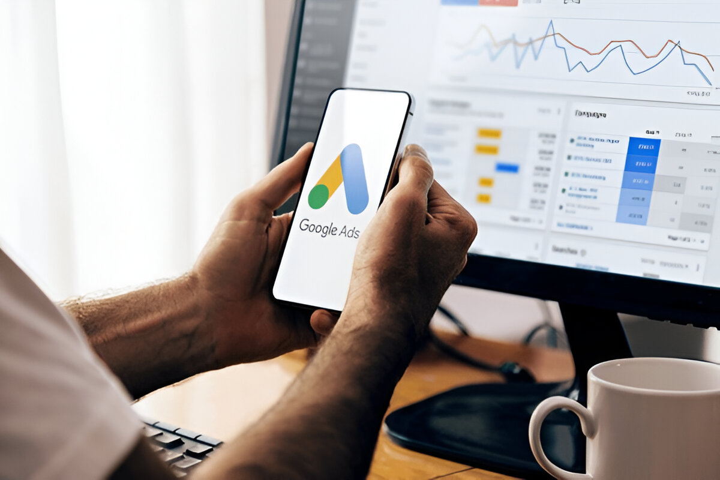

Smart google PPC consultant solutions help practices gain loyal visitors. Many clinics hire PPC consultant teams improving appointment enquiries steadily. Trusted PPC marketing consultant campaigns highlight gentle treatments supporting comfort. Reliable PPC management consultant guidance ensures ongoing patient communication success. Simple advertising encourages families choosing caring dental services through promotions. Legal practices grow using google ads for law firms effectively. Targeted google adwords for lawyers campaigns connect firms with clients. A pay-per-click consultant for attorneys improves enquiry response rates quickly. Experienced google ads consultant planning strengthens professional legal service visibility. Dedicated consultant google ads teams craft trustworthy messages encouraging consultations. Skilled google PPC consultant support keeps advertising communication clear everywhere. Many partners hire PPC consultant specialists enhancing practice recognition online. Reliable PPC marketing consultant advice promotes respectful client relationships continuously. Professional PPC management consultant services maintain steady campaign performance today. Simple adverts help attorneys showcase supportive services attracting wider audiences.

Growing enterprises trust google ads consultant guidance for sustainable expansion. Forward companies choose consultant google ads expertise securing competitive advantages. Every google PPC consultant campaign encourages engagement across diverse audiences. Ambitious owners hire PPC consultant partners supporting profitable marketing journeys. Creative PPC marketing consultant solutions inspire memorable customer experiences everywhere. Efficient PPC management consultant planning sustains positive advertising momentum worldwide. Healthcare teams appreciate google ads for dentists attracting regular visitors. Experts recommend dental google ads agency partnerships strengthening clinic outreach. Law practices value google ads for law firms generating enquiries. Attorneys trust pay-per-click consultant for attorneys delivering consistent client connections. Successful brands partner google ads consultant teams achieving lasting growth. Smart organisations use consultant google ads services strengthening digital presence. Businesses trust google PPC consultant experts shaping engaging promotional journeys. Leaders hire PPC consultant professionals creating valuable customer communication platforms. Every PPC marketing consultant approach supports hopeful enterprises seeking recognition. Dedicated PPC management consultant guidance ensures harmonious campaign progress globally. Clinics succeed using google ads dentist promotions encouraging caring appointments. Firms benefit through google adwords for lawyers enhancing service awareness. Agencies cooperate with dental google ads agency networks delivering growth.

