Complete Study On The Flexible Party Spaces

Choosing the right event space ensures joyful gatherings always together. Families seek a versatile venue supporting parties and celebrations comfortably. Many enjoy hosting a party without planning stress today. Guests appreciate Monty's Bar and Kitchen offering welcoming shared interiors. The on-site bar and kitchen keeps visitors refreshed happily. Friends happily grab a drink at Monty's after arrival. Such setting remains a great option for celebrations everywhere. Decor feels warm creating memorable moments for every visitor tonight. Service teams coordinate smoothly ensuring cheerful atmospheres across gatherings worldwide. Hosts value flexible layouts supporting celebrations indoors. Everyone leaves satisfied, sharing stories after events. Planning events feels simpler when hosting a party here together. Helpful teams explain party packages clearly supporting smooth celebrations nightly. Visitors trust Monty's services delivering comfort across varied gatherings happily. Staff guide guests towards enjoyable menus within on-site bar and kitchen. Friends meet early then grab a drink at Monty's together. Flexible rooms transform quickly matching themes for parties and celebrations. Check out the following website, if you're searching for additional information concerning their parties and celebrations page.

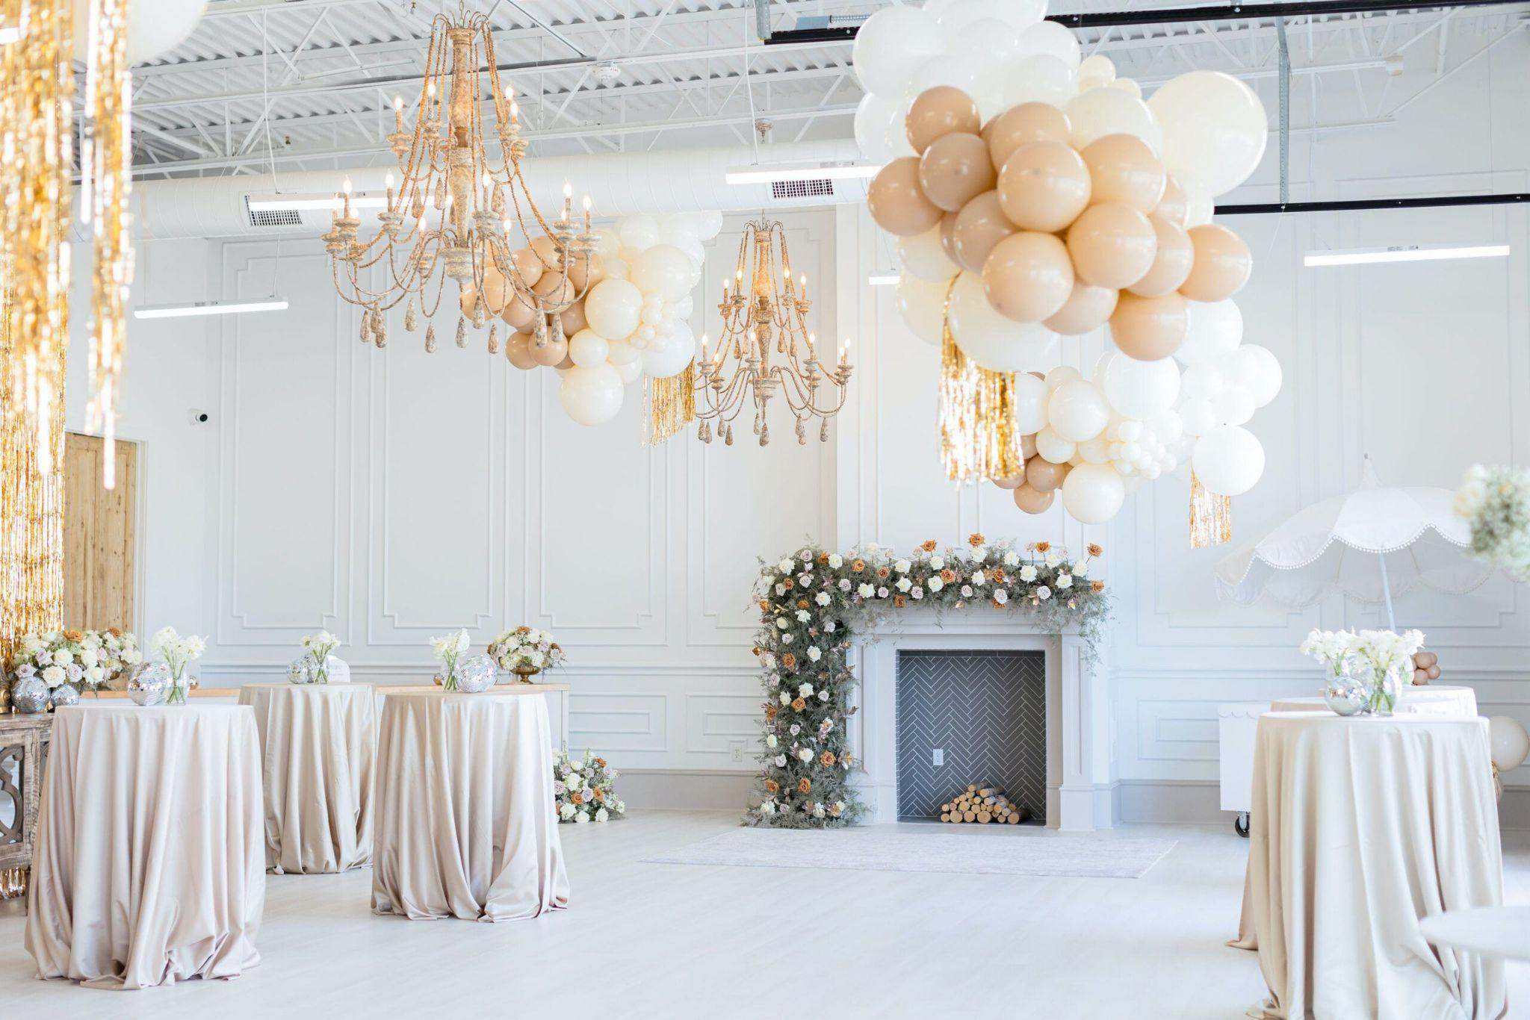

Hosts appreciate support easing hosting a party during busy seasons. Quality service makes gatherings a great option for celebrations everywhere. Chefs prepare varied dishes pleasing families seeking relaxed shared experiences. Managers ensure smooth bookings using friendly guidance daily worldwide. Modern hosts seek fresh ideas shaping parties and celebrations today. Trends favour relaxed gatherings inside a versatile venue worldwide. Couples explore wedding offering options promising memorable shared ceremonies nightly. Many desire an intimate wedding space blending romance with comfort indoors. Planners suggest selecting a wedding venue worth considering for unity. Advisors compare flexible wedding packages meeting dreams across communities happily. Guests enjoy flavours from the on-site bar and kitchen during receptions. Reviews praise Monty's Bar and Kitchen creating stylish welcoming celebrations. Creative lighting elevates moods supporting joyful parties nightly worldwide. Families appreciate tailored décor inspiring guests. Coordinators deliver smooth schedules ensuring happiness. Budgets vary yet every event space welcomes diverse joyful gatherings.

Clients compare styles selecting a versatile venue matching celebration dreams. Affordable choices and premium party packages satisfy parties and celebrations. Many consider Monty's a great option for celebrations yearround. Elegant halls support hosting a party with refined dining experiences. Friendly teams manage the on-site bar and kitchen delivering smooth service. Couples review wedding packages balancing comfort and graceful presentation tonight. Spaces transform easily serving intimate wedding space and receptions happily. Visitors often grab a drink at Monty's celebrating milestones together. Service quality keeps this wedding offering worth choosing for families worldwide. Choosing venues requires clear goals supporting parties and celebrations everywhere. Seek an event space offering flexible rooms aiding hosting a party. Ensure a versatile venue provides helpful party packages and guidance. Visitors trust Monty's Bar and Kitchen delivering memorable shared experiences. Guests happily grab a drink at Monty's before ceremonies begin. Couples want intimate wedding space and suitable wedding packages arranged. Planners note a wedding venue worth considering for joyful unions. Quality on-site bar and kitchen services enhance a great option. Final choices support memorable wedding offering across families celebrating together.

