An Overview Of Bell Tents for Your Event

Modern celebrations follow fresh outdoor living trends today. Hosts explore bell tents for your event easily. Guests enjoy comfort through creative open air setups. Organisers compare their bell tent hire options carefully. Many planners review the bell tent range beforehand. Visitors often see what offers suit changing gatherings. Flexible bell tent service supports stylish modern celebrations everywhere. Creative teams share ideas using glamping tent options widely. Services stay available for events across changing occasions globally. Planners happily explore their glamping packages before confirming themes. Families appreciate cosy tents creating memorable shared moments. Booking stays simple through helpful planners supporting celebrations. Budget planning guides choices between comfort and style easily. Families review their bell tent options before final selections. Many clients hire a bell tent near you quickly. Visitors browse their glamping hire page seeking flexible celebrations. Choices feel perfect for a glamping experience during gatherings. Suppliers present their tent hire options for diverse celebrations. Helpful teams repeat bell tent service ensuring memorable outdoor comfort. Are you searching for explore bell tents for your event? Check out the earlier discussed website.

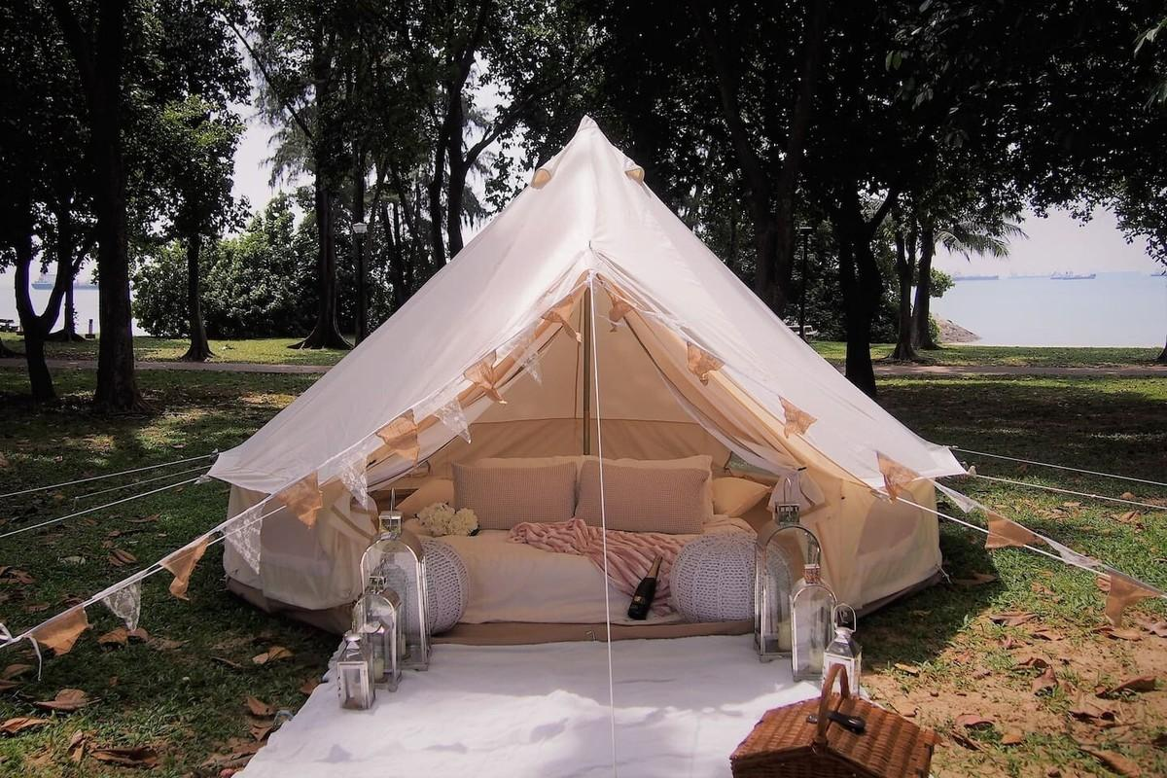

Packages remain available across for events supporting joyful occasions everywhere. Couples confidently book a bell tent creating charming festive spaces. Guests happily see what offers match elegant affordable celebration visions. Trends encourage balanced choices for celebrations. Outdoor parties gain warmth through stylish temporary comfortable living spaces. Organisers explore bell tents for your event enhancing shared happiness. Friendly hosts prefer glamping tent options supporting relaxed social bonding. Reliable bell tent service brings smooth hosting and joyful memories. Guests discover comfort while planners see what offers suit themes. Services remain available for events across celebrating joyful community gatherings. Families appreciate perfect for a glamping experience during reunions together. Suppliers guide clients through their tent hire options confidently today. Organisers encourage friends book a bell tent for comfort outdoors. Celebrations flourish using explore their glamping packages creating excitement everywhere. Unique celebrations combine artful décor with cosy relaxing social spaces. Planners highlight their bell tent options shaping unforgettable festive atmospheres.

Guests hire a bell tent near you enjoying novelty together. Creative guides share their glamping hire page inspiring personalised gatherings. Services remain available across for events boosting lively entertainment experiences. Visitors explore bell tents for your event discovering charming comforts. Friendly crews deliver bell tent service ensuring delightful shared celebrations. Organisers explore their glamping packages crafting memorable themed experiences together. Couples see what offers enhance romantic relaxed evening festivities beautifully. Everyone loves perfect for a glamping experience under stars nightly. Event planning feels easier using modern flexible outdoor living solutions. Teams organise celebrations through their tent hire options smoothly today. Customers quickly book a bell tent reducing preparation worries greatly. Services stay available for events across simplifying festive arrangements everywhere. Planners review bell tent range choosing comfortable stylish welcoming shelters. Families hire a bell tent near you enjoying simplicity together. Organisers check their bell tent hire options ensuring convenience daily. Guests prefer glamping tent options creating relaxed joyful gatherings everywhere. Hosts explore their glamping packages, securing perfect seamless experiences always.

