A Glance At Used Digital Cameras

Interest in used digital cameras is rising again worldwide. Buyers search online for used digital cameras for sale daily. Many prefer pre owned digital cameras offering nostalgic creative experiences today. Others choose cheap retro digital camera options for stylish memories everywhere. Fans love retro camera digital designs returning through social platforms globally. Trends also highlight digital retro camera models inspiring younger photographers worldwide. Classic vintage digital cameras attract collectors seeking joyful everyday shooting experiences. Stores promote vintage compact digital camera choices alongside modern alternatives today. Shoppers appreciate digital vintage camera charm supporting creative storytelling everywhere online. Buyers explore used sony digital camera listings for dependable photography options. Forums discuss sony camera used gear encouraging confident creative purchases today. Collectors seek second hand sony camera pieces celebrating timeless imaging culture. Many families choose second hand sony digital camera kits for memories. Sellers advertise second hand digital cameras for sale widely across communities. Online groups compare second hand digital cameras supporting careful selections daily. Shoppers reviewing used digital cameras discover reliable affordable creative companions everywhere. Go to the below mentioned website, if you're looking for more information on used digital cameras uk.
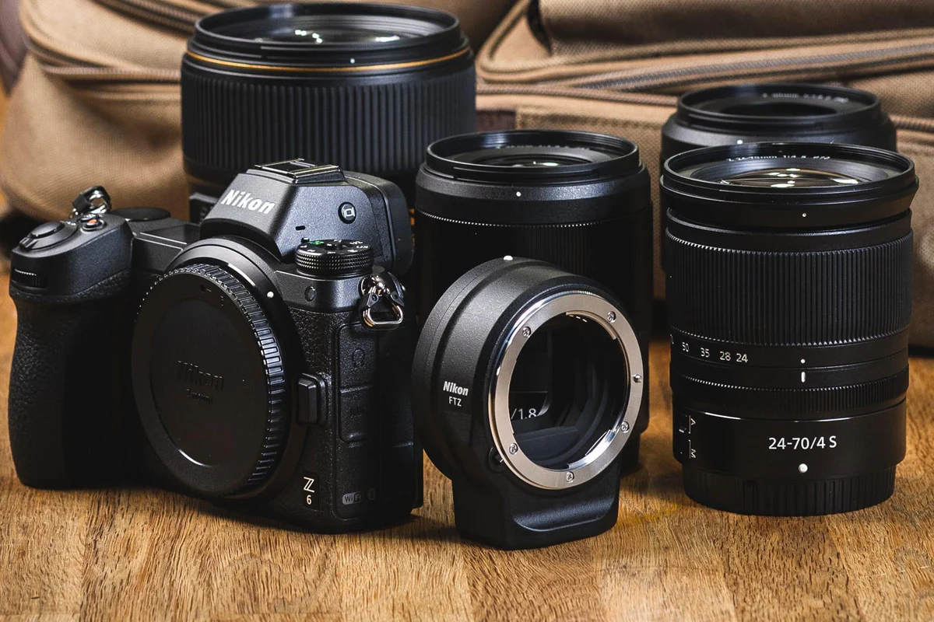
Pre owned digital cameras continue satisfying learners seeking artistic journeys globally. Cheap retro digital camera demand supports thriving nostalgic content creation scenes. Budget seekers compare used digital cameras for sale carefully before buying. Pre owned digital cameras offer savings supporting creative hobbies for everyone. Many prefer second hand digital cameras reducing purchase pressure for beginners. Shoppers find cheap retro digital camera choices delivering fashionable images daily. Retro camera digital styles encourage expressive storytelling without complicated equipment setups. Digital retro camera collections satisfy travellers capturing spontaneous joyful memories everywhere. Vintage digital cameras remain affordable inspiring passionate community sharing across platforms. A vintage compact digital camera suits minimal everyday creative needs perfectly. Digital vintage camera appeal supports budget friendly content production worldwide today. Creators admire digital vintage camera looks enhancing social storytelling aesthetics online. Vintage digital cameras produce charming colours pleasing artistic audiences everywhere today. Retro camera digital bodies complement fashion shoots and lifestyle visuals beautifully. Digital retro camera gear pairs perfectly with minimal creative wardrobes everywhere.

Used sony digital camera aesthetics inspire stylish photography across communities globally. Second hand sony camera fans celebrate timeless designs encouraging artistic expression. Second hand sony digital camera lovers share colourful storytelling online daily. Second hand digital cameras for sale attract style focused creators worldwide. Used digital cameras and pre owned digital cameras enhance aesthetics everywhere. Collectors predict used digital cameras gaining future sentimental investment value globally. Buyers monitor used digital cameras for sale expecting appreciation later worldwide. Pre owned digital cameras and second hand digital cameras attract investors. Cheap retro digital camera collections inspire renewed demand among enthusiasts everywhere. Retro camera digital trends strengthen digital retro camera resale potential globally. Vintage compact digital camera digital vintage camera markets flourish steadily. Fans also seek second hand digital cameras for sale across platforms. Demand for sony camera used and used sony digital camera rises. Second hand sony camera second hand sony digital camera thrive worldwide.

