User Guide On Glass Flat Roof Lights

Lighting shapes how a space feels, looks, and flows daily. Soft light creates calm moods. Bright light lifts energy. Natural light feels open and welcoming. Glass flat roof lights help spread light evenly. Flat glass rooflights keep spaces clear and balanced. A frameless flat glass rooflight adds a clean appearance. Light from above reduces heavy shadows. Rooms feel larger and calmer. Glass rooflights for flat roof areas invite gentle brightness. Roof lanterns add charm and depth. Skylights roof lanterns improve visual comfort. A roof lantern skylight enhances warmth. Large velux roof windows bring openness indoors. As light changes, ambience shifts smoothly through the day. Gentle daylight feels refreshing and soft. Evening light feels calm and restful. Glass flat roof lights help balance these changes. Flat glass rooflights allow light without distraction. A frameless flat glass rooflight keeps views simple. If you are seeking to learn more about glass flat roof lights, look at the mentioned above site.

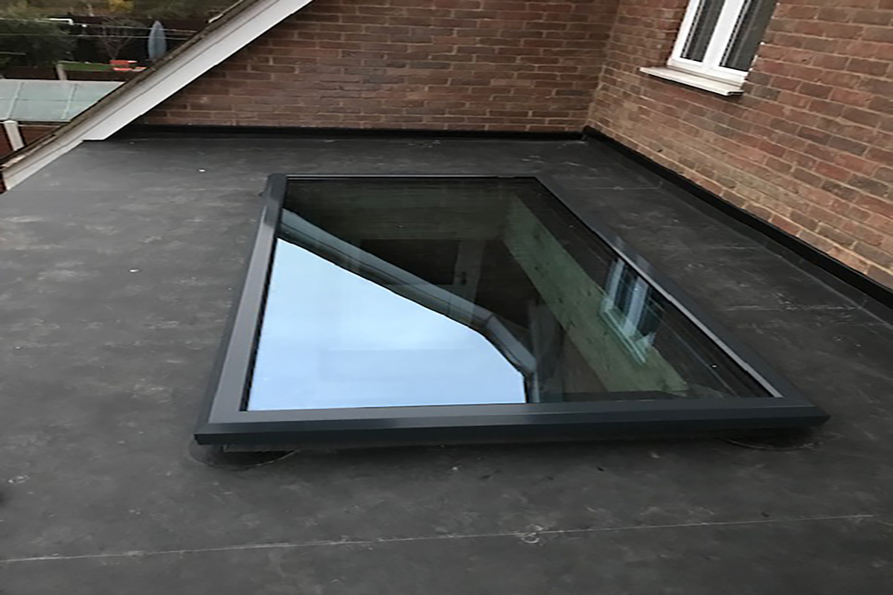

Glass rooflights for flat roof spaces support steady brightness. Roof lanterns add layered light effects. Skylights roof lanterns spread glow evenly. A roof lantern skylight supports relaxed moods. Large velux roof windows allow natural transitions. Velux roof lights help guide light gently. Velux roof windows maintain comfort. Velux pitched roof windows soften changing light patterns beautifully. Lighting also shapes how spaces feel emotionally. Calm light supports quiet moments. Bright light lifts social energy. Glass flat roof lights help manage these moods. Flat glass rooflights maintain a peaceful feel. A frameless flat glass rooflight adds visual clarity. Glass rooflights for flat roof areas reduce dull corners. Roof lanterns create inviting focal points. Skylights roof lanterns bring balanced illumination. A roof lantern skylight adds gentle drama. Large velux roof windows open interiors visually. Velux roof lights soften interior tones. Velux roof windows keep rooms welcoming. Velux pitched roof windows help light feel natural and flowing.

Modern roof light solutions support comfort and harmony. Light feels cleaner and more even. Spaces feel calmer and brighter. Glass flat roof lights support daily living. Flat glass rooflights suit many interior styles. A frameless flat glass rooflight feels modern and light. Glass rooflights for flat roof areas reduce darkness. Roof lanterns add visual interest. Skylights roof lanterns bring gentle daylight. A roof lantern skylight enhances atmosphere. Large velux roof windows support airy layouts. Velux roof lights improve visual balance. Velux roof windows add openness. Velux pitched roof windows blend light naturally inside. Choosing the right roof lighting enhances interior character. Light influences mood and perception. Balanced light feels soothing and fresh. Glass flat roof lights suit open layouts. Flat glass rooflights keep designs simple. A frameless flat glass rooflight feels refined. Glass rooflights for flat roof spaces feel bright. Roof lanterns add elegance and depth. Skylights roof lanterns create soft focus. A roof lantern skylight feels inviting. Large velux roof windows expand visual space. Velux roof lights improve daily comfort. Velux roof windows suit many interiors. Velux pitched roof windows complete harmonious lighting solutions.

