Thorough Analysis On The Website Management Tools

Website tools help create strong online spaces for modern businesses today. These tools support planning, building, and improving pages smoothly. Website digital tools keep content clear, fresh, and engaging. Website management tools simplify updates and daily care tasks. Digital tools for business websites improve reach and visibility. Many businesses value simple and flexible online solutions. Website tools for small business offer control without pressure. A free website build helps new ventures start confidently. Website build for free options reduce early stress. Build a business website for free encourages creativity. These tools support growth, trust, and steady progress for lasting success. Every business benefits from understanding what website tools actually do. These solutions organise content and guide online actions. Website digital tools shape how visitors explore information. Website management tools help maintain balance and order. Digital tools for business websites support daily operations gently. Website tools for small business simplify learning and handling tasks. A free website build allows easy online entry. Website build for free removes barriers for beginners. If you are seeking for additional details on website tools, view the above site.

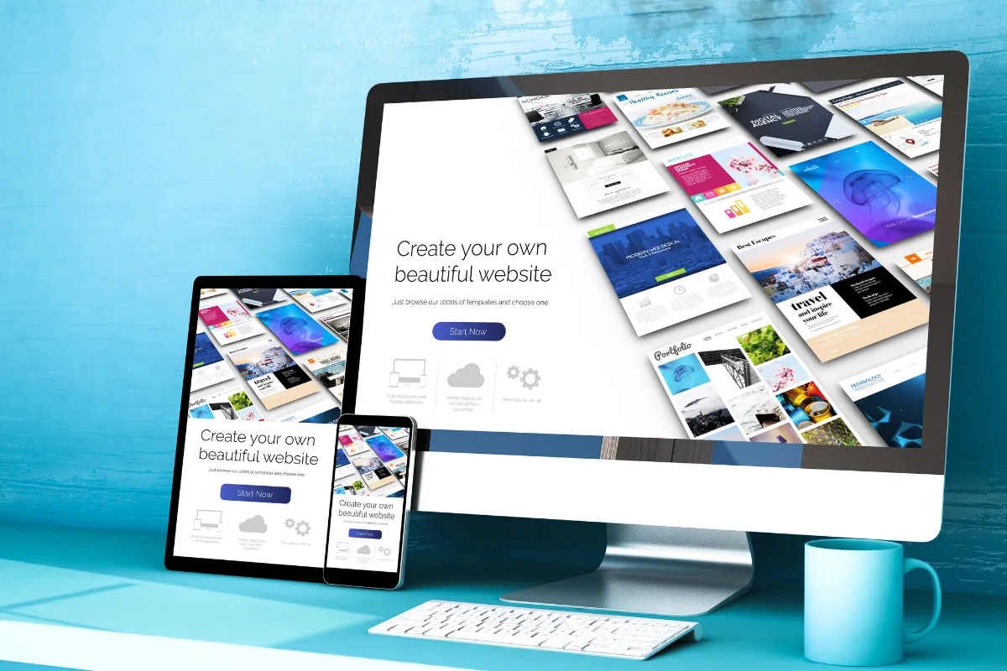

Build a business website for free supports early ideas. Clear systems improve confidence and consistency. Such tools encourage smooth communication and dependable presence for modern growing business needs today everywhere online. Website tools also shape how layouts feel and flow. Website digital tools support clear structure and visual harmony. Website management tools help adjust pages with ease. Digital tools for business websites suit many working styles. Website tools for small business offer adaptable layout choices. A small business website package supports organised presentation. Website package for small business improves clarity and trust. Business website package options encourage consistency. Affordable website packages allow smart planning. A free website build supports simple layout experiments. Website build for free helps ideas evolve naturally without stress and confusion during creative growth and steady positive results. Choosing website tools requires clear thinking and simple goals. Website management tools help guide careful selection steps. Website digital tools should match daily working habits. Digital tools for business websites must feel supportive. Website tools for small business encourage steady decision making. A website package for small business offers helpful structure.

Small business website package choices build confidence. Business website package options feel flexible and reassuring. Affordable website packages support thoughtful budgeting. Build a business website for free helps testing ideas. Website build for free supports calm evaluation while ensuring positive outcomes and smooth progress always for long term success. Website tools also help reduce ongoing business costs. Website management tools streamline tasks and save effort. Website digital tools reduce repeated manual work. Digital tools for business websites improve efficiency gently. Website tools for small business support smarter spending choices. Affordable website packages limit unnecessary expenses. A free website build reduces early investment pressure. Website build for free keeps planning flexible. Build a business website for free supports resource balance. Small business website package options grow value steadily. Business website package solutions encourage sustainable success and promote stability, clarity, and positive long term growth for evolving business needs today online.

