Meadow Grass Mix And Their Misconceptions

Wild meadows feel more important within modern lifestyles today. Natural spaces bring calm and balance. Wild meadow seeds help create open and gentle surroundings. These areas feel relaxed and welcoming. Wildflower meadow seeds support colourful growth and soft movement. English wildflower seeds reflect long valued planting traditions. Wild flower seeds add charm and visual interest. Wild seeds symbolise freedom and renewal. These choices suit changing outdoor habits. They fit slower living styles. People seek natural beauty daily. Wild areas support peaceful moods. Meadows feel timeless and comforting. Growth appears simple and effortless. This approach feels future ready. Natural planting supports gentle living rhythms. Modern choices often focus on ease and harmony. Wildflower mix offers simple planting options. Growth appears natural and unforced. Wild grasses seeds add soft texture and movement. Wild grass seed supports flowing ground cover. Meadow grass mix blends gently with open spaces. These options suit busy routines. They require less planning. Check out the following website, if you're looking for more details concerning wild grasses seeds.

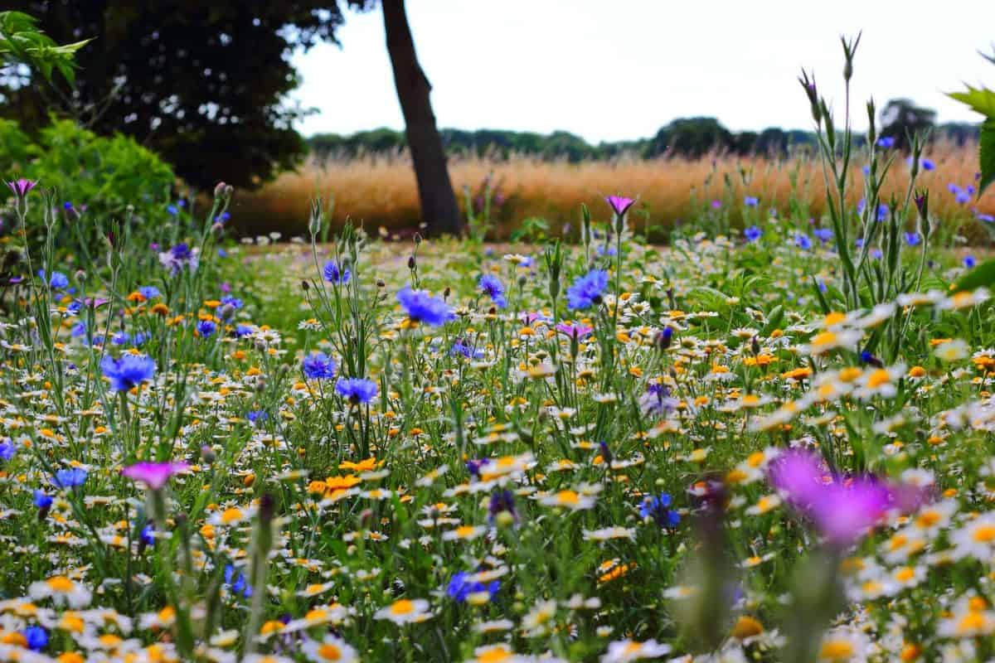

Wild meadow seeds align with mindful living values. Wildflower meadow seeds support relaxed landscapes. English wildflower seeds connect past and present styles. Wild flower seeds encourage varied colours. Wild seeds promote organic appearance. Meadows become calming escapes. Simple planting brings joy. Natural growth feels rewarding. These meadows fit modern outdoor preferences well. Balance feels essential within modern environments. Wild meadow seeds help restore gentle surroundings. Wildflower meadow seeds create visual balance. English wildflower seeds offer classic charm. Wild flower seeds support soft layers. Wild seeds allow nature led patterns. Wildflower mix blends tones and textures. Wild grasses seeds add flowing lines. Wild grass seed enhances ground softness. Meadow grass mix completes the scene. Together these elements feel harmonious. Meadows feel calm yet lively. Balance appears without strict control. Growth feels natural and unforced. These spaces support relaxed living. Natural balance reduces visual stress. Meadows encourage slower moments. They suit thoughtful outdoor choices. Care and awareness shape modern planting decisions. Wild meadow seeds reflect thoughtful choices. Wildflower meadow seeds support living beauty. English wildflower seeds feel gentle and familiar. Wild flower seeds encourage varied growth.

Wild seeds represent natural cycles. Wildflower mix offers supportive diversity. Wild grasses seeds add strength and flow. Wild grass seed supports ground coverage. Meadow grass mix brings unity. Caring choices create welcoming spaces. Meadows support gentle surroundings. Planting becomes an act of care. These choices respect natural rhythms. Growth feels steady and positive. Meadows inspire appreciation. Natural spaces feel valued. Careful planting supports lasting enjoyment. Choosing wisely matters within changing lifestyles. Wild meadow seeds offer reliable results. Wildflower meadow seeds suit open landscapes. English wildflower seeds feel timeless. Wild flower seeds add lasting appeal. Wild seeds bring organic charm. Wildflower mix supports flexible designs. Wild grasses seeds enhance texture. Wild grass seed strengthens coverage. Meadow grass mix completes planting plans. These options suit future focused choices. Meadows remain attractive through seasons. Growth feels balanced and calm. Natural areas feel purposeful. Simple choices deliver strong results. Meadows support everyday wellbeing. Thoughtful selection brings satisfaction. Natural planting remains a trusted option.

