Important Things About Spray Foam Removal Certificate

Spray foam removal is a process used to clear unwanted insulation safely and neatly. It helps restore space comfort and airflow inside homes and buildings. Many homeowners seek spray foam removal for improved comfort indoors. Ageing layers can affect balance and everyday comfort over time. Careful removal supports cleaner interiors and smoother future upgrades. This approach keeps areas usable and visually pleasing again. The process feels simple when handled with planning and care. Clear outcomes depend on experience patience and steady methods. Proper spray foam removal also protects surfaces from avoidable stress. It adds lasting peace overall. Many homeowners seek spray foam removal for improved comfort indoors. Old insulation may limit flexibility or reduce visual appeal gradually. A reliable spray foam removal company brings order clarity and calm. Skilled teams plan work carefully and respect surrounding spaces throughout. Trusted spray foam removal companies focus on smooth results every time. They value clear communication and steady progress during each project. Are you searching for spray foam insulation removal certificate? View the earlier outlined site.

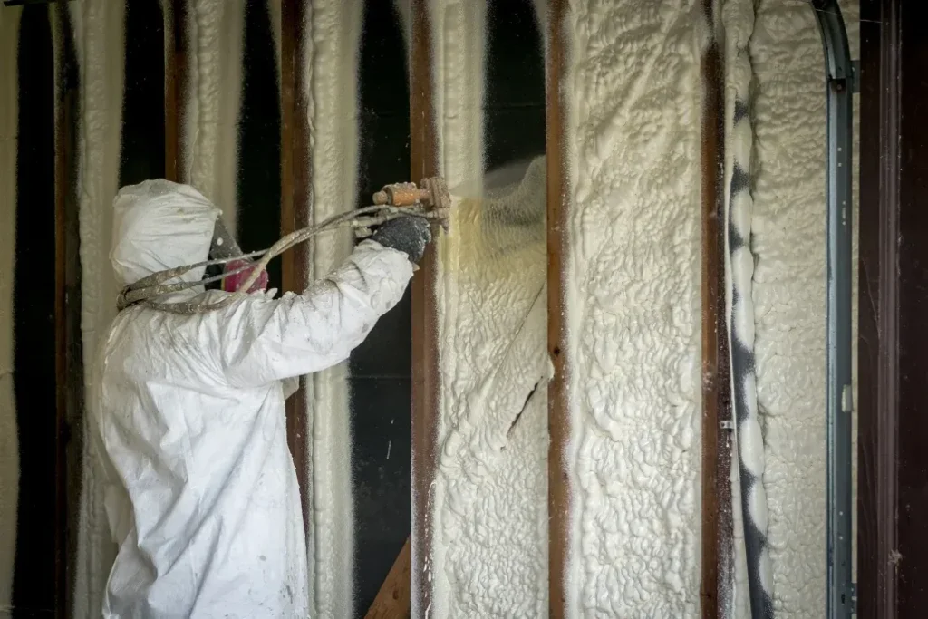

Such support reduces worry and builds confidence quickly. Good service ensures areas feel refreshed and well prepared again. Positive outcomes encourage long term satisfaction and comfort daily. This approach suits changing needs and modern living styles well today. Certification plays an important role in quality focused spray foam removal. A Spray foam removal certificate shows training awareness and trusted practice. It signals commitment to care clarity and consistent outcomes always. A spray foam insulation removal certificate also reassures property owners greatly. Documents like these support confidence during planning and decisions made. Certified spray foam removal experts follow clear steps and calm routines. Their guidance helps work progress smoothly without confusion or delay. Knowledge backed by recognition supports better overall experiences. Certification also reflects pride and positive professional standards. This focus strengthens trust across many projects and situations daily. Loft spray foam removal often needs special attention and careful planning. Upper spaces affect comfort warmth and general balance inside homes. Proper spray foam removal keeps these areas open and adaptable.

Experienced spray foam removal experts understand gentle approaches for such spaces. Their methods help preserve structure and visual harmony well. Reliable spray foam removal companies support smooth loft changes with ease. Clear processes reduce disruption and maintain comfort levels nicely. Positive handling creates inviting results and lasting value. Such projects benefit from calm timing and coordination always. Careful work keeps spaces useful longer. Satisfaction grows through thoughtful planning execution. Choosing the right spray foam removal company supports value focused outcomes. Clear processes help manage resources wisely and smoothly overall. Trusted spray foam removal companies deliver balanced results consistently. Certified teams align quality with sensible planning goals well. A Spray foam removal certificate reinforces dependable service standards clearly. The spray foam insulation removal certificate adds further assurance during decisions. Spray foam removal experts help avoid repeated work through careful action. Their experience supports long lasting comfort and steady performance. Loft spray foam removal benefits from this thoughtful approach greatly. Overall spray foam removal brings comfort clarity and positive change forward.

