Important Things About Loft Extension Plans

Modern architecture continues to reshape how planning permission drawing is approached today. Clean forms, flexible spaces, and balanced layouts influence early ideas. Designers focus on clarity, light, and flow. Architectural drawings for planning permission now reflect simple shapes and thoughtful proportions. Every drawing for planning permission must communicate intent clearly. Planning drawings support understanding between all parties. A strong planning application drawing sets the tone for approval. Visual harmony matters. These changes help designs feel current while remaining practical. Modern trends encourage adaptable concepts that respond well to review expectations and long term use across evolving residential design needs today. Current design trends influence how building extension drawings are prepared and reviewed. Open layouts connect spaces smoothly. Natural light guides placement choices. Extension design plans now favor simplicity and balance. Home extension drawings reflect clean lines and calm structure. Extension plans are shaped by modern living habits. Loft extension plans also follow these ideas. Loft extension drawings emphasize proportion and efficient use. Are you searching for extension design plans? Visit the previously outlined site.

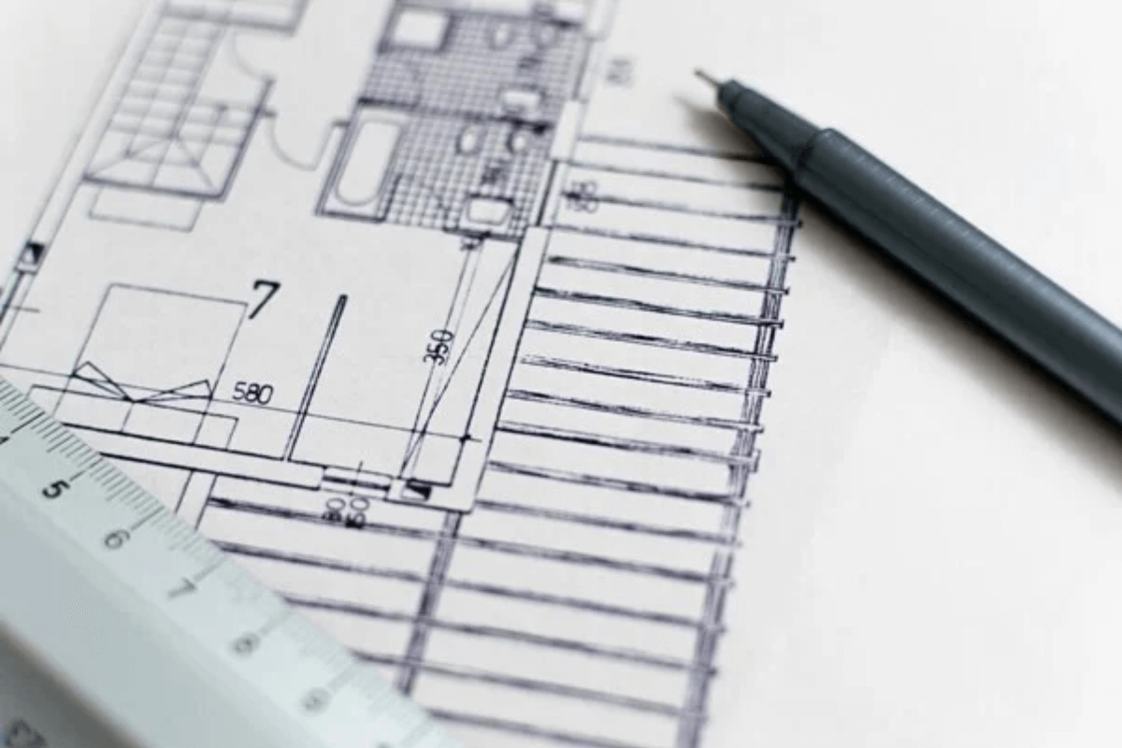

Planning drawings must show these qualities clearly. When modern thinking guides drawings, proposals appear organized, relevant, and easier to understand for assessment teams and wider project coordination during approval stages and design communication processes across current development cycles. Evolving architecture also affects how planning permission drawing quality is judged. Clear presentation is essential. Simple visuals reduce confusion. Architectural drawings for planning permission now avoid clutter. Each drawing for planning permission highlights purpose and scale. Planning application drawing standards continue to align with modern aesthetics. Planning drawings present ideas in an orderly way. Building extension drawings benefit from this clarity. Home extension drawings feel more coherent. When extension plans follow modern principles, decision making becomes smoother, communication improves, and the overall planning process feels more transparent and predictable for everyone involved from early concepts through final approval stages reviews. Modern trends also shape how costs are considered during design stages. Efficient layouts reduce unnecessary changes. Planning permission drawing accuracy supports financial control. Architectural drawings for planning permission help limit revisions.

Planning drawings clarify scope early. Planning application drawing detail reduces uncertainty. Extension design plans become easier to assess. Building extension drawings align design intent with available resources. Loft extension plans benefit from smart use. When extension plans are clear, budgeting feels more manageable, balanced, and aligned with realistic expectations throughout the planning journey. Home extension drawings also support informed decisions and controlled outcomes across modern project development planning cycles. Professional insight connects modern architecture with effective documentation. Experience helps interpret current design expectations. Planning permission drawing quality improves with guidance. Architectural drawings for planning permission benefit from structured thinking. Drawing for planning permission becomes more consistent. Planning drawings gain clarity and balance. Planning application drawing preparation feels smoother. Home extension drawings align with design goals. Building extension drawings and loft extension drawings follow modern direction. With expert support, extension design plans and loft extension plans meet review needs, reflect trends, and move forward confidently through approval processes.

