Important Things About High Quality Printing

Modern marketing still values a strong print shop presence today. Physical materials create trust and lasting brand awareness. Printing services support campaigns across many customer touchpoints. Clear printing helps messages feel real and dependable. Businesses rely on printers for consistent visual communication. Digital printing adds speed, flexibility, and creative freedom. Marketing plans often mix online reach with printed support. This balanced approach improves recall and engagement. Signs displayed in visible spaces guide attention naturally. Professional signs strengthen identity and recognition. A reliable print shop supports marketing goals through quality, clarity, and dependable delivery. These materials remain relevant across promotional environments. Printing services play a vital role in modern promotion efforts. A print shop offers variety, choice, and helpful guidance. Skilled sign makers create visuals that attract quick attention. Experienced sign writers shape messages that feel clear. Signs communicate offers without digital distraction. If you are hunting to learn more about hertfordshire printers, explore the earlier mentioned site.

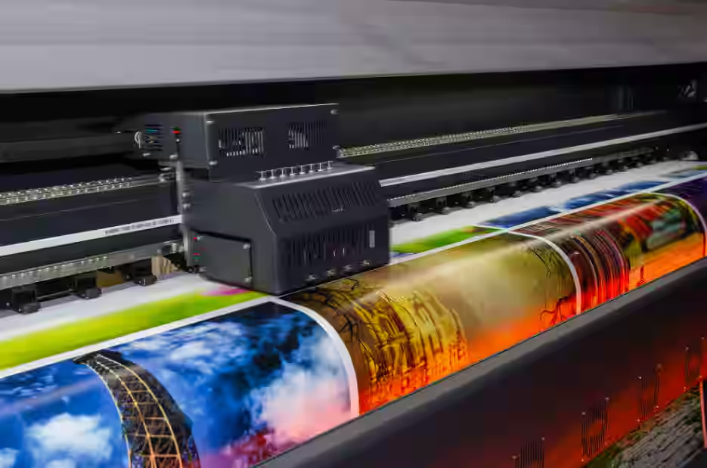

Printing allows control over colour, finish, and style. Digital printing supports short runs and fast updates. Marketing teams value flexibility and quick turnaround. Printed banners support events, displays, and campaigns. Clear signs help audiences understand messages instantly. Strong printing services help brands appear organised, confident, and professional everywhere. This support strengthens visibility and builds lasting marketing trust consistently. Modern buyers often search for fast local solutions. Phrases like roll up banner printing near me show intent. Such searches reflect urgent marketing needs. A print shop meets these expectations smoothly. Printers handle requests with speed and care. Roller banner printing near me remains popular for promotions. Banners are portable, simple, and visually strong. Printing helps businesses prepare for events quickly. Digital printing allows updates without long delays. Signs and banners support face to face engagement. Reliable printers help marketing plans move forward confidently and smoothly. This convenience supports timely campaigns and improves audience response across many promotional situations daily. Quality remains central to successful printing outcomes. A trusted print shop values consistency and detail. Printing services focus on clarity and strong presentation.

High standards help messages look polished. Printers ensure colours feel balanced and appealing. Digital printing supports clean finishes and sharp output. Sign makers focus on durability and visual impact. Sign writers ensure wording stays readable and engaging. Signs with quality materials last longer. Strong printing reflects care and professionalism. Quality printing services help marketing feel reliable, clear, and positively memorable. This consistency supports trust and reinforces long term brand perception across varied promotional touchpoints everywhere today consistently. Budget friendly printing supports growing marketing needs. A print shop offers options for different budgets. Printing services help manage costs without losing impact. Printers suggest practical formats and materials. Digital printing reduces waste and extra expense. Signs provide strong value over time. Sign makers plan designs that maximise use. Sign writers create messages that work repeatedly. Roll up banner printing near me suits affordable promotion. Roller banner printing near me offers reuse and flexibility. Smart printing choices help marketing stay effective, visible, and financially comfortable. This approach supports sustainable growth and positive long term planning for modern businesses everywhere today.

