Important Things About Forensic Psychology Services

The need for truth is still a major part of the current practices of modern investigation. A lot of procedures aim to establish credibility and truthfulness. A lie detector test aids in establishing trust when confronted with sensitive situations. The lie detector helps promote the openness of discussion and calm discussions. A polygraph test is a well-structured examination without lengthy explanation. This type of test helps to clear doubts and help restore confidence. A private lie detector test suits discreet personal concerns. The test is respectful and controlled. Experts in polygraphs guide the sessions using balanced judgement. Polygraph examiners concentrate on honesty and attentive listening. Their presence soothes the participants as well as those who are watching. They are a source of well-balanced insight. Positive outcomes support confident decisions. The modern investigation is constantly evolving and using proven assessment techniques. Innovations help to understand human behavior patterns. The lie detector remains relevant through adaptive approaches. A polygraph test fits changing expectations of investigators easily. Polygraph experts combine experience with flexibility in thinking. Are you hunting for lie detector test? Visit the earlier discussed site.

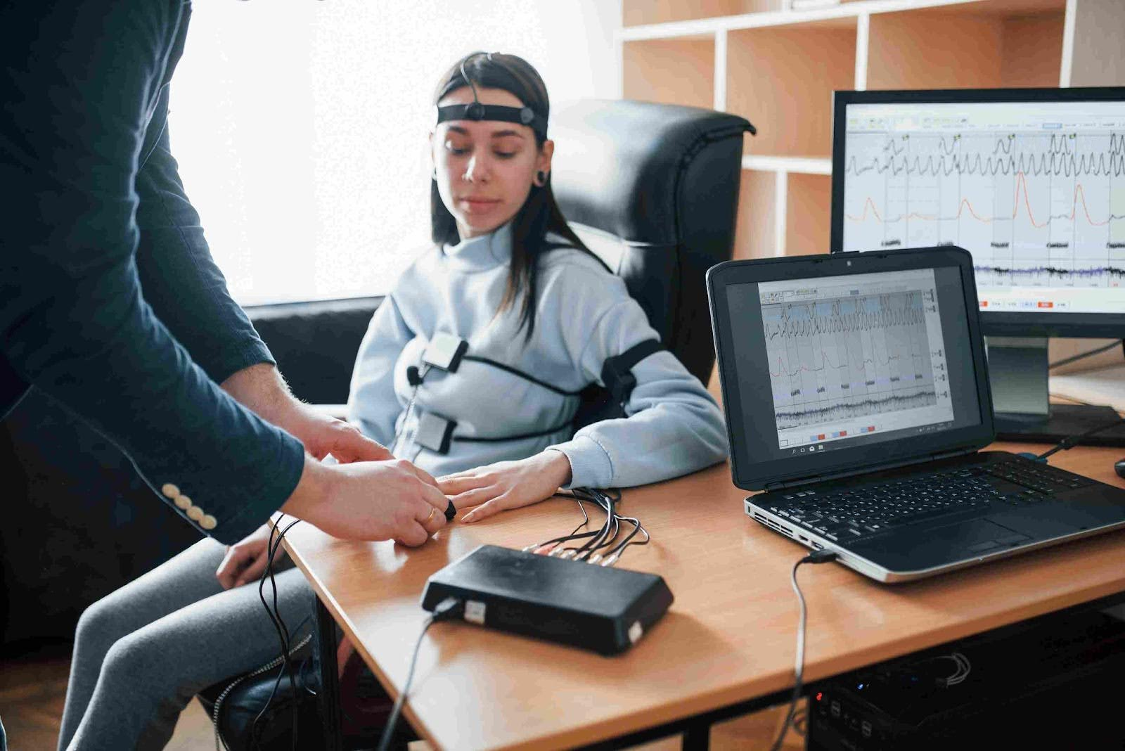

Examiners for polygraphs alter their test sessions to provide convenience and clarity. A private lie detector test reflects modern privacy needs. This service supports calm and co-operative engagement. Forensic cyberpsychology adds behavioural awareness to investigations. Cyber psychology experts help interpret digital behaviour patterns. Combining these strategies, they produce an accurate and fair evaluation. Progress strengthens trust and confidence. Investigations benefit from intelligent and flexible services. Finding suitable specialists remains essential for meaningful outcomes. Polygraph experts can provide insightful and constant direction. Polygraph examiners provide calm testing environments. Their work helps to promote the clarity and understanding of the test. The lie detector test benefits from the expertise of a professional. The lie detector performs best with careful supervision. The test is reassuring with a competent oversight. A lie detector test in private requires sensitivity and discretion. Forensic cyberpsychology helps to develop greater understanding of behavior. Cyber psychology experts provide valuable information on behavior. Expert involvement strengthens credibility. Trustworthy guidance can help achieve positive results. Careful selection ensures positive investigative experiences. Accuracy remains a key reason for the continued use. A lie detector test supports careful truth assessment.

The lie detector helps to encourage honest responses through its structure. A polygraph test promotes consistent assessments. Examiners in the polygraph focus on attentive monitoring. Polygraph experts maintain an even and fair approach. A private lie detector test can provide a clear and precise evaluation. This enables clear and solid understanding. Cyberpsychology with forensics can provide insight into the patterns of behaviour. Cyber psychology experts support informed interpretation. Combining methods increase confidence of the outcome. Accurate processes reduce uncertainty. Clear results help informed decision making. Professional standards provide trust in investigative services. The lie detector test adheres to accepted ethical practices. The lie detector works within specific guidelines. Polygraph tests are in accordance with established procedures. Polygraph experts adhere to responsibility and fairness. Examiners for polygraphs adhere to a professional manner during the entire test. A private lie detector test takes pride in confidence and self-respect. Cyberpsychology forforensics supports ethical behaviour evaluation. Cyber psychology experts help promote ethical awareness. These guidelines protect all parties. Regularly followed practices increase confidence and peace of mind. Legal knowledge is a key factor in achieving reliable results. These services are trusted and admired.

