Detailed Analysis On The Weddings Events Venue

Venue hire shapes special moments for many celebrations. An event venue feels welcoming, bright, and flexible. A lively bar adds warmth to shared gatherings. The bar and kitchen blends flavour with comfort. Spacious halls suit weddings, parties, and reunions. Wedding venues create joy for families and friends. Reception venues feel elegant yet relaxed. Thoughtful design makes every guest feel included. Smooth service keeps events calm and memorable. Warm lighting and music lift every mood. Clear space invites easy movement and happy chatter. Simple layouts help guests connect, laugh, and celebrate together. Comfort builds lasting positive memories. Unique experiences grow through smart venue hire choices. An event venue adapts to different themes and styles. A cosy function room suits small groups perfectly. Larger halls welcome big lively crowds. Private function rooms offer privacy with warm charm. Dry hire wedding venues let hosts personalise spaces freely. If you are searching for additional details on venue hire watford, view the above site.

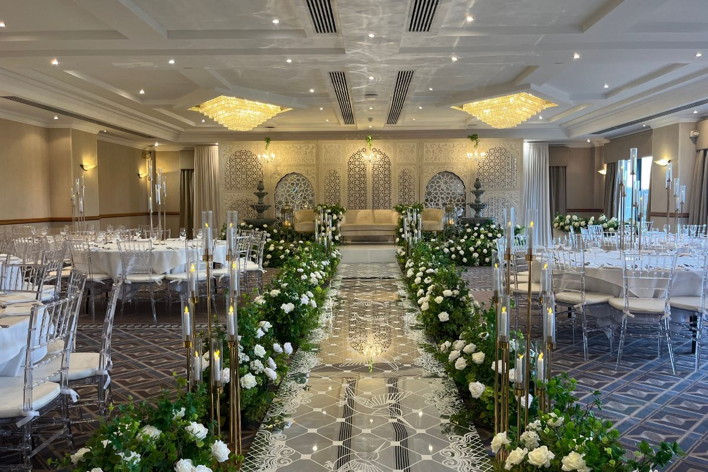

Creative layouts inspire photos and storytelling. Soft décor creates calm, elegant atmospheres. Friendly staff guide guests gently throughout events. Music, colours, and textures blend smoothly. Flexible seating keeps comfort high for everyone. Open flow encourages movement, laughter, and meaningful conversations among guests. Bright lighting adds warmth and cheerful energy. Quality service elevates every event venue experience. Skilled teams welcome guests with genuine warmth. A friendly bar serves tasty drinks and smiles. The bar and kitchen delivers hearty fresh meals. Thoughtful menus suit weddings, receptions, and parties. Wedding venues pair care with consistent hospitality. Reception venues feel smooth from arrival to farewell. Calm staff solve small needs quickly and kindly. Guests relax and enjoy each moment together. Shared dining builds connection, laughter, and joy. Clean tables and bright spaces show respect for visitors. Warm greetings make families feel valued and deeply appreciated. Great food turns gatherings into celebrations.Beautiful ambience transforms simple venue hire into magic. An event venue feels bright, calm, and stylish.

Wide halls offer room for movement and dance. Well-lit corners invite warm friendly chats. Private function rooms create cosy intimate moods. Soft décor blends with gentle music seamlessly. Clean facilities keep guests comfortable throughout visits. Clear layouts help people mingle easily. Welcoming entrances set a joyful tone instantly. Thoughtful details make every moment special. Natural light lifts spirits and adds charm. Comfortable seating supports long happy gatherings. Versatile spaces suit celebrations, ceremonies, and relaxed social evenings. Family friendly spaces welcome all ages with warmth. Event venue designs suit children, parents, and elders. Dog friendly pubs let pets join happy celebrations. Calm halls keep noise balanced and cheerful. A bright function room suits playful activities well. Reception venues feel relaxed and inclusive always. Dry hire wedding venues empower families creatively. Simple layouts support easy movement for prams. Friendly staff help guests of every age. Shared moments build love, laughter, and unity. Safe spaces let children explore while adults connect. Comfortable seating keeps everyone relaxed. Gentle music creates calm, cheerful, and comforting atmosphere.

