Complete Analysis On The Voice Over Artist Agency

Different voices strongly shape how audiences feel and respond. A calm sound builds trust quickly. A bright sound feels friendly and open. A deep sound feels steady and confident. Vocal variety changes mood, meaning, and attention levels. Media messages rely on this impact daily. Listeners connect faster when voices feel natural. Emotional tones guide focus without effort. This is why careful voice choice matters. A voice over artist agency understands these subtle differences. They match projects with suitable voices. This support improves clarity and response. Voice variety keeps content engaging, smooth, and memorable across platforms for modern creative communication needs. Vocal variety influences listener perception in powerful ways. Tone shifts affect emotion and belief. Soft delivery suggests care and warmth. Firm delivery suggests strength and assurance. Audiences notice these changes instantly. A skilled voice over artist controls these shifts smoothly. Such skill grows through guidance and exposure. A voice over agency provides that access. Experienced voice over agents understand casting balance. Make a search on the following website, if you are hunting for more details on voice over artist agency.

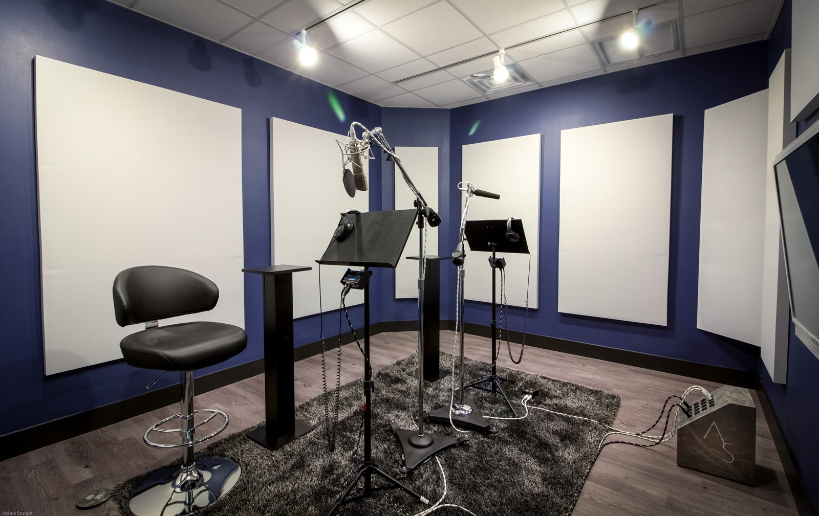

They present voice over artists with distinct styles. This variety supports different messages. Brands benefit from clear matching. Strong alignment improves reach, recall, and audience trust over time while delivering consistent value across varied media formats and communication channels. Working with professionals ensures access to broad talent. A voice over artist agency builds curated voice pools. These pools include diverse voice over artists. Each voice brings a unique rhythm and tone. Voice over artist agents guide selection with insight. Their experience reduces uncertainty and delays. Voice over agents manage expectations clearly. They help align sound with purpose. This process supports strong storytelling outcomes. Voice over services become smoother and more reliable. Quality voices elevate simple messages. Consistent sound choices strengthen identity. Audience connection grows through thoughtful voice decisions across content for campaigns seeking clarity emotional pull and lasting engagement everywhere. Different media require different vocal approaches. Short content needs energy and pace. Longer formats need calm flow. Voice modulation supports these shifts naturally. A voice over agency recognises these needs early.

They recommend voices that adapt easily. Top voice over agents focus on versatility. Best voice over agents value consistency and range. This guidance improves overall delivery. Voice over services then meet varied creative goals. Balanced voices hold attention longer. Clear expression supports understanding. Well matched voices help messages feel authentic, appealing, and easy to absorb across platforms styles audiences and evolving communication demands with clarity warmth balance trust flow. Audience impact improves when voices feel intentional. Thoughtful selection shapes perception and response. Voice over agencies simplify this process. They connect brands with fitting talent. A trusted voice over artist agency ensures quality control. Voice over artist agents support creative alignment. Voice over agents coordinate smooth delivery stages. Voice over services stay flexible and supportive. Skilled voice over artists bring scripts to life. Each voice over artist adds personality and depth. Together these elements strengthen communication. Messages sound natural and engaging. The right voice choice leaves lasting impressions across media while building trust connection clarity recall and positive audience response.

