All You Want To Know About The Mobility Scooter Experts

Choosing mobility scooters starts with understanding personal movement needs and comfort. Daily routines, balance, and energy levels matter greatly. A mobility scooter should support freedom and confidence. Some people prefer a lightweight mobility scooter for gentle use. Others need stronger support for longer outings. Affordable mobility scooters can still feel reliable and smooth. Exploring mobility scooter shops helps compare styles easily. A calm approach reduces confusion during selection. Comfort, ease, and control guide better decisions. The right scooter for mobility fits life naturally and encourages positive daily movement. This process supports independence and steady confidence. Choices improve wellbeing and satisfaction. Personal ability shapes which mobility scooter feels most suitable. Strength, posture, and space needs influence comfort. A heavy duty mobility scooter offers steady support. It suits extended use and varied surfaces. A portable mobility scooter suits flexible lifestyles. Easy handling brings relaxed experiences outside. A travel mobility scooter supports smooth journeys. It fits changing plans and active schedules. Visiting a mobility scooter shop allows clearer choices. Visit the following site, if you're looking for more information regarding mobility scooter birmingham.

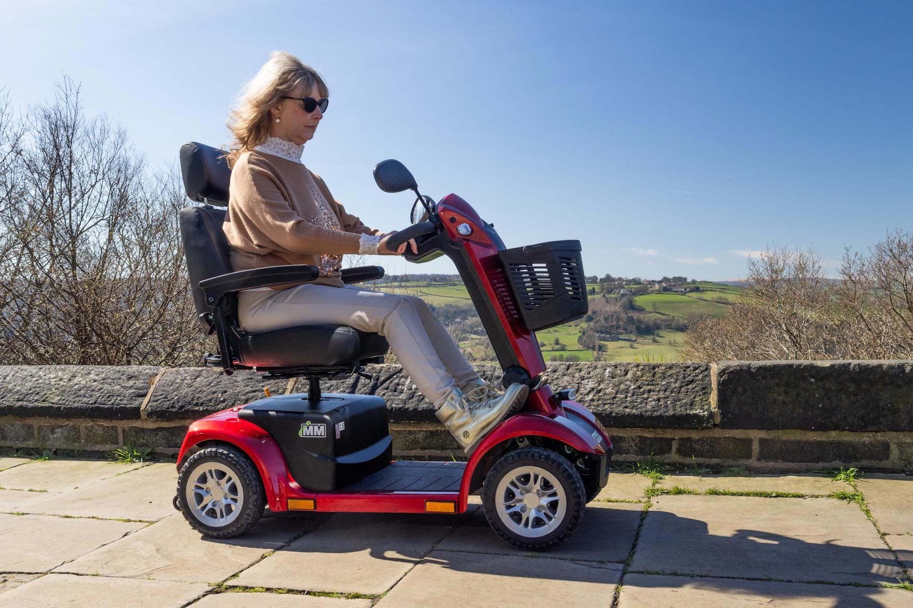

Guidance helps people buy mobility scooter options matching daily habits. This approach avoids stress and builds assurance. Simple comparisons create clarity and calm decisions. Supportive features encourage trust and steady use. Comfort remains essential. Different lifestyles benefit from varied mobility scooters designs. Some users value simplicity and light movement. A lightweight mobility scooter feels easy and calm. Others require dependable strength for confidence. A heavy duty mobility scooter meets those needs well. Portable designs suit changing daily routines. A portable mobility scooter feels adaptable and reassuring. Travel friendly options support independence beyond home. Mobility scooter shops present helpful comparisons. Friendly spaces make choices relaxed and positive for everyone. Selection becomes smoother with patience and thoughtful review. Clear options inspire confidence and daily motivation. This balance supports comfort, dignity, and ongoing independence. For varied needs. Cost awareness matters when choosing supportive movement aids. Affordable mobility scooters balance value and comfort. Price clarity reduces worry and builds trust. Mobility scooter shops often show varied options.

A mobility scooter shop experience feels helpful and calm. Simple guidance supports confident selection. People can buy mobility scooter choices without pressure. Ease of use improves daily satisfaction. Controls feel natural and responsive. Each scooter for mobility should feel welcoming, smooth, and dependable. Design focus keeps movement relaxed and enjoyable. Practical layouts help confidence grow naturally. Clear displays and seating improve calm daily experiences. Overall comfort supports happier routines. With ease. Safety confidence shapes satisfaction with mobility scooters choices. Stable movement encourages relaxed daily use. A heavy duty mobility scooter feels grounded and secure. Balanced frames support smooth control. A lightweight mobility scooter offers gentle handling. Portable options maintain confidence while moving around. A travel mobility scooter supports safe transitions. Mobility scooter shops highlight reassurance through choice. Trust grows with supportive designs and calm operation. The right scooter for mobility brings peace, assurance, and lasting independence. Positive experiences strengthen confidence and daily enjoyment. Supportive choices encourage active routines. Reliable designs help users feel secure every day. Comfort remains a priority. Always.

