A Peek At Buy Teltonika Credits

Managing connected devices feels smooth with easy tools. People often want to buy RMS quickly. Many prefer to buy teltonika RMS credit online. They can also get RMS credits online fast. An instant buy RMS saves time and effort. Simple steps help users feel calm and confident. Clear guidance makes the whole process friendly. This approach suits both new and regular users. Buying options remain simple, clear, and welcoming. People like fast access to RMS credits teltonika. This ease builds trust and steady daily usage. Smooth buying reduces stress for every busy team. Simple choices keep things calm daily everywhere. The process begins with a simple account login. Users then choose to purchase RMS credits. Many also purchase teltonika RMS credits online. Clear buttons guide calm and steady actions. Make a search on the below mentioned site, if you are seeking for additional information regarding buy teltonika rms credit.

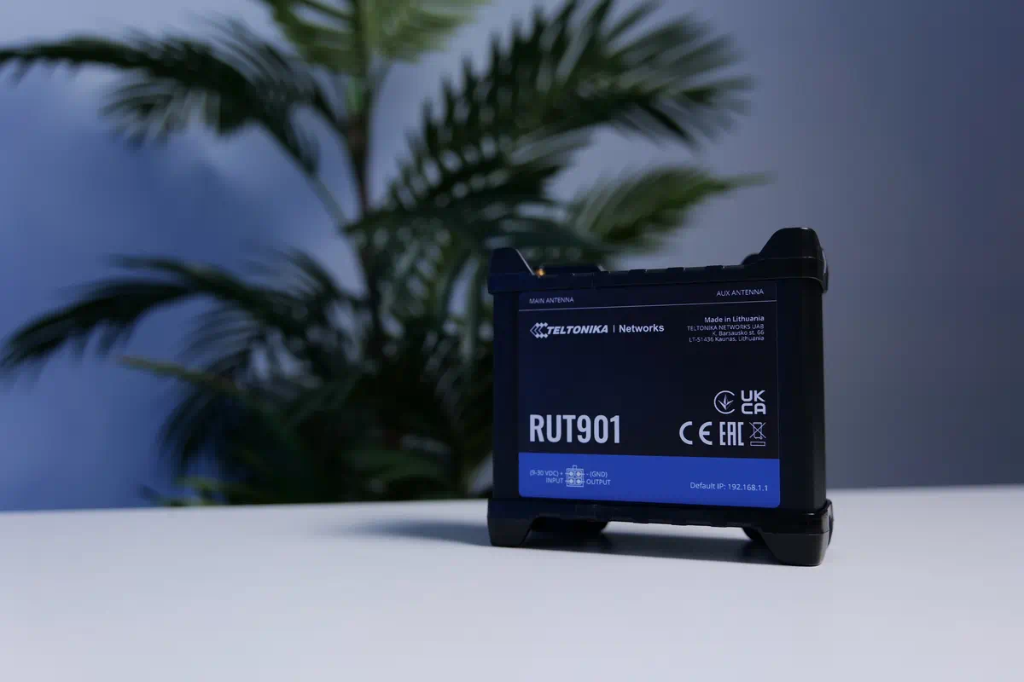

Friendly screens keep the mood light. Users can teltonika RMS add credits easily. This step feels natural and very smooth. Helpful prompts reassure every careful buyer. Calm design builds confidence in the process. Users enjoy simple paths without confusion. Each click feels gentle and purposeful. This method supports both small and large teams. Smooth steps help daily work stay balanced. Reliable choices make device care feel easy always for every user. Different RMS credit packs teltonika suit varied needs. Some prefer smaller teltonika RMS credit packs. Others choose larger options for steady use. RMS credits teltonika remain flexible and friendly. These packs help teams plan with clarity. Simple choices reduce daily decision fatigue. Users appreciate clear labels and guidance. Calm design keeps every step reassuring. Pack variety supports both light and heavy usage. Teams feel prepared and confident daily. Clear options prevent worry and build trust. Smooth selection keeps workflow simple and calm. Helpful packs encourage steady and reliable planning for teams.

Simple structure keeps daily device care balanced and calm. Finding the best way to buy RMS matters. Users look for smooth steps and speed. They prefer to buy teltonika RMS credits online. They also like to get RMS credits online. Friendly platforms build calm confidence quickly. Clear guidance makes choices feel simple. Reliable systems keep daily work steady. Users value smooth and gentle experiences. Positive design reduces stress across teams. Easy access supports quick daily decisions. Calm layouts keep attention focused and clear. Smooth buying builds trust with every use. Simple paths help teams feel confident daily in every task. Clear steps keep work calm and steady for everyone. The future feels bright for instant buy RMS. Fast systems will keep getting smoother. Users will still purchase RMS credits easily. teltonika RMS licence credit will stay helpful. Clear tools will make daily work calmer. Friendly designs will build stronger trust. Teams will enjoy smooth, steady access. Systems will guide users with gentle prompts. Buying paths will feel natural and clear. Users will appreciate calm experiences daily. Innovation will keep processes simple and kind. Smooth growth will support every busy team. Clear choices will reduce worry and build confidence for users.

