A Glimpse At Cinematic Brand Stories

Modern creative work evolves through fresh thinking and flexible practices. A videographer adapts quickly and explores new visual paths. Story flow feels natural and engaging for varied audiences. Independent videographer roles encourage originality and confident expression. Freelance video production allows freedom and steady creative growth. Visual ideas remain simple yet expressive throughout projects. A videographer freelance approach values planning and smooth delivery. Creative routines change often to match project moods. Fresh angles support clear messages and emotional balance. This evolving style keeps viewers interested and connected. Creative confidence grows with practice and thoughtful collaboration. Simple methods support consistent visual storytelling. Creative methods shift as freelance videographer work becomes more diverse. A camera operator focuses on movement and steady framing. Freelance camera operator roles encourage adaptability and awareness. Visual rhythm stays calm and pleasing. Simple motion creates engaging scenes without complexity. If you are seeking for more information on independent videographer, visit the mentioned above website.

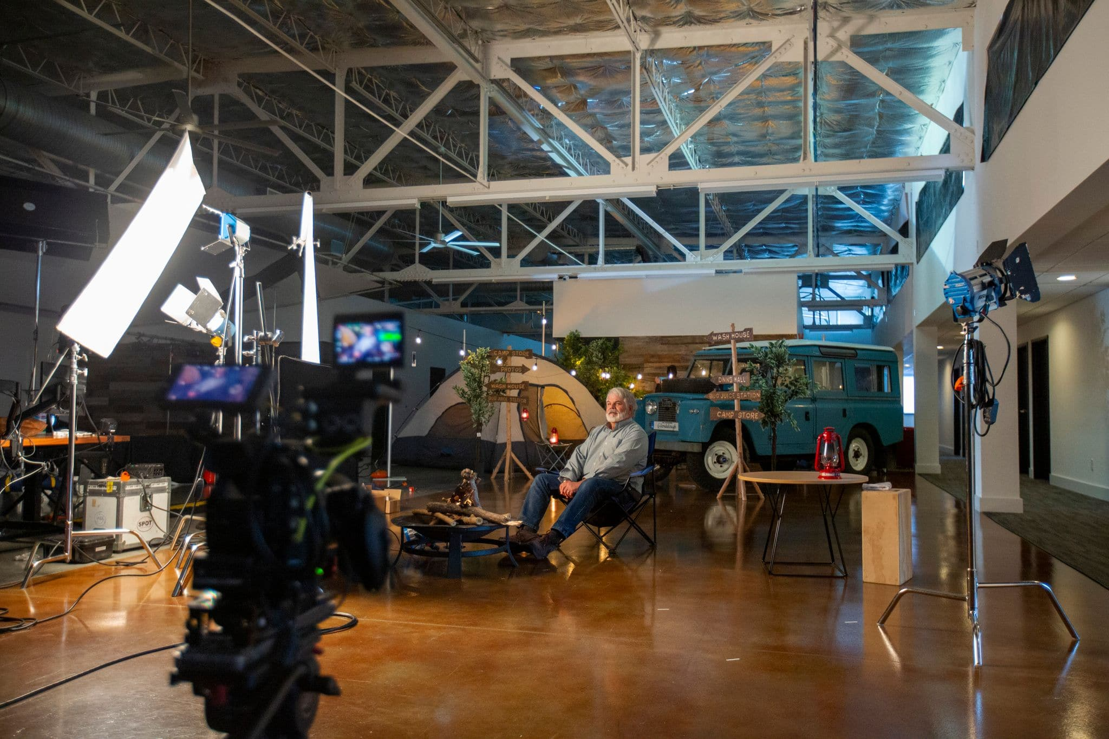

Videographer freelance routines often mix planning and creative freedom. Independent videographer thinking supports bold yet clear choices. Workflows stay flexible and responsive. Collaboration improves flow and shared understanding. These methods strengthen storytelling across varied projects. Freelance video production supports creativity and consistent output. Clear communication keeps tasks organised and progress steady. Visual clarity helps audiences connect with simple ideas. Modern workflows rely on cooperation and shared creative goals. Film editors shape stories through pacing and gentle refinement. A freelance videographer editor supports smooth visual transitions. Videographer freelance projects benefit from teamwork and trust. Independent videographer efforts blend well with editing support. Simple feedback improves flow and clarity. Freelance video production values shared responsibility and openness. Creative exchanges remain respectful and productive. Visual balance stays consistent across scenes. These workflows encourage quality and creative satisfaction. Collaboration reduces confusion and supports confident decision making. Clear roles help teams work calmly and efficiently. Positive energy improves outcomes and shared motivation. Quality remains central within creative visual work. A camera operator maintains steady visuals and pleasing composition. Freelance camera operator skills support consistent results.

Videographer freelance habits prioritise clarity and balance. Independent videographer work reflects careful attention. Simple lighting choices enhance mood and warmth. Film editors refine sequences for smooth viewing. Freelance videographer editor input strengthens final presentation. Freelance video production benefits from shared quality goals. Viewers appreciate clean visuals and clear storytelling. Consistent standards help build trust and lasting engagement. Positive focus encourages pride across creative teams. Simple checks ensure reliable visual outcomes. Strong results support ongoing creative confidence. Modern approaches support value and creative efficiency. Freelance video production adapts to varied budget needs. A videographer uses smart planning and flexible ideas. Videographer freelance services remain accessible and effective. Independent videographer work balances creativity and value. Freelance videographer editor support reduces rework and delays. Film editors help maximise existing visuals. A camera operator plans shots carefully and calmly. Freelance camera operator experience supports smooth progress. These methods keep quality high and costs controlled. Creative flexibility encourages practical choices and steady outcomes. Positive planning supports confidence and long term satisfaction. Simple collaboration keeps projects enjoyable and successful.

